On Steeds and Sonnets: A Conversation with Viggo Mortensen

A film review by Blake French - Copyright © 2004 filmcritic.com
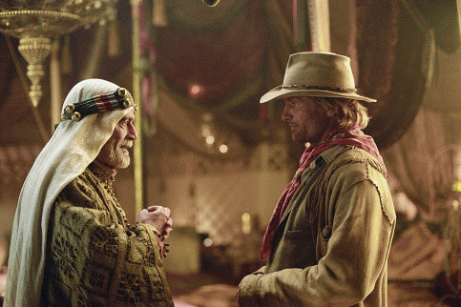

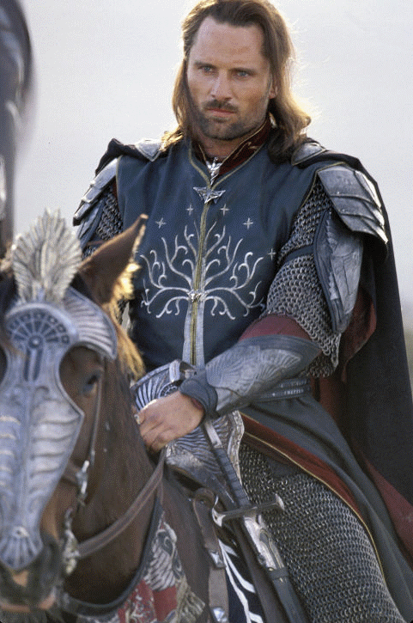
Before he replaced Stuart Townsend in the role of Aragorn in The Lord of the Rings trilogy, Viggo Mortensen was merely a supporting — albeit familiar — presence in American cinema. From Gwyneth Paltrow’s murderous lover in A Perfect Murder (1998) to Demi Moore’s hard-core training instructor in G.I. Jane (1997), to Lucifer himself in The Prophecy (1995), the suave, stylish actor has portrayed a wide assortment of supporting characters throughout his career.
Today, however, it appears as if Mortensen’s supporting roles are things of the past. He most recently starred in Disney’s Hidalgo — except this time he’s not acting alongside anyone. He is the star — the face on the poster and name mentioned in advertisements on TV. Yet, he still hasn’t lost interest in his other artistic endeavors, which include painting, poetry, music, and photography. Recently, we had an opportunity to ask him about his promising career.
filmcritic.com: Hidalgo is the first film in which you bare the responsibility of being the only big star. You are almost selling the film single-handedly. Where do you see you’re career going now that your face is up on the posters?
Viggo Mortensen: Yeah, my big fat head is taking up a lot of room on the poster (laughs). But it really isn’t until now that it has dawned on me that I’m responsible for selling it. While we were shooting… it was no different than The Lord of the Rings, where there was a pretty big cast of very talented people all doing a very good job. I didn’t have any sense of obligation or special responsibility. It wasn’t my idea — the big fat head poster. I was thinking this morning about some of the other performers, other than Omar Sharif and myself. He’s known for a long and interesting career, and the public now knows me because of The Lord of the Rings. But, apart from that, there are all these other actors. Journalists in different cities and all kinds of different people who have seen it, they all seem to have a pretty good reaction to this story. Therefore… it will probably be pretty popular, I think. [Sorry, Viggo – the $78 million movie grossed just $61 million in the U.S. –Ed.] If something is interesting and well told, it deserves to be seen. Most of the cast of The Lord of the Rings— even if they were experienced — was not that well known, including myself. Then, with the success of The Fellowship of the Ring, all of a sudden, they were known, and became increasingly known with the each of the other parts of the trilogy. I think it will be similar for the actors in this movie.
Now that audiences worldwide recognize you as a movie star, has that changed your life? Is it strange to have people running down the street to get your autograph?
In some ways, it’s a little strange. On one level, people are assuming they know you because they know a character that they’re seeing on screen. The guy in the picture is me, but it’s not me. I’m behaving like someone else. I’m dressed like someone else. There’s weirdness about that. But, overall, I take it as an indirect compliment, not just to me, but also to those who I’ve worked with. It tells me that we got something right… that the story is striking a chord and touching people in a way, and making them think about many different things, and that’s good. I can’t complain about that. I always have in mind the fact that extreme fascination with a particular actor or actress is a passing thing. As someone else popular comes along, people will move on. I think, not only is that realistic to look at it that way, but you’re not liable to be disappointed when they move on to someone else.

In addition to acting, you are also a painter, a poet, and a photographer. Why did you decide to focus your attention on acting? With so many different interests, how do you decide on which to specialize?
On a practical level, poetry isn’t something anybody has really made a great living at. I might sell some books and, once in a while, someone might pay to hear me read. Likewise with photography. Even before The Lord of the Rings, I could make a modest amount of money selling photographs. On the other hand, [I know a writer who] said he had been asked the same thing. He has lots of interests — he’s a journalist, a writer of novels, and short essays — he says sometimes people ask him, “Why don’t you do just one thing? Why don’t you just focus on one thing and do it really well.” He says, “Why should I?” I kind of agree with that. I wouldn’t quite put it as belligerently. But I guess I don’t really separate them. I think of them as all the same, it’s just a different way of doing the same thing, which is paying attention to your surroundings and trying to remember them — getting in the habit of participating in your own life.
Do you feel all these other artistic endeavors contribute to your work as an actor?
Sometimes they overlap, and I think they do help. Sometimes, they take the onus off you getting too precious about one detail, and getting overly focused on something that you wish you could do better. It’s also a way of resting your mind once in a while. If I’m on a long shoot, I go off and make a drawing or write a poem during lunch instead of taking a nap. It’s a way of resting one part of your mind that you’re using specifically for acting. It’s almost like you’ve had a mental nap, and then you go back and use different muscles, that are about the same thing. In other words, you’ve rested, but you’ve kept your instrument — which is your body — warmed up.
In Hidalgo, you spend a lot of time on horseback. Did you have to learn horseback riding specifically for the movie?
As far as getting along with the horse, the same rules apply anywhere, with any horse, to some degree. Every horse is different, and even the same horse is different on any given day. But if you show them a certain respect, and you don’t try to force them to do things, you end up getting better results, and — on a practical level — it will make shooting a movie that requires you to actually be riding a horse easier. If the horse is more relaxed, you can get better shots. I had ridden when I was a boy, but I never really rode much again until…well, I had a supporting part in Young Guns II, which was shot in Arizona and New Mexico about 12 or 13 years ago, in which I got to ride a little bit. In The Lord of the Rings, of course, I got to ride a little bit in the second and third parts of the trilogy. But it wasn’t until Hidalgo that I got to ride every day. A large part of the preparation — beyond trying to get historically into what that period was, and learning more about the Lakota culture, language, and traditions — was to ride as much as I could, to get comfortable with the particular horse that I’d be riding, and just to get back in shape — get my balance back. I think you have a physical memory of things you learn when you are a child. Sometimes, just by refreshing it, you can regain most of what you knew, although, as an adult, I am warier. I remember, as a boy, just tearing off across the field, bareback, without checking for holes or anthills or anything. As an adult…you’re a little more brittle, and you can think ahead about the consequences, so if the horse starts swirling around, or not responding to you when you’re riding bareback at full speed, it’s scarier, whereas, if you’re a kid, you’re just exhilarated. I also found that I still liked horses, which made the job a lot easier. If you like your job and you like your partner, it’s going to make the job easier, and it’s probably going to give the director better material. It certainly did give Joe Johnston the opportunity to film me as close as he wanted to, and without cutting if he so chose, because I could ride and could do the stunts, and so forth.
Is there anything you would like to say to the people out there that look up to you?
Be kind. It’s worthwhile to make an effort to learn about other people and figure out what you might have in common with them. If you allow yourself to be somewhat curious — and if you get into the habit of doing that—it’s the first step to being open minded… and realizing that your points of view aren’t totally opposite. I don’t think anyone’s are, in the end. It’s just a question of finding out by spending time with them or giving their ideas a chance to be considered.
April 12, 2004

