Upgrading a Yerf Dog 3203

All,

Thanks to all the people on this forum that have posted messages. I have listed below the performance mods that I did after I purchased my 3203 from Sam’s for $1000. The mods listed below cost about $300. Now the Yerf Dog flys. Better buy a helmet if you do these mods. By the way, I am not mechanically inclined but I was able to do them. This information was gathered together from many of the people on the site. All I did was try to put them together. Please feel free to download this document and add pictures plus additional info. This is a start.

Engine Modifications:

Tip1: Print out the Tecumseh Technician’s Handbook found in the “FILES” section of this site.

Tip2: All modifications listed below void factory warranty.

1. Engine Mod 1: Remove the governor - Cost $0
Drain the oil from your cart
Remove the black plastic shield that covers the gears
Remove the torque converter on the engine shaft – 1 bolt in the center of the shaft
Remove the sheet metal shield – 3 bolts attached to the engine
Remove the torque converter from the gear shaft
Remove the small sprocket gear and chain.
Remove the 8 bolts that hold the engine side cover on.
Remove the engine side cover.
The governor is the while plastic gear attached to the side cover of the engine. (See page 23 – figure 5) and picture listed below
Break off the while plastic gear from the shaft using a chisel or screwdriver.
Remove the black oblong plastic gear called the compression release and spring from the cam shaft (See page 72 figure 38). Do not remove the cam shaft.
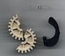
Put every thing back they way it was.
Tip: Remember to add the oil back in.
Tip: Now that you removed the governor – your idle will not be correct. The first time I started my Yerf, it took off across the yard. Thank goodness for the kill switch. So here is what you do….
Adjust the throttle screw all the way out.
Remove the spring that connects the throttle cable lever to the throttle control lever. Replace the spring with a hard wire or a large paper clip. Place the paper clip from hole 5 in the throttle control lever to the throttle cable lever. Now take the original throttle spring and place it in the large hole in the throttle control lever and attach it to the closest engine bolt. The throttle control lever is the one with 5 small numbered holes and one large hole in the center of it. This acts as a spring return for the throttle in case it were to get stuck.

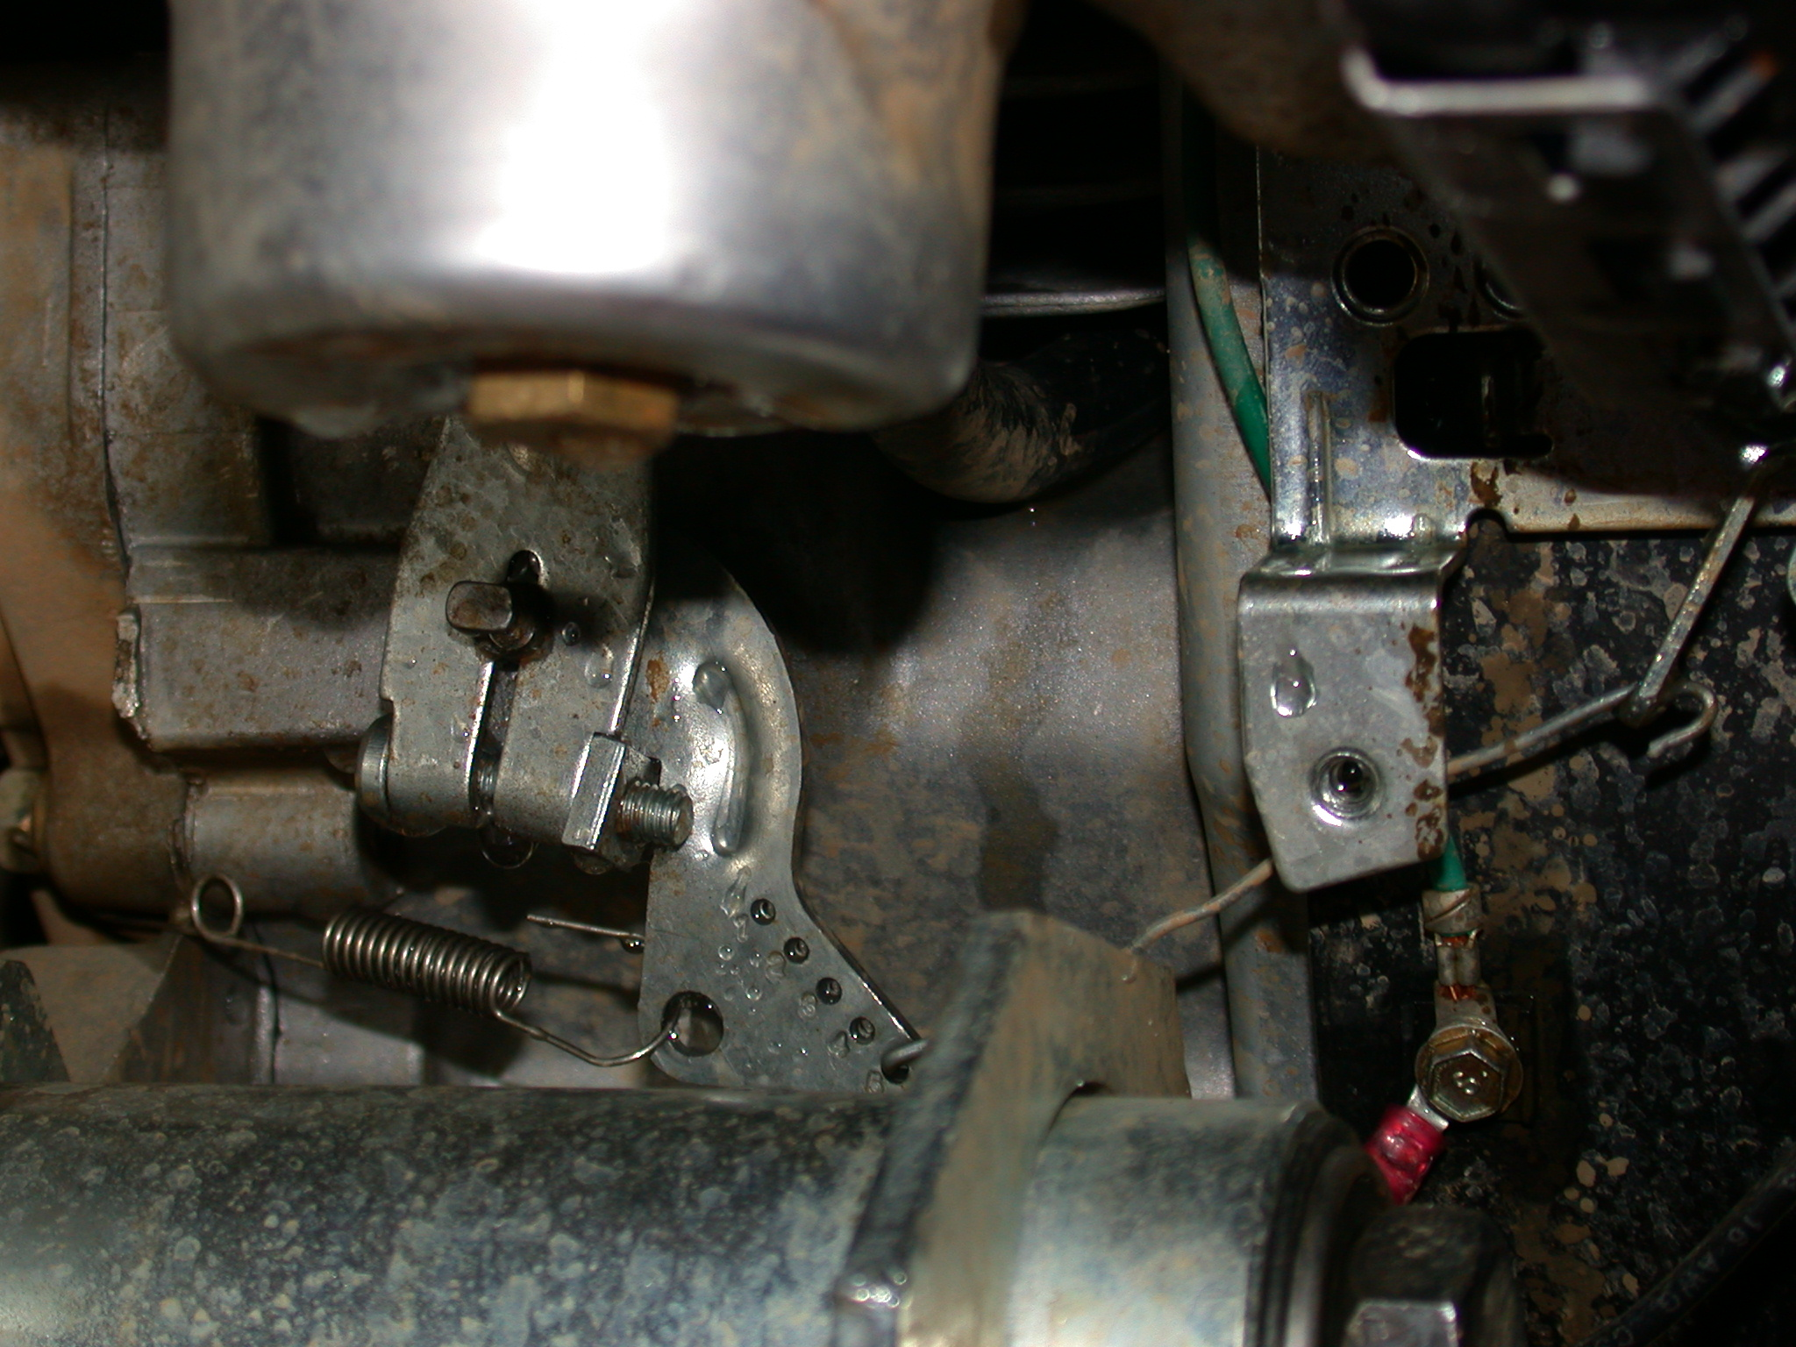

Adjust the idle screw.
Tip: You may want to prop up the back wheels while adjusting the idle.

2. Engine Mod 2: Modify the Carb to open full instead of 3/4 - Cost $0
Tip: Do this when you have an empty gas tank.
Remove the carb.
Bend the Throttle shaft lever so that the throttle plate opens to 90 degree angle when fully open. (See page 17 and 18.)
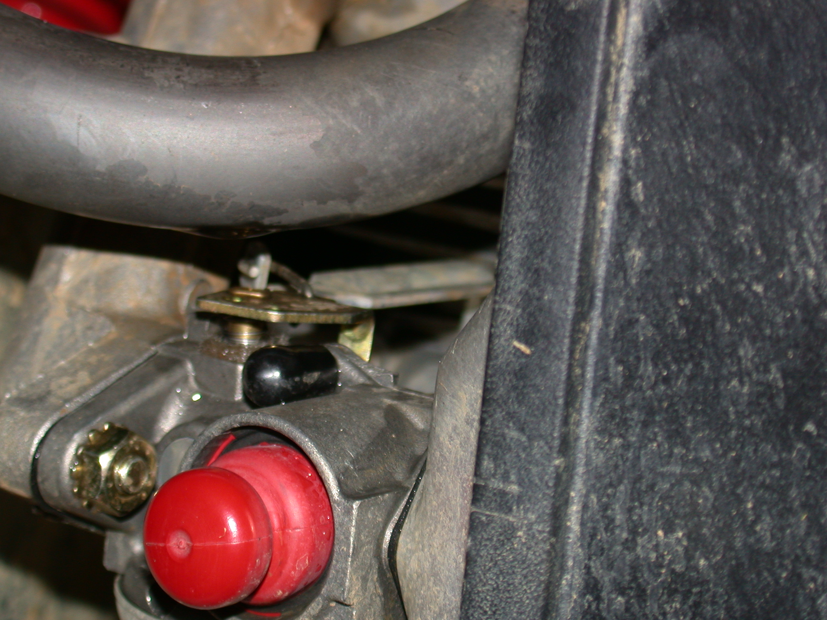

Once you bend the shaft, the throttle lever will not fully return to the idle position since the shaft lever is now too long. To fix this, take a pair of tin snips and cut a 45 degree angle off the end of the shaft. This will allow the lever to return to idle position.

3. Engine Mod 3: Added the Batman Hop-up Kit - Cost $80
This kit contains replacement valve springs (page 79), a hot coil and a new header that replaces the existing muffler.
You will need a set of feeler gauges and an Allen wrenches for this.
To order the kit, send an email to batman@whitneytx.net
Be sure to have David, aka Batman, walk you through the install.
Maybe someone on the site can add a full set of instructions to this.

4. Engine Mod 4: Added NGK B7ES #1111 Spark Plug - Cost $3
Adjust gap to 0.032

Other Mods:

1. Suspension Mod 1: Replacement Shocks - Cost $120
Replaced shocks with adjustable mechanical / hydraulic shocks AZ1700136. Page 193 of American Power Sports catalog www.apskarting.com or 1-800-262-0555. This really made a difference in suspension.

2. Lights Mod 1: Cost $60
Added set of lights, which I purchased at Kmart and powered them with a lawn mower battery from home depot.

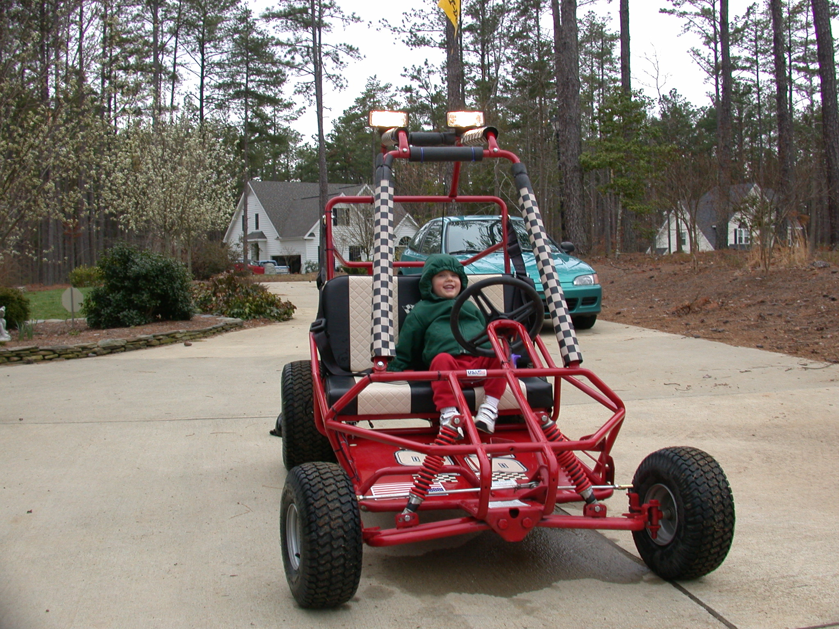
3. Oil Change Mod 1: Cost $10
Added a quick release for oil changes from home depot. This consisted of a ¼ x 4 inch copper extension pipe plus a bearing valve. This is attached to the rear oil plug closest to the back of the kart.
