Danie Adiar
GRA410 Process Book
danielle.unrast@snhu.edu

Sitemap

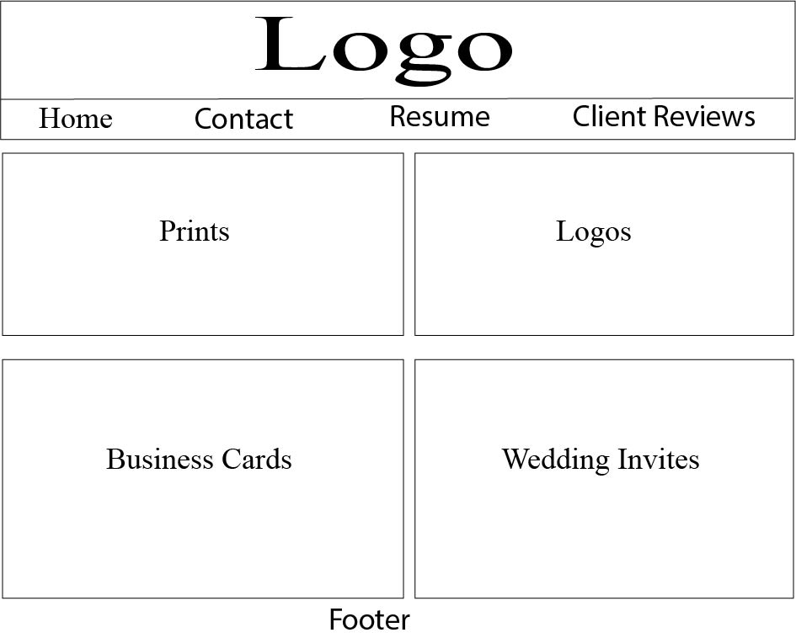
Desktop

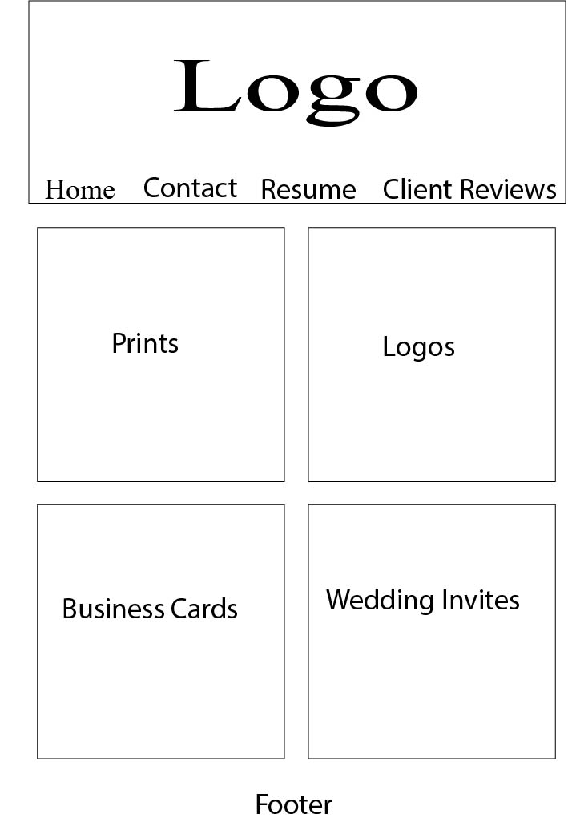
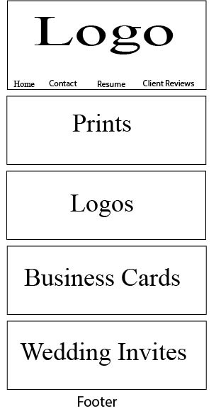
Tablet
Mobile
Daniel Adair
GRA410
Module Three
24 January 2019
What is User Design?
Technology is growing and changing constantly. We no longer find ourselves using dial-up internet, waiting to get home to use our desktops, or waiting five minutes for a website to load. With all the changes that come designers have to be able to stay relevant and know how to evolve with the technology. In the article “What is User Experience Design? Overview, Tools and Resources” Jacob Gube states “with all these sweeping changes, the websites that have consistently stood out were the one that were pleasant to use” (Jube,2019). As designers we can’t just give our clients something that looks good and works, we have to be able to give users an experience they will remember.
The number of things designers need to consider as they build a site are broken down to two main focuses; how the user feels and user friendliness. How the user feels while they are on the site is crucial. Personally, I have been on websites where there is so much content that an overwhelming feeling comes upon me so I leave the site. Another instance, I was looking through a site and trying to find something specific and I just cannot find it on the site, so I leave and find the same product on a different site. On the other hand, I have been on websites and literally spent hours looking through content because I feel as though I am getting some sort of value or knowledge from being there. Websites are a dime a dozen and if you create one that a user does not feel like they are getting something out of they will find what they are looking for somewhere else. Stopping and reviewing the design as you go and reflecting on how it makes you feel, may help you get a better site to your customer.
User friendliness is something that will keep consumers coming back to your page. A great example of a user-friendly website is Amazon. It keeps your card information on file, your address, anything that I would have to type in to make an order. Ordering something on Amazon takes maybe a minute, while other sites make you re-type your information even if you have an account. They also recently updated a “one click” purchasing option. Another user-friendly website is Pinterest. Pinterest is a search engine for any and everything, at the start of Pinterest you would just “pin” pins to a board and then they would be saved for you to look at later. Now the site has made it to where you can organize your boards into categories making it so much easier to find something you saved. I love to cook and have pinned many recipes to my “cooking” pin, but I was searching for through this one board to find this one pin I had pinned forever ago. With the upgrade I am able to make sub categorize. I have chicken, shrimp, snacks ect., in this board so I can later find what I am looking for easier. They also generate popular pins for things that you look at frequently so when you go on the site there are pins on the home page with content that you have previously searched.
In order to focus on how users feel and user-friendliness you have to know who your users are. What does your target audience look like? Are you doing things and designing to keep that target audience coming back to your website? Your job as a designer is to add value, make them stand out against the others, and them be successful. You can’t help a website standout if you don’t know what audience you are designing for, you can’t make them feel some type of way while on your website if you don’t know who they are, and you can’t be user-friendly if you don’t know who your users are.
Sources

Jube, J. (2019). What Is User Experience Design? Overview, Tools And Resources. Retrieved from
https://www.smashingmagazine.com/2010/10/what-is-user-experience-design-overview-tools-
and-resources/

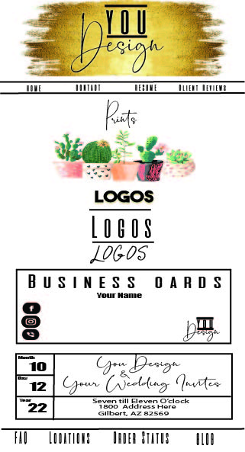
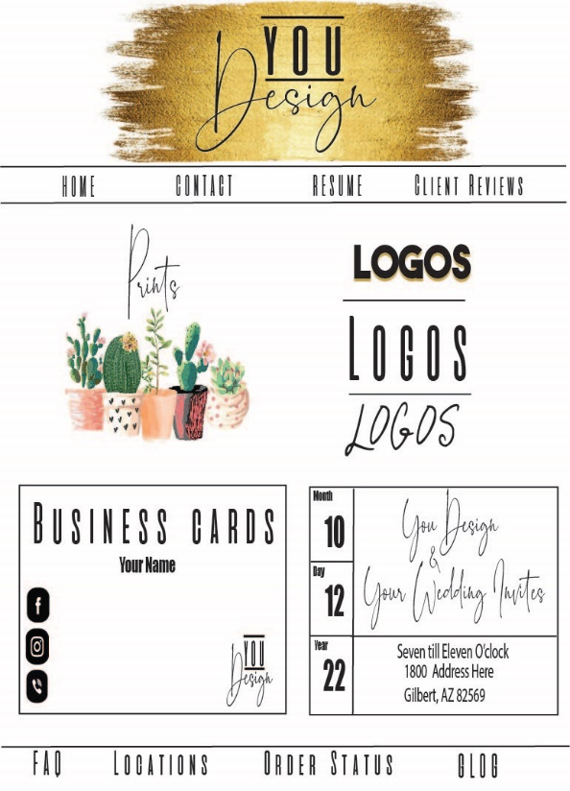
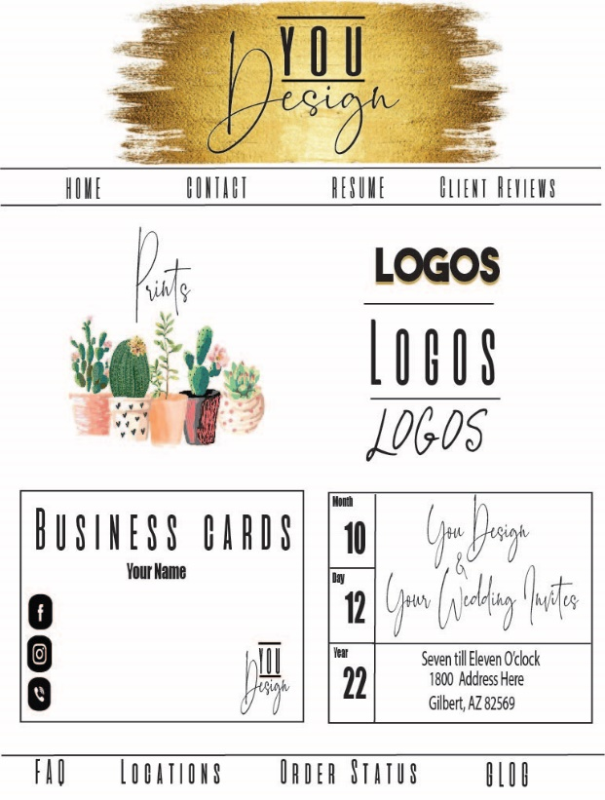
Mobil
Tablet
Desktop
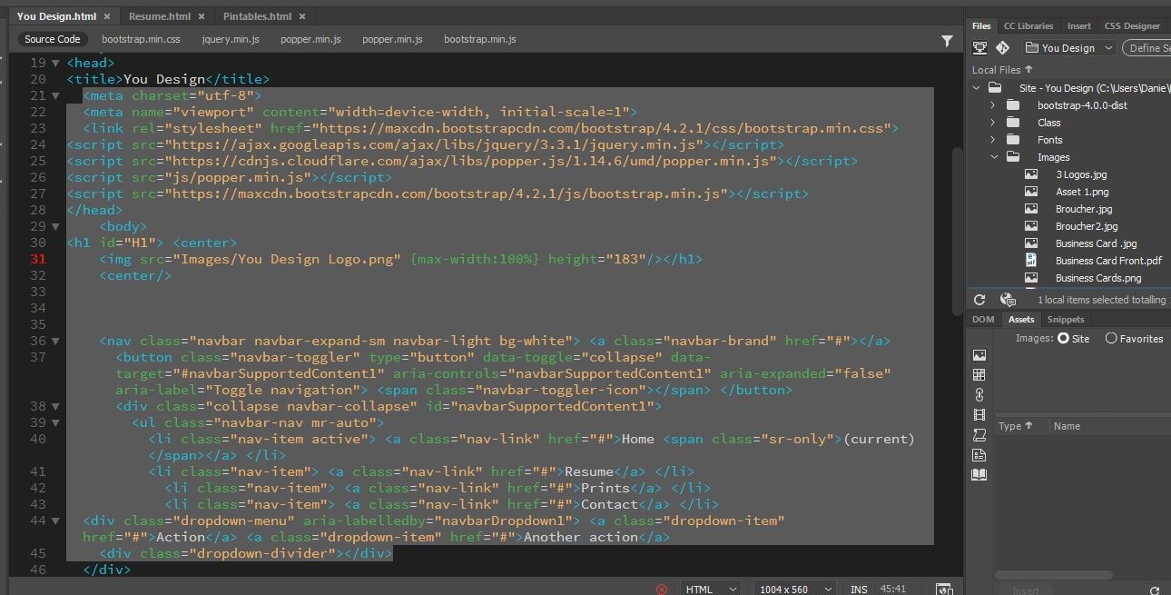
Screenshot of Coding

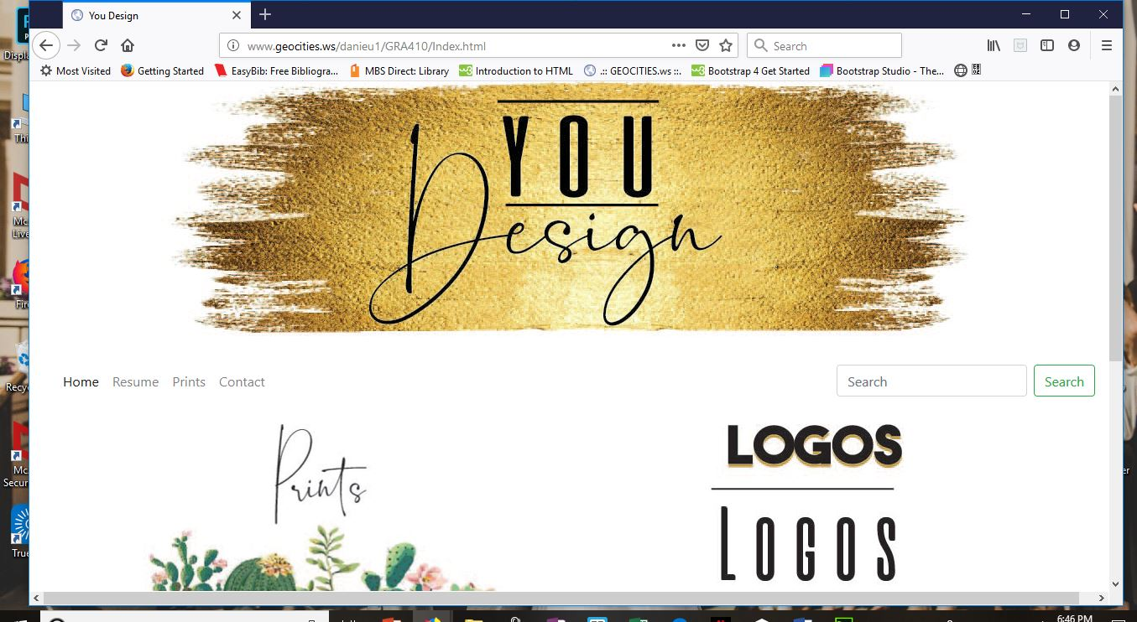
Troubleshooting Screenshots of Website

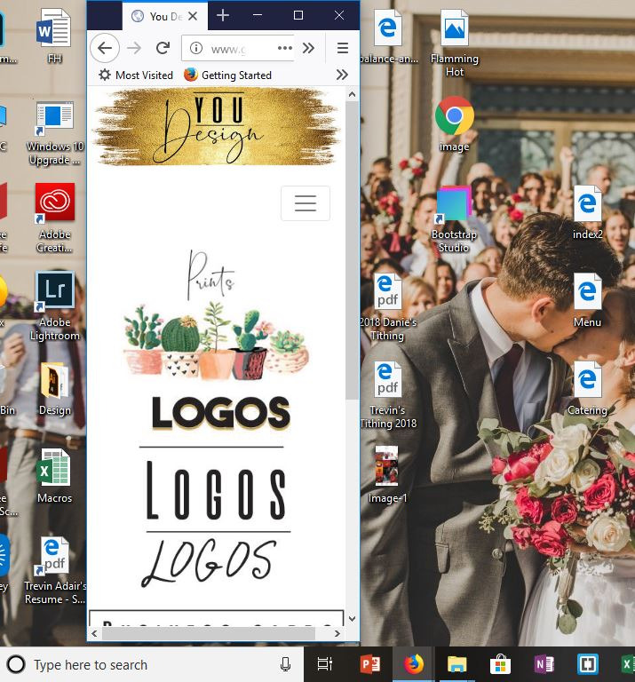
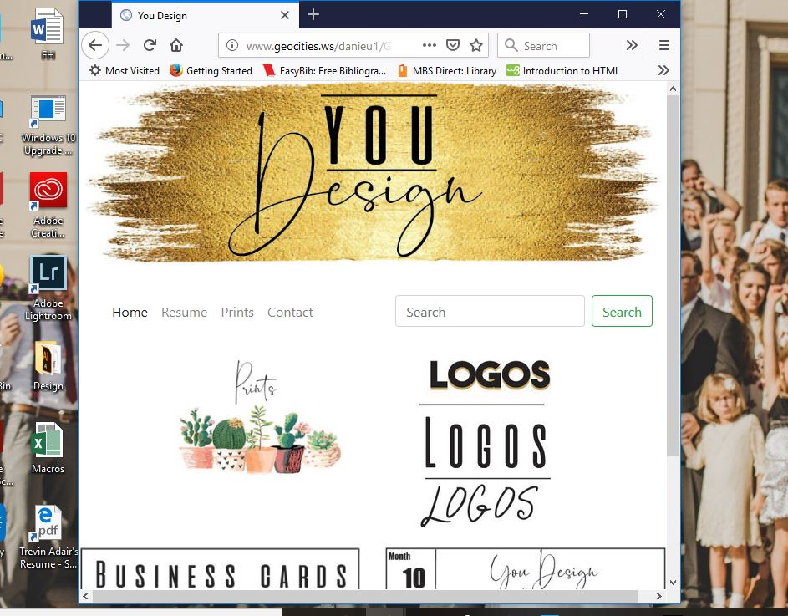

Live link

http://www.geocities.ws/danieu1/GRA410/Index.html

