What is a program?
A computer program is a set of instructions and as a term it can be used as a verb as well as a noun. In terms of a verb, it is used as a process of creating a software program by using programming language. In terms of a noun, an application, program, or application software is used to perform a specific task on the computer. For example, Microsoft PowerPoint is an application, which provides a way to create documents related to the presentation. Furthermore, a browser is also an application, which allows us to browse any website.

Programming Paradigms in Python
Paradigm can also be termed as a method to solve some problems or do some tasks. A programming paradigm is an approach to solve the problem using some programming language or also we can say it is a method to solve a problem using tools and techniques that are available to us following some approach. There are lots of programming languages that are known but all of them need to follow some strategy when they are implemented and this methodology/strategy is paradigms. Apart from varieties of programming languages, there are lots of paradigms to fulfill each and every demand.
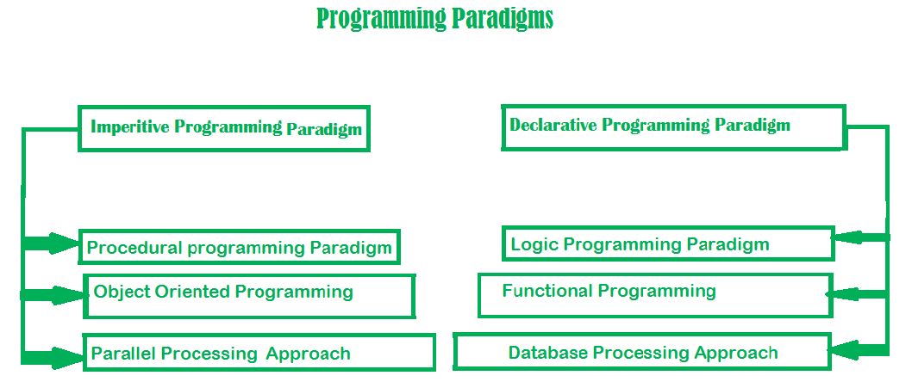
Python supports three types of Programming paradigms
- Object Oriented programming paradigms
- Procedure Oriented programming paradigms
- Functional programming paradigms

Object Oriented programming paradigms
In the object-oriented programming paradigm, objects are the key element of paradigms. Objects can simply be defined as the instance of a class that contains both data members and the method functions. Moreover, the object-oriented style relates data members and methods functions that support encapsulation and with the help of the concept of an inheritance, the code can be easily reusable but the major disadvantage of object-oriented programming paradigm is that if the code is not written properly then the program becomes a monster.
Advantages
- Relation with Real world entities
- Code reusability
- Abstraction or data hiding
Disadvantages
- Data protection
- Not suitable for all types of problems
- Slow Speed
Example:
# class Emp has been defined here
class Emp:
def __init__(self, name, age):
self.name = name
self.age = age

def info(self):
print("Hello, % s. You are % s old." % (self.name, self.age))

# Objects of class Emp has been
# made here
Emps = [Emp("John", 43),
Emp("Hilbert", 16),
Emp("Alice", 30)]

# Objects of class Emp has been
# used here
for emp in Emps:
emp.info()
Output:
Hello, John. You are 43 old.
Hello, Hilbert. You are 16 old.
Hello, Alice. You are 30 old.
Note: For more information, refer to Object Oriented Programming in Python

Procedural programming paradigms
In Procedure Oriented programming paradigms, series of computational steps are divided modules which means that the code is grouped in functions and the code is serially executed step by step so basically, it combines the serial code to instruct a computer with each step to perform a certain task. This paradigm helps in the modularity of code and modularization is usually done by the functional implementation. This programming paradigm helps in an easy organization related items without difficulty and so each file acts as a container.
Advantages
- General-purpose programming
- Code reusability
- Portable source code
Disadvantages
- Data protection
- Not suitable for real-world objects
- Harder to write
Example:
# Procedural way of finding sum
# of a list

mylist = [10, 20, 30, 40]

# modularization is done by
# functional approach
def sum_the_list(mylist):
res = 0
for val in mylist:
res += val
return res

print(sum_the_list(mylist))
Output:
100

Functional programming paradigms
Functional programming paradigms is a paradigm in which everything is bind in pure mathematical functions style. It is known as declarative paradigms because it uses declarations overstatements. It uses the mathematical function and treats every statement as functional expression as an expression is executed to produce a value. Lambda functions or Recursion are basic approaches used for its implementation. The paradigms mainly focus on “what to solve” rather than “how to solve”. The ability to treat functions as values and pass them as an argument make the code more readable and understandable.
Advantages
- Simple to understand
- Making debugging and testing easier
- Enhances the comprehension and readability of the code
Disadvantages
- Low performance
- Writing programs is a daunting task
- Low readability of the code
Example:
# Functional way of finding sum of a list
import functools

mylist = [11, 22, 33, 44]

# Recursive Functional approach
def sum_the_list(mylist):

if len(mylist) == 1:
return mylist[0]
else:
return mylist[0] + sum_the_list(mylist[1:])

# lambda function is used
print(functools.reduce(lambda x, y: x + y, mylist))
Output:
110
Note: For more information, refer to Functional Programming in Python

Programming languages their classification and characteristics

what is a computer. A computer is a device that can accept human instruction, processes it, and responds to it or a computer is a computational device that is used to process the data under the control of a computer program. Program is a sequence of instruction along with data.
The basic components of a computer are:
- Input unit
- Central Processing Unit(CPU)
- Output unit
The CPU is further divided into three parts-
- Memory unit
- Control unit
- Arithmetic Logic unit
Most of us have heard that CPU is called the brain of our computer because it accepts data, provides temporary memory space to it until it is stored(saved) on the hard disk, performs logical operations on it and hence processes(here also means converts) data into information. We all know that a computer consists of hardware and software. Software is a set of programs that performs multiple tasks together. An operating system is also software (system software) that helps humans to interact with the computer system.
A program is a set of instructions given to a computer to perform a specific operation. or computer is a computational device that is used to process the data under the control of a computer program. While executing the program, raw data is processed into the desired output format. These computer programs are written in a programming language which are high-level languages. High level languages are nearly human languages that are more complex than the computer understandable language which are called machine language, or low level language. So after knowing the basics, we are ready to create a very simple and basic program. Like we have different languages to communicate with each other, likewise, we have different languages like C, C++, C#, Java, python, etc to communicate with the computers. The computer only understands binary language (the language of 0’s and 1’s) also called machine-understandable language or low-level language but the programs we are going to write are in a high-level language which is almost similar to human language.

Between high-level language and machine language, there are assembly languages also called symbolic machine code. Assembly languages are particularly computer architecture specific. Utility program (Assembler) is used to convert assembly code into executable machine code. High Level Programming Language is portable but requires Interpretation or compiling to convert it into a machine language that is computer understood.
Hierarchy of Computer language –
There have been many programming languages some of them are listed below:
C | Python | C++
C# | R | Ruby
COBOL | ADA | Java
Fortran | BASIC | Altair BASIC
True BASIC | Visual BASIC | GW BASIC
QBASIC | PureBASIC | PASCAL
Turbo Pascal | GO | ALGOL
LISP | SCALA | Swift
Rust | Prolog | Reia
Racket | Scheme | Shimula
Perl | PHP | Java Script
CoffeeScript | VisualFoxPro | Babel
Logo | Lua | Smalltalk
Matlab | F | F#
Dart | Datalog | dbase
Haskell | dylan | Julia
ksh | metro | Mumps
Nim | OCaml | pick
TCL | D | CPL
Curry | ActionScript | Erlang
Clojure | DarkBASCIC | Assembly

Characteristics of a programming Language –
- A programming language must be simple, easy to learn and use, have good readability, and be human recognizable.
- Abstraction is a must-have Characteristics for a programming language in which the ability to define the complex structure and then its degree of usability comes.
- A portable programming language is always preferred.
- Programming language’s efficiency must be high so that it can be easily converted into a machine code and executed consumes little space in memory.
- A programming language should be well structured and documented so that it is suitable for application development.
- Necessary tools for the development, debugging, testing, maintenance of a program must be provided by a programming language.
- A programming language should provide a single environment known as Integrated Development Environment(IDE).
- A programming language must be consistent in terms of syntax and semantics.

What is a language translator in programming?
Language translators allow computer programmers to write sets of instructions in specific programming languages. These instructions are converted by the language translator into machine code. The computer system then reads these machine code instructions and executes them.

Algorithm is a step-by-step procedure, which defines a set of instructions to be executed in a certain order to get the desired output. Algorithms are generally created independent of underlying languages, i.e. an algorithm can be implemented in more than one programming language.
From the data structure point of view, following are some important categories of algorithms −

Search − Algorithm to search an item in a data structure.

Sort − Algorithm to sort items in a certain order.

Insert − Algorithm to insert item in a data structure.

Update − Algorithm to update an existing item in a data structure.

Delete − Algorithm to delete an existing item from a data structure.

Characteristics of an Algorithm
Not all procedures can be called an algorithm. An algorithm should have the following characteristics −

Unambiguous − Algorithm should be clear and unambiguous. Each of its steps (or phases), and their inputs/outputs should be clear and must lead to only one meaning.

Input − An algorithm should have 0 or more well-defined inputs.

Output − An algorithm should have 1 or more well-defined outputs, and should match the desired output.

Finiteness − Algorithms must terminate after a finite number of steps.

Feasibility − Should be feasible with the available resources.

Independent − An algorithm should have step-by-step directions, which should be independent of any programming code.

How to Write an Algorithm?
There are no well-defined standards for writing algorithms. Rather, it is problem and resource dependent. Algorithms are never written to support a particular programming code.
As we know that all programming languages share basic code constructs like loops (do, for, while), flow-control (if-else), etc. These common constructs can be used to write an algorithm.
We write algorithms in a step-by-step manner, but it is not always the case. Algorithm writing is a process and is executed after the problem domain is well-defined. That is, we should know the problem domain, for which we are designing a solution.

Example
Let's try to learn algorithm-writing by using an example.

Problem − Design an algorithm to add two numbers and display the result.

step 1 − START
step 2 − declare three integers a, b & c
step 3 − define values of a & b
step 4 − add values of a & b
step 5 − store output of step 4 to c
step 6 − print c
step 7 − STOP
Algorithms tell the programmers how to code the program. Alternatively, the algorithm can be written as −
step 1 − START ADD
step 2 − get values of a & b
step 3 − c ← a + b
step 4 − display c
step 5 − STOP
In design and analysis of algorithms, usually the second method is used to describe an algorithm. It makes it easy for the analyst to analyze the algorithm ignoring all unwanted definitions. He can observe what operations are being used and how the process is flowing.
Writing step numbers, is optional.
We design an algorithm to get a solution of a given problem. A problem can be solved in more than one ways.
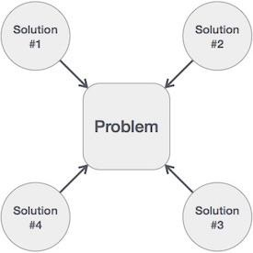
Hence, many solution algorithms can be derived for a given problem. The next step is to analyze those proposed solution algorithms and implement the best suitable solution.

Flowcharts
Flowcharts graphically represent the flow of a program. There are four basic shapes used in a flow chart. Each shape has a specific use:
- oval: start / end
- parallelogram: input / output
- rectangle: calculations
- diamond: selection structures
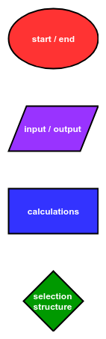
Arrows connect the basic shapes in a flowchart. The shapes and arrows of a flowchart describe the flow of a program from start to end. Flowcharts typically flow from the top to the bottom or flow from the left to the right. Below is the description of a simple program:
The program starts. Then the program prints out "Output!". Finally, the program ends.
A flowchart that describes this simple program is shown.
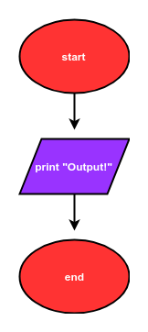
The Python code that corresponds to this flowchart is:
# start
print("Output!")
# end
A description of a program that includes a calculation is below:
The program starts. Next, the program asks a user for a number. Two is added to the number. Next, the resulting sum is printed. Finally, the program ends.
A flowchart that describes this program is is shown.
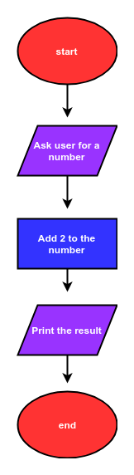
The Python code that corresponds to this flow chart is:
# start
num = input("Enter a number: ")
num = float(num)
num_plus_2 = num + 2
print(num_plus_2)
# end
The description of another program is below:
The program starts. Next the program asks a user for a number. If the number is greater than zero, the program prints "Greater than 0", then the program ends.
A flow chart that describes this program is shown.
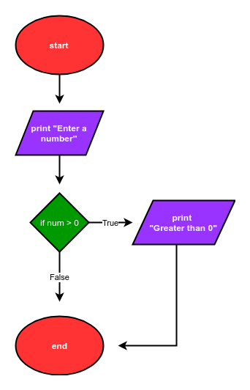
The Python code that corresponds to this flow chart is:
# start
num = input("Enter a number: ")
num = float(num)
if num>0:
print("Greater than 0")
# end
The description of a more complex program is below:
The program starts. Next, the program asks a user for a number. If the number is greater than zero, the program prints "Greater than 0". If the number is less than zero, the program prints "Less than 0". Then the program prints "Done" and the program ends.
A flowchart that describes this program is below:
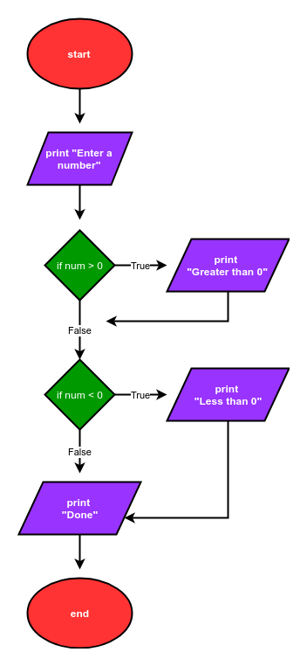
The Python code that corresponds to this flow chart is:
# start
num = input('Enter a number: ')
num = float(num)
if num>0:
print('num greater than zero')
if num<0:
print('num less than zero')
print('Done')
# end

Building blocks of program:
Data types are the classification or categorization of data items. It represents the kind of value that tells what operations can be performed on a particular data. Since everything is an object in Python programming, data types are actually classes and variables are instance (object) of these classes.
Following are the standard or built-in data type of Python:
- Numeric
- Sequence Type
- Boolean
- Set
- Dictionary
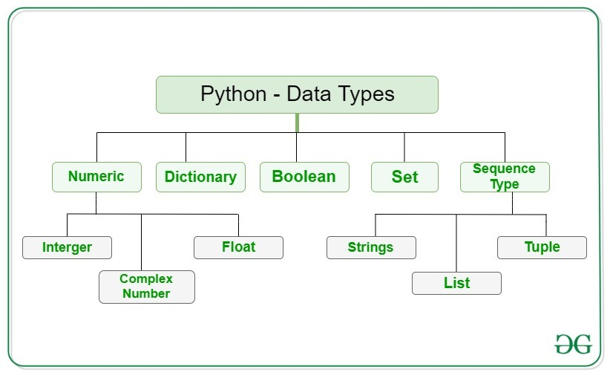

Numeric
In Python, numeric data type represent the data which has numeric value. Numeric value can be integer, floating number or even complex numbers. These values are defined as int, float and complex class in Python.
- Integers – This value is represented by int class. It contains positive or negative whole numbers (without fraction or decimal). In Python there is no limit to how long an integer value can be.
- Float – This value is represented by float class. It is a real number with floating point representation. It is specified by a decimal point. Optionally, the character e or E followed by a positive or negative integer may be appended to specify scientific notation.
- Complex Numbers – Complex number is represented by complex class. It is specified as (real part) + (imaginary part)j. For example – 2+3j
Note
– type() function is used to determine the type of data type.
# Python program to
# demonstrate numeric value

a = 5
print("Type of a: ", type(a))

b = 5.0
print("\nType of b: ", type(b))

c = 2 + 4j
print("\nType of c: ", type(c))
Output:
Type of a: <class 'int'>

Type of b: <class 'float'>

Type of c: <class 'complex'>

Sequence Type
In Python, sequence is the ordered collection of similar or different data types. Sequences allows to store multiple values in an organized and efficient fashion. There are several sequence types in Python –
- String
- List
- Tuple

1) String
In Python, Strings are arrays of bytes representing Unicode characters. A string is a collection of one or more characters put in a single quote, double-quote or triple quote. In python there is no character data type, a character is a string of length one. It is represented by str class.

Creating String
Strings in Python can be created using single quotes or double quotes or even triple quotes.
# Python Program for
# Creation of String

# Creating a String
# with single Quotes
String1 = 'Welcome to the Geeks World'
print("String with the use of Single Quotes: ")
print(String1)

# Creating a String
# with double Quotes
String1 = "I'm a Geek"
print("\nString with the use of Double Quotes: ")
print(String1)
print(type(String1))

# Creating a String
# with triple Quotes
String1 = '''I'm a Geek and I live in a world of "Geeks"'''
print("\nString with the use of Triple Quotes: ")
print(String1)
print(type(String1))

# Creating String with triple
# Quotes allows multiple lines
String1 = '''Geeks
For
Life'''
print("\nCreating a multiline String: ")
print(String1)

Output:
String with the use of Single Quotes:
Welcome to the Geeks World

String with the use of Double Quotes:
I'm a Geek
<class 'str'>

String with the use of Triple Quotes:
I'm a Geek and I live in a world of "Geeks"
<class 'str'>

Creating a multiline String:
Geeks
For
Life

Accessing elements of String
In Python, individual characters of a String can be accessed by using the method of Indexing. Indexing allows negative address references to access characters from the back of the String, e.g. -1 refers to the last character, -2 refers to the second last character and so on.
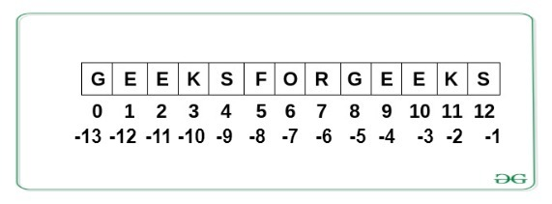
# Python Program to Access
# characters of String

String1 = "GeeksForGeeks"
print("Initial String: ")
print(String1)

# Printing First character
print("\nFirst character of String is: ")
print(String1[0])

# Printing Last character
print("\nLast character of String is: ")
print(String1[-1])
Output:
Initial String:
GeeksForGeeks

First character of String is:
G

Last character of String is:
s

Note – To know more about strings, refer Python String.

2) List
Lists are just like the arrays, declared in other languages which is a ordered collection of data. It is very flexible as the items in a list do not need to be of the same type.

Creating List
Lists in Python can be created by just placing the sequence inside the square brackets[].
# Python program to demonstrate
# Creation of List

# Creating a List
List = []
print("Initial blank List: ")
print(List)

# Creating a List with
# the use of a String
List = ['GeeksForGeeks']
print("\nList with the use of String: ")
print(List)

# Creating a List with
# the use of multiple values
List = ["Geeks", "For", "Geeks"]
print("\nList containing multiple values: ")
print(List[0])
print(List[2])

# Creating a Multi-Dimensional List
# (By Nesting a list inside a List)
List = [['Geeks', 'For'], ['Geeks']]
print("\nMulti-Dimensional List: ")
print(List)
Output:
Initial blank List:
[]

List with the use of String:
['GeeksForGeeks']

List containing multiple values:
Geeks
Geeks

Multi-Dimensional List:
[['Geeks', 'For'], ['Geeks']]

Accessing elements of List
In order to access the list items refer to the index number. Use the index operator [ ] to access an item in a list. In Python, negative sequence indexes represent positions from the end of the array. Instead of having to compute the offset as in List[len(List)-3], it is enough to just write List[-3]. Negative indexing means beginning from the end, -1 refers to the last item, -2 refers to the second-last item, etc.
# Python program to demonstrate
# accessing of element from list

# Creating a List with
# the use of multiple values
List = ["Geeks", "For", "Geeks"]

# accessing a element from the
# list using index number
print("Accessing element from the list")
print(List[0])
print(List[2])

# accessing a element using
# negative indexing
print("Accessing element using negative indexing")

# print the last element of list
print(List[-1])

# print the third last element of list
print(List[-3])
Output:
Accessing element from the list
Geeks
Geeks
Accessing element using negative indexing
Geeks
Geeks
Note – To know more about Lists, refer Python List.

3) Tuple
Just like list, tuple is also an ordered collection of Python objects. The only difference between tuple and list is that tuples are immutable i.e. tuples cannot be modified after it is created. It is represented by tuple class.

Creating Tuple
In Python, tuples are created by placing a sequence of values separated by ‘comma’ with or without the use of parentheses for grouping of the data sequence. Tuples can contain any number of elements and of any datatype (like strings, integers, list, etc.).
Note: Tuples can also be created with a single element, but it is a bit tricky. Having one element in the parentheses is not sufficient, there must be a trailing ‘comma’ to make it a tuple.
# Python program to demonstrate
# creation of Set

# Creating an empty tuple
Tuple1 = ()
print("Initial empty Tuple: ")
print (Tuple1)

# Creating a Tuple with
# the use of Strings
Tuple1 = ('Geeks', 'For')
print("\nTuple with the use of String: ")
print(Tuple1)

# Creating a Tuple with
# the use of list
list1 = [1, 2, 4, 5, 6]
print("\nTuple using List: ")
print(tuple(list1))

# Creating a Tuple with the
# use of built-in function
Tuple1 = tuple('Geeks')
print("\nTuple with the use of function: ")
print(Tuple1)

# Creating a Tuple
# with nested tuples
Tuple1 = (0, 1, 2, 3)
Tuple2 = ('python', 'geek')
Tuple3 = (Tuple1, Tuple2)
print("\nTuple with nested tuples: ")
print(Tuple3)
Output:
Initial empty Tuple:
()

Tuple with the use of String:
('Geeks', 'For')

Tuple using List:
(1, 2, 4, 5, 6)

Tuple with the use of function:
('G', 'e', 'e', 'k', 's')

Tuple with nested tuples:
((0, 1, 2, 3), ('python', 'geek'))

Note – Creation of Python tuple without the use of parentheses is known as Tuple Packing.

Accessing elements of Tuple
In order to access the tuple items refer to the index number. Use the index operator [ ] to access an item in a tuple. The index must be an integer. Nested tuples are accessed using nested indexing.
# Python program to
# demonstrate accessing tuple

tuple1 = tuple([1, 2, 3, 4, 5])

# Accessing element using indexing
print("First element of tuple")
print(tuple1[0])

# Accessing element from last
# negative indexing
print("\nLast element of tuple")
print(tuple1[-1])

print("\nThird last element of tuple")
print(tuple1[-3])
Output:
First element of tuple
1

Last element of tuple
5

Third last element of tuple
3
Note – To know more about tuples, refer Python Tuples.

Boolean
Data type with one of the two built-in values, True or False. Boolean objects that are equal to True are truthy (true), and those equal to False are falsy (false). But non-Boolean objects can be evaluated in Boolean context as well and determined to be true or false. It is denoted by the class bool.
Note – True and False with capital ‘T’ and ‘F’ are valid booleans otherwise python will throw an error.
# Python program to
# demonstrate boolean type

print(type(True))
print(type(False))

print(type(true))
Output:
<class 'bool'>
<class 'bool'>
Traceback (most recent call last):
File "/home/7e8862763fb66153d70824099d4f5fb7.py", line 8, in
print(type(true))
NameError: name 'true' is not defined

Data binding

In python variables are not declared – as declared in many languages like C, C++, Java etc. Python associates variable type on the basis of value stored in it.
Now since its not always we assign a value to a variable while writing a code, sometime value is assigned at the run-time. For example – more often we take the input from the user and assign it to a variable. In such a case variables can’t be associated with certain type (data type) while writing a code.
It is because of this reason in python is known as dynamically typed language because it uses dynamic binding or late binding – i.e. at the run time.

Examples
Let us understand using some coding examples:
#Let us assign some integer value to a variable X
X=10
print(type(X))
X="Hello"
print(type(X))
Gives the output:
<class ‘int’>
<class ‘str’>

Explanation:
Let us try to understand the code above:
- Line no. 3 assigns the value 10 at some memory address, and
- Binds the variable which is actually just a label to that memory address. That is why – type of X is displayed as <class ‘int’> which means type of X is integer.
- Line no. 6 re-assigns the value “Hello” to the same variable X.
  - First of all this was only possible because Python uses dynamic binding or late binding.
  - In case of static binding used in C, C++, java etc. you cannot reassign some other data type to an existing variable. It will produce an error.
- Since “Hello” is a string of characters, Python stores “Hello” to some other memory location, if it does not exists. Python then binds X to either some other existing location or this new memory location holding the value “Hello”. Now the type of X is String and because of the same line 7 displays the output as <class ‘str’>

What are variables in Python ?

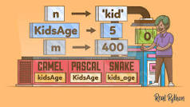

A Python variable is a symbolic name that is a reference or pointer to an object. Once an object is assigned to a variable, you can refer to the object by that name. But the data itself is still contained within the object.

Python Constants

Sometimes, you may want to store values in variables. But you don’t want to change these values throughout the execution of the program.
To do it in other programming languages, you can use constants. The constants like variables but their values don’t change during the program executes.
The bad news is that Python doesn’t support constants.
To work around this, you use all capital letters to name a variable to indicate that the variable should be treated as a constant. For example:
FILE_SIZE_LIMIT = 2000
Code language: Python (python)
When encountering variables like these, you should not change their values. These variables are constant by convention, not by rules.

Summary
- Python doesn’t have built-in constant types.
- By convention, Python uses a variable whose name contains all capital letters to define a constant.

Variables
Variables are containers for storing data values
.

Creating Variables
Python has no command for declaring a variable
.
A variable is created the moment you first assign a value to it
.

Example
x = 5
y = "John"
print(x)
print(y)
Variables do not need to be declared with any particular type, and can even change type after they have been set.

Example
x = 4 # x is of type int
x = "Sally" # x is now of type str
print(x)

Assignment Operators in Python
Operators are used to perform operations on values and variables. These are the special symbols that carry out arithmetic, logical, bitwise computations. The value the operator operates on is known as Operand.
Here, we will cover Assignment Operators in Python. So, Assignment Operators are used to assigning values to variables.
Operator | Description | Syntax
= | Assign value of right side of expression to left side operand | x = y + z
+= | Add and Assign: Add right side operand with left side operand and then assign to left operand | a += b
-= | Subtract AND: Subtract right operand from left operand and then assign to left operand: True if both operands are equal | a -= b
*= | Multiply AND: Multiply right operand with left operand and then assign to left operand | a *= b
/= | Divide AND: Divide left operand with right operand and then assign to left operand | a /= b
%= | Modulus AND: Takes modulus using left and right operands and assign result to left operand | a %= b
//= | Divide(floor) AND: Divide left operand with right operand and then assign the value(floor) to left operand | a //= b
**= | Exponent AND: Calculate exponent(raise power) value using operands and assign value to left operand | a **= b
Now Let’s see each Assignment Operator one by one.
1) Assign: This operator is used to assign the value of the right side of the expression to the left side operand.
Syntax:
x = y + z
Example:
# Assigning values using
# Assignment Operator

a = 3
b = 5

c = a + b

# Output
print(c)
Output:
8
2) Add and Assign: This operator is used to add the right side operand with the left side operand and then assigning the result to the left operand.
Syntax:
x += y
Example:
a = 3
b = 5

# a = a + b
a += b

# Output
print(a)
Output:
8
3) Subtract and Assign: This operator is used to subtract the right operand from the left operand and then assigning the result to the left operand.
Syntax:
x -= y
Example –
a = 3
b = 5

# a = a - b
a -= b

# Output
print(a)
Output:
-2
4) Multiply and Assign: This operator is used to multiply the right operand with the left operand and then assigning the result to the left operand.
Syntax:
x *= y
Example:
a = 3
b = 5

# a = a * b
a *= b

# Output
print(a)
Output:
15
5) Divide and Assign: This operator is used to divide the left operand with the right operand and then assigning the result to the left operand.
Syntax:
x /= y
Example:
a = 3
b = 5

# a = a / b
a /= b

# Output
print(a)
Output:
0.6
6) Modulus and Assign: This operator is used to take the modulus using the left and the right operands and then assigning the result to the left operand.
Syntax:
x %= y
Example:
a = 3
b = 5

# a = a % b
a %= b

# Output
print(a)
Output:
3
7) Divide (floor) and Assign: This operator is used to divide the left operand with the right operand and then assigning the result(floor) to the left operand.
Syntax:
x //= y
Example:
a = 3
b = 5

# a = a // b
a //= b

# Output
print(a)
Output:
0
8) Exponent and Assign: This operator is used to calculate the exponent(raise power) value using operands and then assigning the result to the left operand.
Syntax:
x **= y
Example:
a = 3
b = 5

# a = a ** b
a **= b

# Output
print(a)
Output:
243

Python Arithmetic Operators
Arithmetic operators are used to perform mathematical operations like addition, subtraction, multiplication and division.
There are 7 arithmetic operators in Python :
- Addition
- Subtraction
- Multiplication
- Division
- Modulus
- Exponentiation
- Floor division
1. Addition Operator : In Python, + is the addition operator. It is used to add 2 values.
Example :
val1 = 2
val2 = 3

# using the addition operator
res = val1 + val2
print(res)
Output :
5
2. Subtraction Operator : In Python, – is the subtraction operator. It is used to subtract the second value from the first value.
Example :
val1 = 2
val2 = 3

# using the subtraction operator
res = val1 - val2
print(res)
Output :
-1
3. Multiplication Operator : In Python, * is the multiplication operator. It is used to find the product of 2 values.
Example :
val1 = 2
val2 = 3

# using the multiplication operator
res = val1 * val2
print(res)
Output :
6
4. Division Operator : In Python, / is the division operator. It is used to find the quotient when first operand is divided by the second.
Example :
val1 = 3
val2 = 2

# using the division operator
res = val1 / val2
print(res)
Output :
1.5
5. Modulus Operator : In Python, % is the modulus operator. It is used to find the remainder when first operand is divided by the second.
Example :
val1 = 3
val2 = 2

# using the modulus operator
res = val1 % val2
print(res)
Output :
1
6. Exponentiation Operator : In Python, ** is the exponentiation operator. It is used to raise the first operand to power of second.
Example :
val1 = 2
val2 = 3

# using the exponentiation operator
res = val1 ** val2
print(res)
Output :
8
7. Floor division : In Python, // is used to conduct the floor division. It is used to find the floorof the quotient when first operand is divided by the second.
Example :
val1 = 3
val2 = 2

# using the floor division
res = val1 // val2
print(res)
Output :
1 Below is the summary of all the 7 operators :

Operator | Description | Syntax
+ | Addition: adds two operands | x + y
– | Subtraction: subtracts two operands | x – y
* | Multiplication: multiplies two operands | x * y
/ | Division (float): divides the first operand by the second | x / y
// | Division (floor): divides the first operand by the second | x // y
% | Modulus: returns the remainder when first operand is divided by the second | x % y
** | Power : Returns first raised to power second | x ** y

Relational Operators in Python
Relational operators are used for comparing the values. It either returns True or False according to the condition. These operators are also known as Comparison Operators.
Operator | Description | Syntax
> | Greater than: True if the left operand is greater than the right | x > y
< | Less than: True if the left operand is less than the right | x < y
== | Equal to: True if both operands are equal | x == y
!= | Not equal to – True if operands are not equal | x != y
>= | Greater than or equal to: True if left operand is greater than or equal to the right | x >= y
<= | Less than or equal to: True if left operand is less than or equal to the right | x <= y
Now Let’s see each Relational Operator one by one.
1) Greater than: This operator returns True if the left operand is greater than the right operand.
Syntax:
x > y
Example:
a = 9
b = 5

# Output
print(a > b)
Output:
True
2) Less than: This operator returns True if the left operand is less than the right operand.
Syntax:
x < y
Example:
a = 9
b = 5

# Output
print(a < b)
Output:
False
3) Equal to: This operator returns True if both the operands are equal i.e. if both the left and the right operand are equal to each other.
Example:
a = 9
b = 5

# Output
print(a == b)
Output:
False
4) Not equal to: This operator returns True if both the operands are not equal.
Syntax:
x != y
Example:
a = 9
b = 5

# Output
print(a != b)
Output:
True
5) Greater than or equal to: This operator returns True if the left operand is greater than or equal to the right operand.
Syntax:
x >= y
Example:
a = 9
b = 5

# Output
print(a >= b)
Output:
True
6) Less than or equal to: This operator returns True if the left operand is less than or equal to the right operand.
Syntax:
x <= y
Example:
a = 9
b = 5

# Output
print(a <= b)
Output:
False

Python Logical Operators with Examples
Operators are used to perform operations on values and variables. These are the special symbols that carry out arithmetic and logical computations. The value the operator operates on is known as Operand.
Table of Content
- Logical operators
  - Logical AND operator
  - Logical OR operator
  - Logical NOT operator
- Order of evaluation of logical operators

Logical operators
In Python, Logical operators are used on conditional statements (either True or False). They perform Logical AND, Logical OR and Logical NOT operations.
OPERATOR | DESCRIPTION | SYNTAX
and | Logical AND: True if both the operands are true | x and y
or | Logical OR: True if either of the operands is true | x or y
not | Logical NOT: True if operand is false | not x

Logical AND operator
Logical operator returns True if both the operands are True else it returns False.
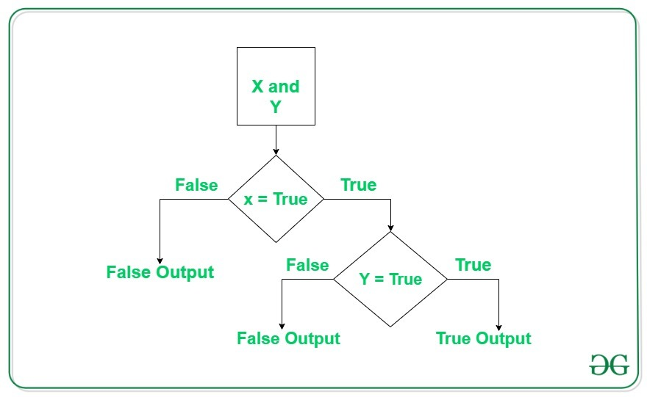
Example #1:
# Python program to demonstrate
# logical and operator

a = 10
b = 10
c = -10

if a > 0 and b > 0:
print("The numbers are greater than 0")

if a > 0 and b > 0 and c > 0:
print("The numbers are greater than 0")
else:
print("Atleast one number is not greater than 0")
Output:
The numbers are greater than 0
Atleast one number is not greater than 0
Example #2:
# Python program to demonstrate
# logical and operator

a = 10
b = 12
c = 0

if a and b and c:
print("All the numbers have boolean value as True")
else:
print("Atleast one number has boolean value as False")
Output:
Atleast one number has boolean value as False
Note: If the first expression evaluated to be false while using and operator, then the further expressions are not evaluated.

Logical or operator
Logical or operator returns True if either of the operands is True.
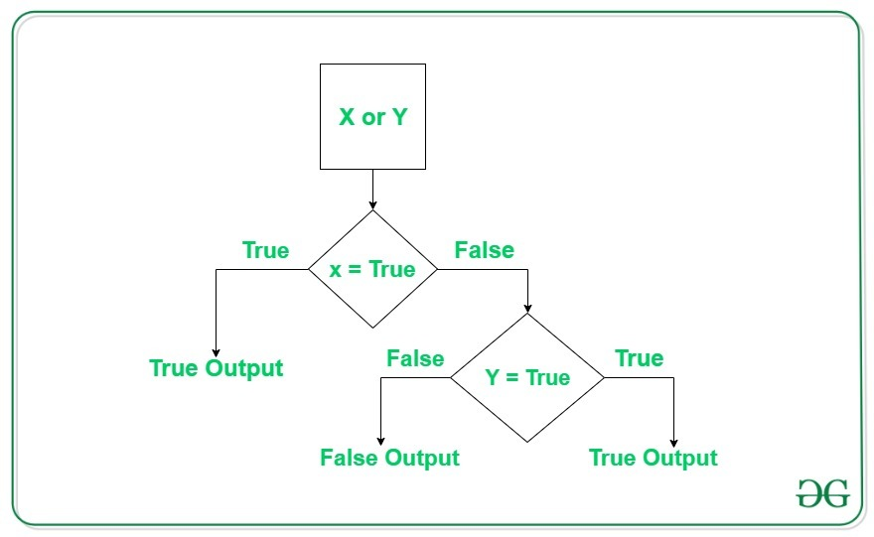
Example #1:
# Python program to demonstrate
# logical or operator

a = 10
b = -10
c = 0

if a > 0 or b > 0:
print("Either of the number is greater than 0")
else:
print("No number is greater than 0")

if b > 0 or c > 0:
print("Either of the number is greater than 0")
else:
print("No number is greater than 0")
Output:
Either of the number is greater than 0
No number is greater than 0
Example #2:
# Python program to demonstrate
# logical and operator

a = 10
b = 12
c = 0

if a or b or c:
print("Atleast one number has boolean value as True")
else:
print("All the numbers have boolean value as False")
Output:
Atleast one number has boolean value as True
Note: If the first expression evaluated to be True while using or operator, then the further expressions are not evaluated.

Logical not operator
Logical not operator work with the single boolean value. If the boolean value is True it returns False and vice-versa.
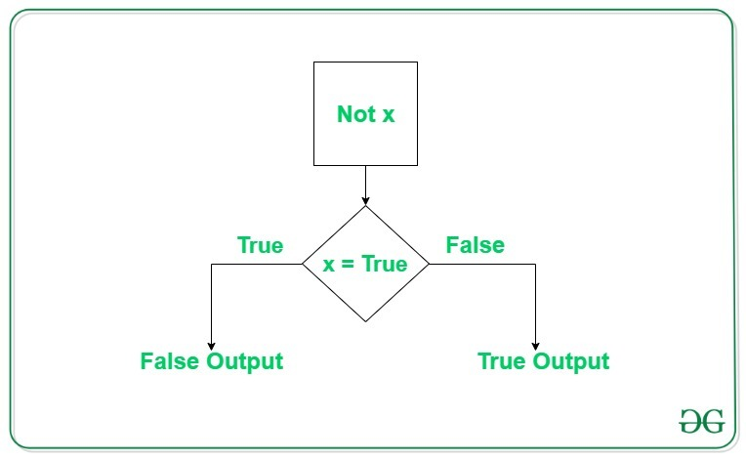
Example:
# Python program to demonstrate
# logical not operator

a = 10

if not a:
print("Boolean value of a is True")

if not (a%3 == 0 or a%5 == 0):
print("10 is not divisible by either 3 or 5")
else:
print("10 is divisible by either 3 or 5")
Output:
10 is divisible by either 3 or 5

Order of evaluation of logical operators
In the case of multiple operators, Python always evaluates the expression from left to right. This can be verified by the below example.
Example:
# Python program to demonstrate
# order of evaluation of logical
# operators

def order(x):
print("Method called for value:", x)
return True if x > 0 else False

a = order
b = order
c = order

if a(-1) or b(5) or c(10):
print("Atleast one of the number is positive")
Output:
Method called for value: -1
Method called for value: 5
Atleast one of the number is positive

Dry Run
Dry Runs are often misunderstood. While they can be of huge benefit to a project, time and again they do not get factored into the testing schedule, and so, they can become a ‘nice to have’ rather than a mandatory part of the testing cycle.
The most common approach to doing a Dry Run is when the software tester has all the test scripts written and in place and the software is deemed ready for testing by the software developer. The Dry Run can then be executed by informally running through the test scripts and logging any issues.
An alternative to this could be for a tester to take the system requirements, and again run through the full system, but without following a test script.
Although documented test evidence is not required for a Dry Run, it is a good idea to keep track of any issues and resolutions.
The benefits of doing a Dry Run include saving money and time, although this may not seem the case to the project manager when timelines and budgets are looming. To use a Dry Run before the formal testing begins is an unrecognised advantage going into the OQ (Operational Qualification).

There are a number of hidden benefits to doing a Dry Run:

Benefits to the Developer:
- Confidence in the code or product being handed over to the software tester for formal qualification.

Benefits to the Software Tester:
- Saves time in the long run as there are less discrepancies with code when formal testing is being executed.
- Less formal documentation is needed with regard to software bug fixes
- More testing time
- If there are any test script errors found these can be fixed before formal testing (if the test scripts have not been signed), again this saves time on having to raise these as issues in formal testing.
- It allows the tester feel more confident when going into OQ

Benefits to the Customer:
- A fully tested system which may save time and money in the long run with regard to bugs being found at the PQ stage and in the ‘Live’ environment.
Taking the above benefits and time savings into consideration it is difficult to class a Dry Run as a waste of time.
At Dataworks we believe that the benefits of a Dry Run can only truly be considered and assessed on a project by project basis – taking all of the advantages to each stakeholder into account.

Evaluating efficiency of algorithms in terms of number of operations and variables used

How do you Write Algorithms?
Algorithms are generally written as a combination of user-understandable language and some common programming languages. They are commonly written down in steps however, it is not always necessary to do so. There are no distinct rules to formulate algorithms but you will need to keep the following points in mind:
- Figure out what is the exact problem
- Determine where you need to start
- Determine where you need to stop
- Formulate the intermediate steps
- Review your steps
For example, if you have to formulate an algorithm to check if a student has passed in an exam or not, you can follow the given steps:
Step 1: START
Step 2: Declare two variables x, y
Step 3: Store the marks obtained by the student in x
Step 4: Store the minimum passing score in y
Step 5: Check if x is greater than or equal to y. If yes, then return “Pass” else return “Fail”
Step 6: STOP
However, you can manipulate the steps according to your preference. For instance, you can assign the values to the variables in step 2 itself rather than taking steps 3 and 4. This way, a single problem can have multiple solutions and it depends on the problem and the programmer to choose the most feasible and reliable solution.

Introduction to python programming

Python Features
Python is a dynamic, high level, free open source and interpreted programming language. It supports object-oriented programming as well as procedural oriented programming.
In Python, we don’t need to declare the type of variable because it is a dynamically typed language.
For example, x = 10
Here, x can be anything such as String, int, etc.

Features in Python
There are many features in Python, some of which are discussed below –
1. Easy to code:
Python is a high-level programming language. Python is very easy to learn the language as compared to other languages like C, C#, Javascript, Java, etc. It is very easy to code in python language and anybody can learn python basics in a few hours or days. It is also a developer-friendly language.
2. Free and Open Source:
Python language is freely available at the official website and you can download it from the given download link below search on the URL.
https://www.python.org/downloads/
Since it is open-source, this means that source code is also available to the public. So you can download it as, use it as well as share it.
3. Object-Oriented Language:
One of the key features of python is Object-Oriented programming. Python supports object-oriented language and concepts of classes, objects encapsulation, etc.
4. GUI Programming Support:
Graphical User interfaces can be made using a module such as PyQt5, PyQt4, wxPython, or Tk in python.
PyQt5 is the most popular option for creating graphical apps with Python.
5. High-Level Language:
Python is a high-level language. When we write programs in python, we do not need to remember the system architecture, nor do we need to manage the memory.
6. Extensible feature:
Python is a Extensible language. We can write us some Python code into C or C++ language and also we can compile that code in C/C++ language.
7. Python is Portable language:
Python language is also a portable language. For example, if we have python code for windows and if we want to run this code on other platforms such as Linux, Unix, and Mac then we do not need to change it, we can run this code on any platform.
8. Python is Integrated language:
Python is also an Integrated language because we can easily integrated python with other languages like c, c++, etc.
9. Interpreted Language:
Python is an Interpreted Language because Python code is executed line by line at a time. like other languages C, C++, Java, etc. there is no need to compile python code this makes it easier to debug our code. The source code of python is converted into an immediate form called bytecode.
10. Large Standard Library
Python has a large standard library which provides a rich set of module and functions so you do not have to write your own code for every single thing. There are many libraries present in python for such as regular expressions, unit-testing, web browsers, etc.
11. Dynamically Typed Language:
Python is a dynamically-typed language. That means the type (for example- int, double, long, etc.) for a variable is decided at run time not in advance because of this feature we don’t need to specify the type of variable.

First Python Program
Let us execute programs in different modes of programming.

Interactive Mode Programming
Invoking the interpreter without passing a script file as a parameter brings up the following prompt −
$ pythonPython 2.4.3 (#1, Nov 11 2010, 13:34:43)[GCC 4.1.2 20080704 (Red Hat 4.1.2-48)] on linux2Type "help", "copyright", "credits" or "license" for more information.>>>
Type the following text at the Python prompt and press the Enter −
>>> print "Hello, Python!"
If you are running new version of Python, then you would need to use print statement with parenthesis as in print ("Hello, Python!");. However in Python version 2.4.3, this produces the following result −
Hello, Python!

Script Mode Programming
Invoking the interpreter with a script parameter begins execution of the script and continues until the script is finished. When the script is finished, the interpreter is no longer active
.
Let us write a simple Python program in a script. Python files have extension .py. Type the following source code in a test.py file −
print "Hello, Python!"
We assume that you have Python interpreter set in PATH variable. Now, try to run this program as follows −
$ python test.py
This produces the following result −
Hello, Python!
Let us try another way to execute a Python script. Here is the modified test.py file −
#!/usr/bin/python
print "Hello, Python!"
We assume that you have Python interpreter available in /usr/bin directory. Now, try to run this program as follows −
$ chmod +x test.py # This is to make file executable
$./test.py
This produces the following result −
Hello, Python!

Python Identifiers
A Python identifier is a name used to identify a variable, function, class, module or other object. An identifier starts with a letter A to Z or a to z or an underscore (_) followed by zero or more letters, underscores and digits (0 to 9).
Python does not allow punctuation characters such as @, $, and % within identifiers. Python is a case sensitive programming language. Thus, Manpower and manpower are two different identifiers in Python.
Here are naming conventions for Python identifiers −

Class names start with an uppercase letter. All other identifiers start with a lowercase letter.

Starting an identifier with a single leading underscore indicates that the identifier is private.

Starting an identifier with two leading underscores indicates a strongly private identifier.

If the identifier also ends with two trailing underscores, the identifier is a language-defined special name.

Reserved Words
The following list shows the Python keywords. These are reserved words and you cannot use them as constant or variable or any other identifier names. All the Python keywords contain lowercase letters only.
and | exec | not
assert | finally | or
break | for | pass
class | from | print
continue | global | raise
def | if | return
del | import | try
elif | in | while
else | is | with
except | lambda | yield

Lines and Indentation
Python provides no braces to indicate blocks of code for class and function definitions or flow control
. Blocks of code are denoted by line indentation, which is rigidly enforced.
The number of spaces in the indentation is variable, but all statements within the block must be indented the same amount. For example −
if True:
print "True"
else:
print "False"
However, the following block generates an error −
if True:print "Answer"print "True"else:print "Answer"print "False"
Thus, in Python all the continuous lines indented with same number of spaces would form a block. The following example has various statement blocks −
Note − Do not try to understand the logic at this point of time. Just make sure you understood various blocks even if they are without braces.
#!/usr/bin/python
import sys
try:
# open file stream
file = open(file_name, "w")except IOError:
print "There was an error writing to", file_name
sys.exit()print "Enter '", file_finish,print "' When finished"while file_text != file_finish:
file_text = raw_input("Enter text: ")
if file_text == file_finish:
# close the file
file.close
break
file.write(file_text)
file.write("\n")
file.close()
file_name = raw_input("Enter filename: ")if len(file_name) == 0:
print "Next time please enter something"
sys.exit()try:
file = open(file_name, "r")except IOError:
print "There was an error reading file"
sys.exit()
file_text = file.read()
file.close()print file_text

Multi-Line Statements
Statements in Python typically end with a new line. Python does, however, allow the use of the line continuation character (\) to denote that the line should continue. For example −
total = item_one + \
item_two + \
item_three
Statements contained within the [], {}, or () brackets do not need to use the line continuation character. For example −
days = ['Monday', 'Tuesday', 'Wednesday',
'Thursday', 'Friday']

Quotation in Python
Python accepts single ('), double (") and triple (''' or """) quotes to denote string literals, as long as the same type of quote starts and ends the string.
The triple quotes are used to span the string across multiple lines
. For example, all the following are legal −
word = 'word'
sentence = "This is a sentence."
paragraph = """This is a paragraph. It is
made up of multiple lines and sentences."""

Comments in Python
A hash sign (#) that is not inside a string literal begins a comment. All characters after the # and up to the end of the physical line are part of the comment and the Python interpreter ignores them.
#!/usr/bin/python
# First commentprint "Hello, Python!" # second comment
This produces the following result −
Hello, Python!
You can type a comment on the same line after a statement or expression −
name = "Madisetti" # This is again comment
You can comment multiple lines as follows −
# This is a comment.
# This is a comment, too.
# This is a comment, too.
# I said that already.
Following triple-quoted string is also ignored by Python interpreter and can be used as a multiline comments:
'''
This is a multiline
comment.
'''

Using Blank Lines
A line containing only whitespace, possibly with a comment, is known as a blank line and Python totally ignores it.
In an interactive interpreter session, you must enter an empty physical line to terminate a multiline statement.

Waiting for the User
The following line of the program displays the prompt, the statement saying “Press the enter key to exit”, and waits for the user to take action −
#!/usr/bin/python

raw_input("\n\nPress the enter key to exit.")
Here, "\n\n" is used to create two new lines before displaying the actual line. Once the user presses the key, the program ends. This is a nice trick to keep a console window open until the user is done with an application.

Multiple Statements on a Single Line
The semicolon ( ; ) allows multiple statements on the single line given that neither statement starts a new code block. Here is a sample snip using the semicolon −
import sys; x = 'foo'; sys.stdout.write(x + '\n')

Multiple Statement Groups as Suites
A group of individual statements, which make a single code block are called suites in Python. Compound or complex statements, such as if, while, def, and class require a header line and a suite.
Header lines begin the statement (with the keyword) and terminate with a colon ( : ) and are followed by one or more lines which make up the suite. For example −
if expression :
suite
elif expression :
suite
else :
suite

Command Line Arguments
Many programs can be run to provide you with some basic information about how they should be run. Python enables you to do this with -h −
$ python -h
usage: python [option] ... [-c cmd | -m mod | file | -] [arg] ...Options and arguments (and corresponding environment variables):-c cmd : program passed in as string (terminates option list)-d : debug output from parser (also PYTHONDEBUG=x)-E : ignore environment variables (such as PYTHONPATH)-h : print this help message and exit
[ etc. ]

Data types in Python
Every value in Python has a datatype. Since everything is an object in Python programming, data types are actually classes and variables are instance (object) of these classes.
There are various data types in Python. Some of the important types are listed below.

Python Numbers
Integers, floating point numbers and complex numbers fall under Python numbers category. They are defined as int, float and complex classes in Python.
We can use the type() function to know which class a variable or a value belongs to. Similarly, the isinstance() function is used to check if an object belongs to a particular class.
a = 5print(a, "is of type", type(a))

a = 2.0print(a, "is of type", type(a))

a = 1+2jprint(a, "is complex number?", isinstance(1+2j,complex))

Output
5 is of type <class 'int'>
2.0 is of type <class 'float'>
(1+2j) is complex number? True
Integers can be of any length, it is only limited by the memory available.
A floating-point number is accurate up to 15 decimal places. Integer and floating points are separated by decimal points. 1 is an integer, 1.0 is a floating-point number.
Complex numbers are written in the form, x + yj, where x is the real part and y is the imaginary part. Here are some examples.
>>> a = 1234567890123456789>>> a1234567890123456789>>> b = 0.1234567890123456789>>> b0.12345678901234568>>> c = 1+2j>>> c
(1+2j)
Notice that the float variable b got truncated.

Python List
List is an ordered sequence of items. It is one of the most used datatype in Python and is very flexible. All the items in a list do not need to be of the same type.
Declaring a list is pretty straight forward. Items separated by commas are enclosed within brackets [ ].
a = [1, 2.2, 'python']
We can use the slicing operator [ ] to extract an item or a range of items from a list. The index starts from 0 in Python.
a = [5,10,15,20,25,30,35,40]
# a[2] = 15print("a[2] = ", a[2])
# a[0:3] = [5, 10, 15]print("a[0:3] = ", a[0:3])
# a[5:] = [30, 35, 40]print("a[5:] = ", a[5:])
Output
a[2] = 15
a[0:3] = [5, 10, 15]
a[5:] = [30, 35, 40]
Lists are mutable, meaning, the value of elements of a list can be altered.
a = [1, 2, 3]
a[2] = 4print(a)
Run Code
Output
[1, 2, 4]

Python Tuple
Tuple is an ordered sequence of items same as a list. The only difference is that tuples are immutable. Tuples once created cannot be modified.
Tuples are used to write-protect data and are usually faster than lists as they cannot change dynamically.
It is defined within parentheses () where items are separated by commas.
t = (5,'program', 1+3j)
We can use the slicing operator [] to extract items but we cannot change its value.
t = (5,'program', 1+3j)
# t[1] = 'program'print("t[1] = ", t[1])
# t[0:3] = (5, 'program', (1+3j))print("t[0:3] = ", t[0:3])
# Generates error# Tuples are immutable
t[0] = 10
Run Code
Output
t[1] = program
t[0:3] = (5, 'program', (1+3j))
Traceback (most recent call last):
File "test.py", line 11, in <module>
t[0] = 10
TypeError: 'tuple' object does not support item assignment

Python Strings
String is sequence of Unicode characters. We can use single quotes or double quotes to represent strings. Multi-line strings can be denoted using triple quotes, ''' or """.
s = "This is a string"print(s)
s = '''A multiline
string'''print(s)
Run Code
Output
This is a string
A multiline
string
Just like a list and tuple, the slicing operator [ ] can be used with strings. Strings, however, are immutable.
s = 'Hello world!'
# s[4] = 'o'print("s[4] = ", s[4])
# s[6:11] = 'world'print("s[6:11] = ", s[6:11])
# Generates error# Strings are immutable in Python
s[5] ='d'
Run Code
Output
s[4] = o
s[6:11] = world
Traceback (most recent call last):
File "<string>", line 11, in <module>
TypeError: 'str' object does not support item assignment

Python Set
Set is an unordered collection of unique items. Set is defined by values separated by comma inside braces { }. Items in a set are not ordered.
a = {5,2,3,1,4}
# printing set variableprint("a = ", a)
# data type of variable aprint(type(a))
Run Code
Output
a = {1, 2, 3, 4, 5}
<class 'set'>
We can perform set operations like union, intersection on two sets. Sets have unique values. They eliminate duplicates.
a = {1,2,2,3,3,3}print(a)
Run Code
Output
{1, 2, 3}
Since, set are unordered collection, indexing has no meaning. Hence, the slicing operator [] does not work.
>>> a = {1,2,3}>>> a[1]
Traceback (most recent call last):
File "<string>", line 301, in runcode
File "<interactive input>", line 1, in <module>
TypeError: 'set' object does not support indexing

Python Dictionary
Dictionary is an unordered collection of key-value pairs.
It is generally used when we have a huge amount of data. Dictionaries are optimized for retrieving data. We must know the key to retrieve the value.
In Python, dictionaries are defined within braces {} with each item being a pair in the form key:value. Key and value can be of any type.
>>> d = {1:'value','key':2}>>> type(d)
<class 'dict'>
We use key to retrieve the respective value. But not the other way around.
d = {1:'value','key':2}print(type(d))
print("d[1] = ", d[1])
print("d['key'] = ", d['key'])
# Generates errorprint("d[2] = ", d[2])
Run Code
Output
<class 'dict'>
d[1] = value
d['key'] = 2
Traceback (most recent call last):
File "<string>", line 9, in <module>
KeyError: 2

Conversion between data types
We can convert between different data types by using different type conversion functions like int(), float(), str(), etc.
>>> float(5)5.0
Conversion from float to int will truncate the value (make it closer to zero).
>>> int(10.6)10>>> int(-10.6)-10
Conversion to and from string must contain compatible values.
>>> float('2.5')2.5>>> str(25)'25'>>> int('1p')
Traceback (most recent call last):
File "<string>", line 301, in runcode
File "<interactive input>", line 1, in <module>
ValueError: invalid literal for int() with base 10: '1p'
We can even convert one sequence to another.
>>> set([1,2,3])
{1, 2, 3}>>> tuple({5,6,7})
(5, 6, 7)>>> list('hello')
['h', 'e', 'l', 'l', 'o']
To convert to dictionary, each element must be a pair:
>>> dict([[1,2],[3,4]])
{1: 2, 3: 4}>>> dict([(3,26),(4,44)])
{3: 26, 4: 44}
Data types

Numeric
In Python, numeric data type represent the data which has numeric value. Numeric value can be integer, floating number or even complex numbers. These values are defined as int, float and complex class in Python.
- Integers – This value is represented by int class. It contains positive or negative whole numbers (without fraction or decimal). In Python there is no limit to how long an integer value can be.
- Float – This value is represented by float class. It is a real number with floating point representation. It is specified by a decimal point. Optionally, the character e or E followed by a positive or negative integer may be appended to specify scientific notation.
- Complex Numbers – Complex number is represented by complex class. It is specified as (real part) + (imaginary part)j. For example – 2+3j
Note – type() function is used to determine the type of data type.
# Python program to
# demonstrate numeric value

a = 5
print("Type of a: ", type(a))

b = 5.0
print("\nType of b: ", type(b))

c = 2 + 4j
print("\nType of c: ", type(c))
Output:
Type of a: <class 'int'>

Type of b: <class 'float'>

Type of c: <class 'complex'>

1) String
In Python, Strings are arrays of bytes representing Unicode characters. A string is a collection of one or more characters put in a single quote, double-quote or triple quote. In python there is no character data type, a character is a string of length one. It is represented by str class.

Creating String
Strings in Python can be created using single quotes or double quotes or even triple quotes.
# Python Program for
# Creation of String

# Creating a String
# with single Quotes
String1 = 'Welcome to the Geeks World'
print("String with the use of Single Quotes: ")
print(String1)

# Creating a String
# with double Quotes
String1 = "I'm a Geek"
print("\nString with the use of Double Quotes: ")
print(String1)
print(type(String1))

# Creating a String
# with triple Quotes
String1 = '''I'm a Geek and I live in a world of "Geeks"'''
print("\nString with the use of Triple Quotes: ")
print(String1)
print(type(String1))

# Creating String with triple
# Quotes allows multiple lines
String1 = '''Geeks
For
Life'''
print("\nCreating a multiline String: ")
print(String1)
Output:
String with the use of Single Quotes:
Welcome to the Geeks World

String with the use of Double Quotes:
I'm a Geek
<class 'str'>

String with the use of Triple Quotes:
I'm a Geek and I live in a world of "Geeks"
<class 'str'>

Creating a multiline String:
Geeks
For
Life

Python Variables

Variables
Variables are containers for storing data values
.

Creating Variables
Python has no command for declaring a variable
.
A variable is created the moment you first assign a value to it
.

Example
x = 5
y = "John"
print(x)
print(y)
Variables do not need to be declared with any particular type, and can even change type after they have been set.

Example
x = 4 # x is of type int
x = "Sally" # x is now of type str
print(x)

Casting
If you want to specify the data type of a variable, this can be done with casting
.

Example
x = str(3) # x will be '3'
y = int(3) # y will be 3
z = float(3) # z will be 3.0

Get the Type
You can get the data type of a variable with the type() function
.

Example
x = 5
y = "John"
print(type(x))
print(type(y))
You will learn more about data types and casting later in this tutorial.

Single or Double Quotes?
String variables can be declared either by using single or double quotes:

Example
x = "John"
# is the same as
x = 'John'

Case-Sensitive
Variable names are case-sensitive
.

Example
This will create two variables:
a = 4
A = "Sally"
#A will not overwrite a

Python - Variable Names

Variable Names
A variable can have a short name (like x and y) or a more descriptive name (age, carname, total_volume). Rules for Python variables:
- A variable name must start with a letter or the underscore character
- A variable name cannot start with a number
- A variable name can only contain alpha-numeric characters and underscores (A-z, 0-9, and _ )
- Variable names are case-sensitive (age, Age and AGE are three different variables)

Example
Legal variable names:
myvar = "John"
my_var = "John"
_my_var = "John"
myVar = "John"
MYVAR = "John"
myvar2 = "John"

Example
Illegal variable names:
2myvar = "John"
my-var = "John"
my var = "John"
Remember that variable names are case-sensitive

Multi Words Variable Names
Variable names with more than one word can be difficult to read.
There are several techniques you can use to make them more readable:

Camel Case
Each word, except the first, starts with a capital letter:
myVariableName = "John"

Pascal Case
Each word starts with a capital letter:
MyVariableName = "John"

Snake Case
Each word is separated by an underscore character:
my_variable_name = "John"

Python - Output Variables

Output Variables
The Python print() function is often used to output variables.

Example
x = "Python is awesome"
print(x)
In the print() function, you output multiple variables, separated by a comma:

Example
x = "Python"
y = "is"
z = "awesome"
print(x, y, z)
You can also use the + operator to output multiple variables:

Example
x = "Python "
y = "is "
z = "awesome"
print(x + y + z)
Notice the space character after "Python " and "is ", without them the result would be "Pythonisawesome".
For numbers, the + character works as a mathematical operator:

Example
x = 5
y = 10
print(x + y)
In the print() function, when you try to combine a string and a number with the + operator, Python will give you an error:

Example
x = 5
y = "John"
print(x + y)
The best way to output multiple variables in the print() function is to separate them with commas, which even support different data types:

Example
x = 5
y = "John"
print(x, y)

Precedence and Associativity of Operators in Python
In this tutorial, you'll learn how precedence and associativity of operators affect the order of operations in Python.

Precedence of Python Operators
The combination of values, variables, operators, and function calls is termed as an expression. The Python interpreter can evaluate a valid expression.
For example:
>>> 5 - 7-2
Here 5 - 7 is an expression. There can be more than one operator in an expression.
To evaluate these types of expressions there is a rule of precedence in Python. It guides the order in which these operations are carried out.
For example, multiplication has higher precedence than subtraction.
# Multiplication has higher precedence# than subtraction>>> 10 - 4 * 22
But we can change this order using parentheses () as it has higher precedence than multiplication.
# Parentheses () has higher precedence>>> (10 - 4) * 212

The operator precedence in Python is listed in the following table. It is in descending order (upper group has higher precedence than the lower ones).
Operators | Meaning
() | Parentheses
** | Exponent
+x, -x, ~x | Unary plus, Unary minus, Bitwise NOT
*, /, //, % | Multiplication, Division, Floor division, Modulus
+, - | Addition, Subtraction
<<, >> | Bitwise shift operators
& | Bitwise AND
^ | Bitwise XOR
| | Bitwise OR
==, !=, >, >=, <, <=, is, is not, in, not in | Comparisons, Identity, Membership operators
not | Logical NOT
and | Logical AND
or | Logical OR
Let's look at some examples:
Suppose we're constructing an if...else block which runs if when lunch is either fruit or sandwich and only if money is more than or equal to 2.
# Precedence of or & and
meal = "fruit"

money = 0
if meal == "fruit" or meal == "sandwich" and money >= 2:
print("Lunch being delivered")else:
print("Can't deliver lunch")
Output
Lunch being delivered
This program runs if block even when money is 0. It does not give us the desired output since the precedence of and is higher than or.
We can get the desired output by using parenthesis () in the following way:
# Precedence of or & and
meal = "fruit"

money = 0
if (meal == "fruit" or meal == "sandwich") and money >= 2:
print("Lunch being delivered")else:
print("Can't deliver lunch")
Output
Can't deliver lunch

Associativity of Python Operators
We can see in the above table that more than one operator exists in the same group. These operators have the same precedence.
When two operators have the same precedence, associativity helps to determine the order of operations.
Associativity is the order in which an expression is evaluated that has multiple operators of the same precedence. Almost all the operators have left-to-right associativity.
For example, multiplication and floor division have the same precedence. Hence, if both of them are present in an expression, the left one is evaluated first.
# Left-right associativity# Output: 3print(5 * 2 // 3)
# Shows left-right associativity# Output: 0print(5 * (2 // 3))
Output
3
0
Note: Exponent operator ** has right-to-left associativity in Python.
# Shows the right-left associativity of **# Output: 512, Since 2**(3**2) = 2**9print(2 ** 3 ** 2)
# If 2 needs to be exponated fisrt, need to use ()# Output: 64print((2 ** 3) ** 2)
We can see that 2 ** 3 ** 2 is equivalent to 2 ** (3 ** 2).

Non associative operators
Some operators like assignment operators and comparison operators do not have associativity in Python. There are separate rules for sequences of this kind of operator and cannot be expressed as associativity.
For example, x < y < z neither means (x < y) < z nor x < (y < z). x < y < z is equivalent to x < y and y < z, and is evaluated from left-to-right.
Furthermore, while chaining of assignments like x = y = z = 1 is perfectly valid, x = y = z+= 2 will result in error.
# Initialize x, y, z
x = y = z = 1
# Expression is invalid# (Non-associative operators)# SyntaxError: invalid syntax

x = y = z+= 2
Output
File "<string>", line 8
x = y = z+= 2
^
SyntaxError: invalid syntax

Type Conversion in Python
Python defines type conversion functions to directly convert one data type to another which is useful in day-to-day and competitive programming. This article is aimed at providing information about certain conversion functions.
There are two types of Type Conversion in Python:
- Implicit Type Conversion
- Explicit Type Conversion
Let’s discuss them in detail.

Implicit Type Conversion
In Implicit type conversion of data types in Python, the Python interpreter automatically converts one data type to another without any user involvement. To get a more clear view of the topic see the below examples.
Example:
x = 10

print("x is of type:",type(x))

y = 10.6
print("y is of type:",type(y))

x = x + y

print(x)
print("x is of type:",type(x))
Output:
x is of type: <class 'int'>
y is of type: <class 'float'>
20.6
x is of type: <class 'float'>
As we can see the type of ‘x’ got automatically changed to the “float” type from the “integer” type. this is a simple case of Implicit type conversion in python.

Explicit Type Conversion
In Explicit Type Conversion in Python, the data type is manually changed by the user as per their requirement. Various forms of explicit type conversion are explained below:
1. int(a, base): This function converts any data type to integer. ‘Base’ specifies the base in which string is if the data type is a string.
2. float(): This function is used to convert any data type to a floating-point number
# Python code to demonstrate Type conversion
# using int(), float()

# initializing string
s = "10010"

# printing string converting to int base 2
c = int(s,2)
print ("After converting to integer base 2 : ", end="")
print (c)

# printing string converting to float
e = float(s)
print ("After converting to float : ", end="")
print (e)
Output:
After converting to integer base 2 : 18
After converting to float : 10010.0
3. ord() : This function is used to convert a character to integer.
4. hex() : This function is to convert integer to hexadecimal string.
5. oct() : This function is to convert integer to octal string.
# Python code to demonstrate Type conversion
# using ord(), hex(), oct()

# initializing integer
s = '4'

# printing character converting to integer
c = ord(s)
print ("After converting character to integer : ",end="")
print (c)

# printing integer converting to hexadecimal string
c = hex(56)
print ("After converting 56 to hexadecimal string : ",end="")
print (c)

# printing integer converting to octal string
c = oct(56)
print ("After converting 56 to octal string : ",end="")
print (c)
Output:
After converting character to integer : 52
After converting 56 to hexadecimal string : 0x38
After converting 56 to octal string : 0o70
6. tuple() : This function is used to convert to a tuple.
7. set() : This function returns the type after converting to set.
8. list() : This function is used to convert any data type to a list type.
# Python code to demonstrate Type conversion
# using tuple(), set(), list()

# initializing string
s = 'geeks'

# printing string converting to tuple
c = tuple(s)
print ("After converting string to tuple : ",end="")
print (c)

# printing string converting to set
c = set(s)
print ("After converting string to set : ",end="")
print (c)

# printing string converting to list
c = list(s)
print ("After converting string to list : ",end="")
print (c)
Output:
After converting string to tuple : ('g', 'e', 'e', 'k', 's')
After converting string to set : {'k', 'e', 's', 'g'}
After converting string to list : ['g', 'e', 'e', 'k', 's']
9. dict() : This function is used to convert a tuple of order (key,value) into a dictionary.
10. str() : Used to convert integer into a string.
11. complex(real,imag) : This function converts real numbers to complex(real,imag) number.
# Python code to demonstrate Type conversion
# using dict(), complex(), str()

# initializing integers
a = 1
b = 2

# initializing tuple
tup = (('a', 1) ,('f', 2), ('g', 3))

# printing integer converting to complex number
c = complex(1,2)
print ("After converting integer to complex number : ",end="")
print (c)

# printing integer converting to string
c = str(a)
print ("After converting integer to string : ",end="")
print (c)

# printing tuple converting to expression dictionary
c = dict(tup)
print ("After converting tuple to dictionary : ",end="")
print (c)
Output:
After converting integer to complex number : (1+2j)
After converting integer to string : 1
After converting tuple to dictionary : {'a': 1, 'f': 2, 'g': 3}
12. chr(number): This function converts number to its corresponding ASCII character.
- Python3
# Convert ASCII value to characters
a = chr(76)
b = chr(77)

print(a)
print(b)
Output:
L
M
This article is contributed by Manjeet Singh(S. Nandini). If you like GeeksforGeeks and would like to contribute, you can also write an article using write.geeksforgeeks.org or mail your article to review-team@geeksforgeeks.org. See your article appearing on the GeeksforGeeks main page and help other Geeks.
Please write comments if you find anything incorrect, or you want to share more information about the topic discussed above.

Python Conditions and If statements
Python supports the usual logical conditions from mathematics:
- Equals: a == b
- Not Equals: a != b
- Less than: a < b
- Less than or equal to: a <= b
- Greater than: a > b
- Greater than or equal to: a >= b
These conditions can be used in several ways, most commonly in "if statements" and loops
.
An "if statement" is written by using the if keyword.

Example
If statement:
a = 33
b = 200
if b > a:
print("b is greater than a")
In this example we use two variables, a and b, which are used as part of the if statement to test whether b is greater than a. As a is 33, and b is 200, we know that 200 is greater than 33, and so we print to screen that "b is greater than a".

Indentation
Python relies on indentation (whitespace at the beginning of a line) to define scope in the code. Other programming languages often use curly-brackets for this purpose
.

Example
If statement, without indentation (will raise an error):
a = 33
b = 200
if b > a:
print("b is greater than a") # you will get an error

ADVERTISEMENT

Elif
The elif keyword
is pythons way of saying "if the previous conditions were not true, then
try this condition".

Example
a = 33
b = 33
if b > a:
print("b is greater than a")
elif a == b:
print("a and b are equal")
In this example a is equal to b, so the first condition is not true, but the elif condition is true, so we print to screen that "a and b are equal".

Else
The else keyword catches anything which isn't caught by the preceding conditions.

Example
a = 200
b = 33
if b > a:
print("b is greater than a")
elif a == b:
print("a and b are equal")
else:
print("a is greater than b")
In this example a is greater than b, so the first condition is not true, also the elif condition is not true, so we go to the else condition and print to screen that "a is greater than b".
You can also have an else without the elif:

Example
a = 200
b = 33
if b > a:
print("b is greater than a")
else:
print("b is not greater than a")

Short Hand If
If you have only one statement to execute, you can put it on the same line as the if statement
.

Example
One line if statement:
if a > b: print("a is greater than b")

Short Hand If ... Else
If you have only one statement to execute, one for if, and one for else, you can put it all on the same line:

Example
One line if else statement:
a = 2
b = 330
print("A") if a > b else print("B")
This technique is known as Ternary Operators, or Conditional Expressions.
You can also have multiple else statements on the same line:

Example
One line if else statement, with 3 conditions:
a = 330
b = 330
print("A") if a > b else print("=") if a == b else print("B")

And
The and keyword is a logical operator, and is used to combine conditional statements:

Example
Test if a is greater than b, AND if c is greater than a:
a = 200
b = 33
c = 500
if a > b and c > a:
print("Both conditions are True")

Or
The or keyword is a logical operator, and is used to combine conditional statements:

Example
Test if a is greater than b, OR if a is greater than c:
a = 200
b = 33
c = 500
if a > b or a > c:
print("At least one of the conditions is True")

Nested If
You can have if statements inside if statements, this is called nested if statements.

Example
x = 41
if x > 10:
print("Above ten,")
if x > 20:
print("and also above 20!")
else:
print("but not above 20.")

The pass Statement
if statements cannot be empty, but if you for some reason have an if statement with no content, put in the pass statement to avoid getting an error.

Example
a = 33
b = 200
if b > a:
pass

Python For Loops
A for loop is used for iterating over a sequence (that is either a list, a tuple, a dictionary, a set, or a string).
This is less like the for keyword in other programming languages, and works more like an iterator method as found in other object-orientated programming languages.
With the for loop we can execute a set of statements, once for each item in a list, tuple, set etc
.

Example
Print each fruit in a fruit list:
fruits = ["apple", "banana", "cherry"]
for x in fruits:
print(x)
The for loop does not require an indexing variable to set beforehand
.

Looping Through a String
Even strings are iterable objects, they contain a sequence of characters:

Example
Loop through the letters in the word "banana":
for x in "banana":
print(x)

The break Statement
With the break statement we can stop the loop before it has looped through all the items:

Example
Exit the loop when x is "banana":
fruits = ["apple", "banana", "cherry"]
for x in fruits:
print(x)
if x == "banana":
break

Example
Exit the loop when x is "banana", but this time the break comes before the print:
fruits = ["apple", "banana", "cherry"]
for x in fruits:
if x == "banana":
break
print(x)

The continue Statement
With the continue statement we can stop the current iteration of the loop, and continue with the next:

Example
Do not print banana:
fruits = ["apple", "banana", "cherry"]
for x in fruits:
if x == "banana":
continue
print(x)

The range() Function
To loop through a set of code a specified number of times, we can use the range() function,
The range() function returns a sequence of numbers, starting from 0 by default, and increments by 1 (by default), and ends at a specified number
.

Example
Using the range() function:
for x in range(6):
print(x)
Note that range(6) is not the values of 0 to 6, but the values 0 to 5.
The range() function defaults to 0 as a starting value, however it is possible to specify the starting value by adding a parameter: range(2, 6), which means values from 2 to 6 (but not including 6):

Example
Using the start parameter:
for x in range(2, 6):
print(x)
The range() function defaults to increment the sequence by 1,
however it is possible to specify the increment value by adding a third parameter: range(2, 30, 3):

Example
Increment the sequence with 3 (default is 1):
for x in range(2, 30, 3):
print(x)

Else in For Loop
The else keyword in a for loop specifies a block of code to be executed when the loop is finished:

Example
Print all numbers from 0 to 5, and print a message when the loop has ended:
for x in range(6):
print(x)
else:
print("Finally finished!")
Note: The else block will NOT be executed if the loop is stopped by a break statement.

Example
Break the loop when x is 3, and see what happens with the else block:
for x in range(6):
if x == 3: break
print(x)
else:
print("Finally finished!")

Nested Loops
A nested loop is a loop inside a loop.
The "inner loop" will be executed one time for each iteration of the "outer loop":

Example
Print each adjective for every fruit:
adj = ["red", "big", "tasty"]
fruits = ["apple", "banana", "cherry"]
for x in adj:
for y in fruits:
print(x, y)

The pass Statement
for loops cannot be empty, but if you for some reason have a for loop with no content, put in the pass statement to avoid getting an error.

Example
for x in [0, 1, 2]:
pass

What is while loop in Python?
The while loop in Python is used to iterate over a block of code as long as the test expression (condition) is true.
We generally use this loop when we don't know the number of times to iterate beforehand.

Syntax of while Loop in Python
while test_expression:
Body of while
In the while loop, test expression is checked first. The body of the loop is entered only if the test_expression evaluates to True. After one iteration, the test expression is checked again. This process continues until the test_expression evaluates to False.
In Python, the body of the while loop is determined through indentation.
The body starts with indentation and the first unindented line marks the end.
Python interprets any non-zero value as True. None and 0 are interpreted as False.

Flowchart of while Loop
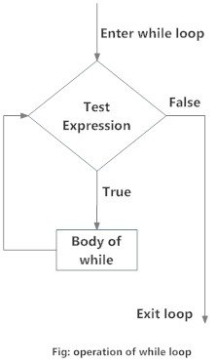
Flowchart for while loop in Python

Example: Python while Loop
# Program to add natural# numbers up to # sum = 1+2+3+...+n
# To take input from the user,# n = int(input("Enter n: "))

n = 10
# initialize sum and counter
sum = 0
i = 1
while i <= n:
sum = sum + i
i = i+1 # update counter
# print the sumprint("The sum is", sum)
Run Code
When you run the program, the output will be:
Enter n: 10
The sum is 55
In the above program, the test expression will be True as long as our counter variable i is less than or equal to n (10 in our program).
We need to increase the value of the counter variable in the body of the loop. This is very important (and mostly forgotten). Failing to do so will result in an infinite loop (never-ending loop).
Finally, the result is displayed.

While loop with else
Same as with for loops, while loops can also have an optional else block.
The else part is executed if the condition in the while loop evaluates to False.
The while loop can be terminated with a break statement. In such cases, the else part is ignored. Hence, a while loop's else part runs if no break occurs and the condition is false.
Here is an example to illustrate this.
'''Example to illustrate
the use of else statement
with the while loop'''

counter = 0
while counter < 3:
print("Inside loop")
counter = counter + 1else:
print("Inside else")
Run Code
Output
Inside loop
Inside loop
Inside loop
Inside else
Here, we use a counter variable to print the string Inside loop three times.
On the fourth iteration, the condition in while becomes False. Hence, the else part is executed.

Control Statements

Termination loops

What is the use of break and continue in Python?
In Python, break and continue statements can alter the flow of a normal loop.
Loops iterate over a block of code until the test expression is false, but sometimes we wish to terminate the current iteration or even the whole loop without checking test expression.
The break and continue statements are used in these cases.

Python break statement
The break statement terminates the loop containing it. Control of the program flows to the statement immediately after the body of the loop.
If the break statement is inside a nested loop (loop inside another loop), the break statement will terminate the innermost loop.

Syntax of break
break

Flowchart of break
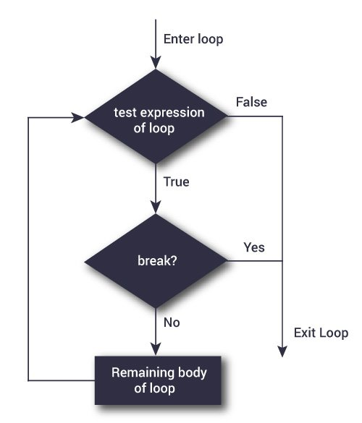Flowchart of break statement in Python
The working of break statement in for loop and while loop is shown below.
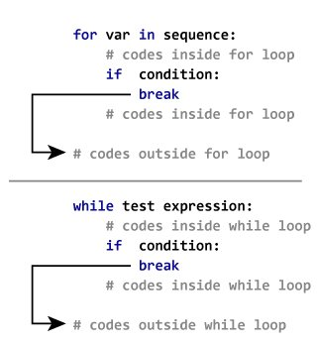Working of the break statement

Example: Python break
# Use of break statement inside the loop
for val in "string":
if val == "i":
break
print(val)
print("The end")
Output
s
t
r
The end
In this program, we iterate through the "string" sequence. We check if the letter is i, upon which we break from the loop. Hence, we see in our output that all the letters up till i gets printed. After that, the loop terminates.

Skipping specific conditions

Python continue statement
The continue statement is used to skip the rest of the code inside a loop for the current iteration only. Loop does not terminate but continues on with the next iteration.

Syntax of Continue
continue

Flowchart of continue
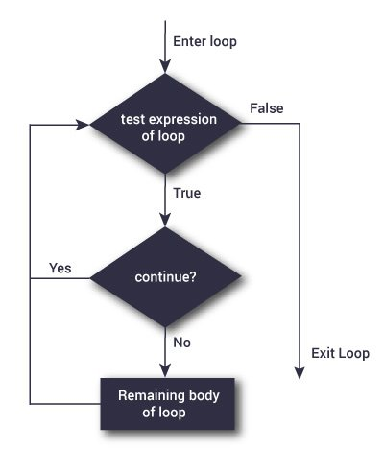
Flowchart of continue statement in Python

The working of the continue statement in for and while loop is shown below.
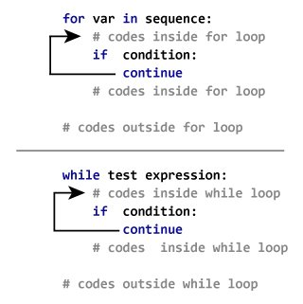
How continue statement works in python

Example: Python continue
# Program to show the use of continue statement inside loops
for val in "string":
if val == "i":
continue
print(val)
print("The end")
Output
s
t
r
n
g
The end
This program is same as the above example except the break statement has been replaced with continue.
We continue with the loop, if the string is i, not executing the rest of the block. Hence, we see in our output that all the letters except i gets printed.

String manipulation

Strings
Strings in python are surrounded by either single quotation marks, or double quotation marks
.
'hello' is the same as "hello".
You can display a string literal with the print() function:

Example
print("Hello")
print('Hello')

Assign String to a Variable
Assigning a string to a variable is done with the variable name followed by an equal sign and the string:

Example
a = "Hello"
print(a)

Multiline Strings
You can assign a multiline string to a variable by using three quotes:

Example
You can use three double quotes:
a = """Lorem ipsum dolor sit amet,
consectetur adipiscing elit,
sed do eiusmod tempor incididunt
ut labore et dolore magna aliqua."""
print(a)
Or three single quotes:

Example
a = '''Lorem ipsum dolor sit amet,
consectetur adipiscing elit,
sed do eiusmod tempor incididunt
ut labore et dolore magna aliqua.'''
print(a)

Python String Functions
There are many functions to operate on String. However, it’s not feasible to remember all of them. So here I am dividing them into different categories.
- Must Know String Functions
- Good to Know String Functions
- Miscellaneous String Functions
- Built-in Functions that work on String
- Useful String Operations

Must Know String Functions
Function | Description
format() | It’s used to create a formatted string from the template string and the supplied values.
split() | Python string split() function is used to split a string into the list of strings based on a delimiter.
join() | This function returns a new string that is the concatenation of the strings in iterable with string object as a delimiter.
strip() | Used to trim whitespaces from the string object.
format_map() | Python string format_map() function returns a formatted version of the string using substitutions from the mapping provided.
upper() | We can convert a string to uppercase in Python using str.upper() function.
lower() | This function creates a new string in lowercase.
replace() | Python string replace() function is used to create a new string by replacing some parts of another string.
find() | Python String find() method is used to find the index of a substring in a string.
translate() | Python String translate() function returns a new string with each character in the string replaced using the given translation table.

Good to Know String Functions
Function | Description
encode() | Python string encode() function is used to encode the string using the provided encoding.
count() | Python String count() function returns the number of occurrences of a substring in the given string.
startswith() | Python string startswith() function returns True if the string starts with the given prefix, otherwise it returns False.
endswith() | Python string endswith() function returns True if the string ends with the given suffix, otherwise it returns False.
capitalize() | Python String capitalize() function returns the capitalized version of the string.
center() | Python string center() function returns a centered string of specified size.
casefold() | Python string casefold() function returns a casefolded copy of the string. This function is used to perform case-insensitive string comparison.
expandtabs() | Python string expandtabs() function returns a new string with tab characters (\t) replaced with one or more whitespaces.
index() | Python String index() function returns the lowest index where the specified substring is found.
__contains__() | Python String class has __contains__() function that we can use to check if it contains another string or not. We can also use “in” operator to perform this check.

Miscellaneous String Functions
Function | Description
isalnum() | Python string isalnum() function returns True if it’s made of alphanumeric characters only.
isalpha() | Python String isalpha() function returns True if all the characters in the string are alphabets, otherwise False.
isdecimal() | Python String isdecimal() function returns True if all the characters in the string are decimal characters, otherwise False.
isdigit() | Python String isdigit() function returns True if all the characters in the string are digits, otherwise False.
isidentifier() | Python String isidentifier() function returns True if the string is a valid identifier according to the Python language definition.
islower() | Python String islower() returns True if all cased characters in the string are lowercase and there is at least one cased character, otherwise it returns False.
isnumeric() | Python String isnumeric() function returns True if all the characters in the string are numeric, otherwise False. If the string is empty, then this function returns False.
isprintable() | Python String isprintable() function returns True if all characters in the string are printable or the string is empty, False otherwise.
isspace() | Python String isspace() function returns True if there are only whitespace characters in the string, otherwise it returns False.
istitle() | Python String istitle() returns True if the string is title cased and not empty, otherwise it returns False.
isupper() | Python String isupper() function returns True if all the cased characters are in Uppercase.
rjust(), ljust() | Utility functions to create a new string of specified length from the source string with right and left justification.
swapcase() | Python String swapcase() function returns a new string with uppercase characters converted to lowercase and vice versa.
partition() | Python String partition() function splits a string based on a separator into a tuple with three strings.
splitlines() | Python String splitlines() function returns the list of lines in the string.
title() | Python String title() function returns a title cased version of the string.
zfill() | Python String zfill(width) function returns a new string of specified width. The string is filled with 0 on the left side to create the specified width.

Built-in Functions that work on String
Function | Description
len() | Python String length can be determined by using built-in len() function.
ascii() | Python ascii() function returns the string representation of the object. This function internally calls repr() function and before returning the representation string, escapes the non-ASCII characters using \x, \u or \U escapes.
bool() | Python bool() function returns Boolean value for an object. The bool class has only two instances – True and False.
bytearray() | Python bytearray() function returns a bytearray object that contains the array of bytes from the input source.
bytes() | This function returns bytes object that is an immutable sequence of integers in the range 0 <= x < 256.
ord() | Python ord() function takes string argument of a single Unicode character and return its integer Unicode code point value.
enumerate() | Python enumerate function takes a sequence, and then make each element of the sequence into a tuple.
float() | As the name says, python float() function returns a floating point number from the input argument.
hash() | This function returns the hash value of the given object.
id() | Python id() function returns the “identity” of the object. The identity of an object is an integer, which is guaranteed to be unique and constant for this object during its lifetime.
int() | Python int() function returns an integer object from the specified input. The returned int object will always be in base 10.
map() | Python map() function is used to apply a function on all the elements of specified iterable and return map object.
print() | Python print() function is used to print data into console.
slice() | Python slice() function returns a slice object representing the set of indices specified by range(start, stop, step).
type() | This function returns the type of the object.

Python Lists

mylist = ["apple", "banana", "cherry"]

List
Lists are used to store multiple items in a single variable
.
Lists are one of 4 built-in data types in Python used to store collections of data, the other 3 are Tuple, Set, and Dictionary, all with different qualities and usage.
Lists are created using square brackets:

Example
Create a List:
thislist = ["apple", "banana", "cherry"]
print(thislist)

List Items
List items are ordered, changeable, and allow duplicate values
.
List items are indexed, the first item has index [0], the second item has index [1] etc.

Ordered
When we say that lists are ordered, it means that the items have a defined order, and that order will not change
.
If you add new items to a list, the new items will be placed at the end of the list.
Note: There are some list methods that will change the order, but in general: the order of the items will not change.

Changeable
The list is changeable, meaning that we can change, add, and remove items in a list after it has been created.

Allow Duplicates
Since lists are indexed, lists can have items with the same value:

Example
Lists allow duplicate values:
thislist = ["apple", "banana", "cherry", "apple", "cherry"]
print(thislist)

List Length
To determine how many items a list has, use the len() function:

Example
Print the number of items in the list:
thislist = ["apple", "banana", "cherry"]
print(len(thislist))

List Items - Data Types
List items can be of any data type:

Example
String, int and boolean data types:
list1 = ["apple", "banana", "cherry"]
list2 = [1, 5, 7, 9, 3]
list3 = [True, False, False]
A list can contain different data types:

Example
A list with strings, integers and boolean values:
list1 = ["abc", 34, True, 40, "male"]

type()
From Python's perspective, lists are defined as objects with the data type 'list':
<class 'list'>

Example
What is the data type of a list?
mylist = ["apple", "banana", "cherry"]
print(type(mylist))

The list() Constructor
It is also possible to use the list() constructor when creating a new list.

Example
Using the list() constructor to make a List:
thislist = list(("apple", "banana", "cherry")) # note the double round-brackets
print(thislist)

Python Tuples
mytuple = ("apple", "banana", "cherry")

Tuple
Tuples are used to store multiple items in a single variable
.
Tuple is one of 4 built-in data types in Python used to store collections of data, the other 3 are List, Set, and Dictionary, all with different qualities and usage.
A tuple is a collection which is ordered and
unchangeable.
Tuples are written with round brackets.

Example
Create a Tuple:
thistuple = ("apple", "banana", "cherry")
print(thistuple)

Tuple Items
Tuple items are ordered, unchangeable, and allow duplicate values
.
Tuple items are indexed, the first item has index [0], the second item has index [1] etc.

Ordered
When we say that tuples are ordered, it means that the items have a defined order, and that order will not change.

Unchangeable
Tuples are unchangeable, meaning that we cannot change, add or remove items after the tuple has been created.

Allow Duplicates
Since tuples are indexed, they can have items with the same value:

Example
Tuples allow duplicate values:
thistuple = ("apple", "banana", "cherry", "apple", "cherry")
print(thistuple)

Tuple Length
To determine how many items a tuple has, use the len() function:

Example
Print the number of items in the tuple:
thistuple = ("apple", "banana", "cherry")
print(len(thistuple))

Create Tuple With One Item
To create a tuple with only one item, you have to add a comma after the item, otherwise Python will not recognize it as a tuple.

Example
One item tuple, remember the comma:
thistuple = ("apple",)
print(type(thistuple))
#NOT a tuple
thistuple = ("apple")
print(type(thistuple))

Tuple Items - Data Types
Tuple items can be of any data type:

Example
String, int and boolean data types:
tuple1 = ("apple", "banana", "cherry")
tuple2 = (1, 5, 7, 9, 3)
tuple3 = (True, False, False)
A tuple can contain different data types:

Example
A tuple with strings, integers and boolean values:
tuple1 = ("abc", 34, True, 40, "male")

type()
From Python's perspective, tuples are defined as objects with the data type 'tuple':
<class 'tuple'>

Example
What is the data type of a tuple?
mytuple = ("apple", "banana", "cherry")
print(type(mytuple))

The tuple() Constructor
It is also possible to use the tuple() constructor to make a tuple.

Example
Using the tuple() method to make a tuple:
thistuple = tuple(("apple", "banana", "cherry")) # note the double round-brackets
print(thistuple)

Python Dictionary
Dictionary in Python is an unordered collection of data values, used to store data values like a map, which, unlike other Data Types that hold only a single value as an element, Dictionary holds key:value pair. Key-value is provided in the dictionary to make it more optimized.
Note – Keys in a dictionary don’t allow Polymorphism.
Disclamer: It is important to note that Dictionaries have been modified to maintain insertion order with the release of Python 3.7, so they are now ordered collection of data values.

Creating a Dictionary
In Python, a Dictionary can be created by placing a sequence of elements within curly {} braces, separated by ‘comma’. Dictionary holds pairs of values, one being the Key and the other corresponding pair element being its Key:value. Values in a dictionary can be of any data type and can be duplicated, whereas keys can’t be repeated and must be immutable.
Note – Dictionary keys are case sensitive, the same name but different cases of Key will be treated distinctly.
# Creating a Dictionary
# with Integer Keys
Dict = {1: 'Geeks', 2: 'For', 3: 'Geeks'}
print("\nDictionary with the use of Integer Keys: ")
print(Dict)

# Creating a Dictionary
# with Mixed keys
Dict = {'Name': 'Geeks', 1: [1, 2, 3, 4]}
print("\nDictionary with the use of Mixed Keys: ")
print(Dict)
Output:
Dictionary with the use of Integer Keys:
{1: 'Geeks', 2: 'For', 3: 'Geeks'}

Dictionary with the use of Mixed Keys:
{1: [1, 2, 3, 4], 'Name': 'Geeks'}
Dictionary can also be created by the built-in function dict(). An empty dictionary can be created by just placing to curly braces{}.
# Creating an empty Dictionary
Dict = {}
print("Empty Dictionary: ")
print(Dict)

# Creating a Dictionary
# with dict() method
Dict = dict({1: 'Geeks', 2: 'For', 3:'Geeks'})
print("\nDictionary with the use of dict(): ")
print(Dict)

# Creating a Dictionary
# with each item as a Pair
Dict = dict([(1, 'Geeks'), (2, 'For')])
print("\nDictionary with each item as a pair: ")
print(Dict)
Output:
Empty Dictionary:
{}

Dictionary with the use of dict():
{1: 'Geeks', 2: 'For', 3: 'Geeks'}

Dictionary with each item as a pair:
{1: 'Geeks', 2: 'For'}

Nested Dictionary:
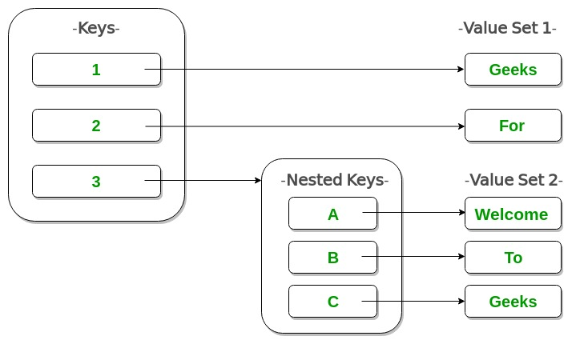

# Creating a Nested Dictionary
# as shown in the below image
Dict = {1: 'Geeks', 2: 'For',
3:{'A' : 'Welcome', 'B' : 'To', 'C' : 'Geeks'}}

print(Dict)
Output:
{1: 'Geeks', 2: 'For', 3: {'A': 'Welcome', 'B': 'To', 'C': 'Geeks'}}

Adding elements to a Dictionary
In Python Dictionary, the Addition of elements can be done in multiple ways. One value at a time can be added to a Dictionary by defining value along with the key e.g. Dict[Key] = ‘Value’. Updating an existing value in a Dictionary can be done by using the built-in update() method. Nested key values can also be added to an existing Dictionary.
Note- While adding a value, if the key-value already exists, the value gets updated otherwise a new Key with the value is added to the Dictionary.
# Creating an empty Dictionary
Dict = {}
print("Empty Dictionary: ")
print(Dict)

# Adding elements one at a time
Dict[0] = 'Geeks'
Dict[2] = 'For'
Dict[3] = 1
print("\nDictionary after adding 3 elements: ")
print(Dict)

# Adding set of values
# to a single Key
Dict['Value_set'] = 2, 3, 4
print("\nDictionary after adding 3 elements: ")
print(Dict)

# Updating existing Key's Value
Dict[2] = 'Welcome'
print("\nUpdated key value: ")
print(Dict)

# Adding Nested Key value to Dictionary
Dict[5] = {'Nested' :{'1' : 'Life', '2' : 'Geeks'}}
print("\nAdding a Nested Key: ")
print(Dict)
Output:
Empty Dictionary:
{}

Dictionary after adding 3 elements:
{0: 'Geeks', 2: 'For', 3: 1}

Dictionary after adding 3 elements:
{0: 'Geeks', 2: 'For', 3: 1, 'Value_set': (2, 3, 4)}

Updated key value:
{0: 'Geeks', 2: 'Welcome', 3: 1, 'Value_set': (2, 3, 4)}

Adding a Nested Key:
{0: 'Geeks', 2: 'Welcome', 3: 1, 5: {'Nested': {'1': 'Life', '2': 'Geeks'}}, 'Value_set': (2, 3, 4)}

Accessing elements from a Dictionary
In order to access the items of a dictionary refer to its key name. Key can be used inside square brackets.
# Python program to demonstrate
# accessing a element from a Dictionary

# Creating a Dictionary
Dict = {1: 'Geeks', 'name': 'For', 3: 'Geeks'}

# accessing a element using key
print("Accessing a element using key:")
print(Dict['name'])

# accessing a element using key
print("Accessing a element using key:")
print(Dict[1])
Output:
Accessing a element using key:
For

Accessing a element using key:
Geeks
There is also a method called get() that will also help in accessing the element from a dictionary.
# Creating a Dictionary
Dict = {1: 'Geeks', 'name': 'For', 3: 'Geeks'}

# accessing a element using get()
# method
print("Accessing a element using get:")
print(Dict.get(3))
Output:
Accessing a element using get:
Geeks

Accessing an element of a nested dictionary
In order to access the value of any key in the nested dictionary, use indexing [] syntax.
# Creating a Dictionary
Dict = {'Dict1': {1: 'Geeks'},
'Dict2': {'Name': 'For'}}

# Accessing element using key
print(Dict['Dict1'])
print(Dict['Dict1'][1])
print(Dict['Dict2']['Name'])
Output:
{1: 'Geeks'}
Geeks
For

Removing Elements from Dictionary

Using del keyword
In Python Dictionary, deletion of keys can be done by using the del keyword. Using the del keyword, specific values from a dictionary as well as the whole dictionary can be deleted. Items in a Nested dictionary can also be deleted by using the del keyword and providing a specific nested key and particular key to be deleted from that nested Dictionary.
Note: The del Dict will delete the entire dictionary and hence printing it after deletion will raise an Error.
# Initial Dictionary
Dict = { 5 : 'Welcome', 6 : 'To', 7 : 'Geeks',
'A' : {1 : 'Geeks', 2 : 'For', 3 : 'Geeks'},
'B' : {1 : 'Geeks', 2 : 'Life'}}
print("Initial Dictionary: ")
print(Dict)

# Deleting a Key value
del Dict[6]
print("\nDeleting a specific key: ")
print(Dict)

# Deleting a Key from
# Nested Dictionary
del Dict['A'][2]
print("\nDeleting a key from Nested Dictionary: ")
print(Dict)
Output:
Initial Dictionary:
{'A': {1: 'Geeks', 2: 'For', 3: 'Geeks'}, 'B': {1: 'Geeks', 2: 'Life'}, 5: 'Welcome', 6: 'To', 7: 'Geeks'}

Deleting a specific key:
{'A': {1: 'Geeks', 2: 'For', 3: 'Geeks'}, 'B': {1: 'Geeks', 2: 'Life'}, 5: 'Welcome', 7: 'Geeks'}

Deleting a key from Nested Dictionary:
{'A': {1: 'Geeks', 3: 'Geeks'}, 'B': {1: 'Geeks', 2: 'Life'}, 5: 'Welcome', 7: 'Geeks'}

Using pop() method
Pop() method is used to return and delete the value of the key specified.
# Creating a Dictionary
Dict = {1: 'Geeks', 'name': 'For', 3: 'Geeks'}

# Deleting a key
# using pop() method
pop_ele = Dict.pop(1)
print('\nDictionary after deletion: ' + str(Dict))
print('Value associated to poped key is: ' + str(pop_ele))
Output:
Dictionary after deletion: {3: 'Geeks', 'name': 'For'}
Value associated to poped key is: Geeks

Using popitem() method
The popitem() returns and removes an arbitrary element (key, value) pair from the dictionary.
# Creating Dictionary
Dict = {1: 'Geeks', 'name': 'For', 3: 'Geeks'}

# Deleting an arbitrary key
# using popitem() function
pop_ele = Dict.popitem()
print("\nDictionary after deletion: " + str(Dict))
print("The arbitrary pair returned is: " + str(pop_ele))
Output:
Dictionary after deletion: {3: 'Geeks', 'name': 'For'}
The arbitrary pair returned is: (1, 'Geeks')

Using clear() method
All the items from a dictionary can be deleted at once by using clear() method.

# Creating a Dictionary
Dict = {1: 'Geeks', 'name': 'For', 3: 'Geeks'}

# Deleting entire Dictionary
Dict.clear()
print("\nDeleting Entire Dictionary: ")
print(Dict)
Output:
Deleting Entire Dictionary:
{}

Dictionary Methods
Methods | Description
copy() | They copy() method returns a shallow copy of the dictionary.
clear() | The clear() method removes all items from the dictionary.
pop() | Removes and returns an element from a dictionary having the given key.
popitem() | Removes the arbitrary key-value pair from the dictionary and returns it as tuple.
get() | It is a conventional method to access a value for a key.
dictionary_name.values() | returns a list of all the values available in a given dictionary.
str() | Produces a printable string representation of a dictionary.
update() | Adds dictionary dict2’s key-values pairs to dict
setdefault() | Set dict[key]=default if key is not already in dict
keys() | Returns list of dictionary dict’s keys
items() | Returns a list of dict’s (key, value) tuple pairs
has_key() | Returns true if key in dictionary dict, false otherwise
fromkeys() | Create a new dictionary with keys from seq and values set to value.
type() | Returns the type of the passed variable.
cmp() | Compares elements of both dict.

Python - Functions

A function is a block of organized, reusable code that is used to perform a single, related action. Functions provide better modularity for your application and a high degree of code reusing.
As you already know, Python gives you many built-in functions like print(), etc. but you can also create your own functions. These functions are called user-defined functions.

Defining a Function
You can define functions to provide the required functionality. Here are simple rules to define a function in Python.

Function blocks begin with the keyword def followed by the function name and parentheses ( ( ) ).

Any input parameters or arguments should be placed within these parentheses. You can also define parameters inside these parentheses.

The first statement of a function can be an optional statement - the documentation string of the function or docstring.

The code block within every function starts with a colon (:) and is indented.

The statement return [expression] exits a function, optionally passing back an expression to the caller. A return statement with no arguments is the same as return None.

Syntax
def functionname( parameters ):
"function_docstring"
function_suite
return [expression]
By default, parameters have a positional behavior and you need to inform them in the same order that they were defined.

Example
The following function takes a string as input parameter and prints it on standard screen.
def printme( str ):
"This prints a passed string into this function"
print str
return

Calling a Function
Defining a function only gives it a name, specifies the parameters that are to be included in the function and structures the blocks of code.
Once the basic structure of a function is finalized, you can execute it by calling it from another function or directly from the Python prompt. Following is the example to call printme() function −
#!/usr/bin/python
# Function definition is heredef printme( str ):
"This prints a passed string into this function"
print str
return;
# Now you can call printme function
printme("I'm first call to user defined function!")
printme("Again second call to the same function")
When the above code is executed, it produces the following result −
I'm first call to user defined function!
Again second call to the same function

Advantages of function
A function is a block of reusable code that is used to perform a specific action. The advantages of using functions are:
- Reducing duplication of code
- Decomposing complex problems into simpler pieces
- Improving clarity of the code
- Reuse of code
- Information hiding

Function types
There are two basic types of functions: built-in functions and user defined functions. The built-in functions are part of the Python language; for instance print(), input(), type(), etc. The user defined functions are functions created with the def keyword.

Anonymous functions:
In Python, an anonymous function means that a function is without a name. As we already know the def keyword is used to define the normal functions and the lambda keyword is used to create anonymous functions. Please see this for details.
# Python code to illustrate the cube of a number
# using lambda function

def cube(x): return x*x*x

cube_v2 = lambda x : x*x*x

print(cube(7))
print(cube_v2(7))
Output
343

Formal and Actual Parameters in Python Function

- CODE OF GEEKS

- 0
Pre-requisite : Functions in Python
In Python, Parameter refers to the information passed to the function. Parameters are also known as arguments.
Typically, Parameters are of two types – Formal Parameters, Actual Parameters
Formal Parameters are the parameters which are specified during the definition of the function.
Consider the following code :
def sum(a, b):
return a + b):
return a + b
In the above code, ‘a’ & ‘b’ are acting as formal parameters.

Actual Parameters are the parameters which are specified during the function call. Actual Parameters are actually of four types :
- Positional Parameters
- Keyword Parameters
- Default Parameters
- Variable length Parameters
Let us explore them one by one

Positional Parameters/ Arguments
Positional Parameters are the parameters that are passed to the function in the correct positional order. For example, consider following code :
D
def result(name, marks):
# some cool code
result("Geek", 95)(name, marks):("Geek", 95)
Above function expects you to provide two parameters during the invocation(function call). During, first parameter should be a string and second parameter should be an integer.
Below code will work and produce output

def result(name, marks):
print("Name of student : ", name)
cgpa = marks/10
print("CGPA is : ", cgpa)
# calling above function with name as "Geek" and marks as 95.
result("Geek",95)
result("Geek",95)
Output :
Name of student : Geek
CGPA is : 9.5
In the above code, parameter name has the value “Geek” and marks has 95 as value.
Now, let’s do some experiment, let’s swap both parameters
def result(name, marks):
def result(name, marks):
print("Name of student : ", name)
cgpa = marks/10
print("CGPA is : ", cgpa)
# calling above function with name as 95 and marks as "Geek".
result(95,"Geek")
result(95,"Geek")
Output :
TypeError: unsupported operand type(s) for /: ‘str’ and ‘int’
So, position matters.

Keyword Parameters/ Arguments
Positional Parameters are the parameters that are are capable of identifying the parameters with their specified name. For example, consider following code :
def result(name, marks):
def result(name, marks):
# some cool code
result(name = "Geek", marks = 95) = "Geek", marks = 95)
Above function expects you to provide two parameters during the invocation(function call). In Keyword parameters, maintaining order is not mandatory as we are already specifying the correct parameter with its name.
Both code will work and produce output
def
def result(name, marks):
print("Name of student : ", name)
cgpa = marks/10
print("CGPA is : ", cgpa)
# calling above function with name as "Geek" and marks as 95.
result(name = "Geek", marks = 95)
result(name = "Geek", marks = 95)
Output :
Name of student : Geek
CGPA is : 9.5
In the above code, parameter name has the value “Geek” and marks has 95 as value.
Now, let’s do some experiment, let’s swap both parameters

def result(name, marks):
def result(name, marks):
print("Name of student : ", name)
cgpa = marks/10
print("CGPA is : ", cgpa)
# calling above function
result(marks = 95,name = "Geek")
result(marks = 95,name = "Geek")
Output :
Name of student : Geek
CGPA is : 9.5

Default Parameters/ Arguments
Default Parameters are the parameters in which we can specify the default value for the parameters in the function definition. For example, consider following code :
def
def result(name, marks = 95):
# some cool code result("Geek"))
Default Parameter is a parameter that assumes a default value if a value is not specified during function invocation. Consider the following code :
def result(name, marks = 95):
def result(name, marks = 95):
print("Name of student : ", name)
cgpa = marks/10
print("CGPA is : ", cgpa)
# calling above function
result("Geek") # Invocation 1
result("Geek", 90) # Invocation 2
In the above code example, we have called same function twice.
Invocation 1 : result() is invoked with “Geek” as the first parameter. In this case, value for second parameter(marks) is not passed. But, in the function definition, value for variable ‘marks’ is defined as 95.
So, for Invocation 1, output would be :
Name of student : Geek
CGPA is : 9.5
Invocation 2 : result() is invoked with “Geek” as the first parameter and 90 as the second parameter. But, in the function definition, value for variable ‘marks’ is defined as 95.
So, in the case where no value is specified for a parameter, default value is considered or else actual value is given more priority over default value.
So, for Invocation 2, output would be :
Name of student : Geek
CGPA is : 9.0

Variable Length Parameters/ Arguments – *args & **kwargs
There might be the cases where even developer is not clear of the number of values a function may receive. In all such cases, we can not specify the number of parameters in the function definition. To encounter this issue, variable length parameters comes into picture.
def def result(farg, *args):
# some cool code
result(1, "Geek")
farg represents the formal argument and *args represents the variable length parameters. We can pass 1 or more values to *args and it will store them in tuple (stores a group of elements).
Let’s understand this with the help of code example :
def square_of_numbers(farg, *args):
print("Type of arg is ", type(args))
print("farg is : ", farg)
for each_arg in args:
print("args is : ", each_arg)
square_of_numbers(1, 5, 10, 15)0, 15)
O/P :
Type of arg is <class ‘tuple’>
farg is : 1
args is : 5
args is : 10
args is : 15

In the above program, we have 1 formal argument and 3 variable length parameters.
Please note that while invoking a function, formal parameters are mandatory meanwhile it is optional to provide variable length parameters.
**kwargs : In Python, **kwargs represents the keyword variable arguments or parameters. This argument represents the dictionary object. Dictionary in Python stores the data in the form of key-value pairs.

Extra Gyan !

A keyword variable argument can accept any number of values provided in the form of key-value pairs.
multiply(num1, num2 = 20)
In the above code, num1 is a formal argument and num2 is a keyword variable argument with ‘num2′ as a key and ’20’ as value. Its representation could be imagined as :
{ "nu{ "num2" : 20 }
One more example,

multiply(rollno, name = "Apurv", marks = 99, result = "PASS")marks = 99, result = "PASS")
In the above code, rollno is a formal parameter and name, marks, & result are keyword variable parameters.
Program : To check the implementation of **kwargs.

def def display(rollno, **kwargs):
for key, val in kwargs.items():
print("{0} : {1}".format(key, val))
display(1, name = 'Apurv', marks = 95, grade = 'A+', result = 'PASS')
O/P :
name : Apurv
marks : 95
grade : A+
result : PASS

Global and Local Variables in Python
Global variables are those which are not defined inside any function and have a global scope whereas local variables are those which are defined inside a function and its scope is limited to that function only. In other words, we can say that local variables are accessible only inside the function in which it was initialized whereas the global variables are accessible throughout the program and inside every function
.

Local Variables
Local variables are those which are initialized inside a function and belongs only to that particular function. It cannot be accessed anywhere outside the function. Let’s see how to create a local variable.
Example: Creating local variables
def f():

# local variable
s = "I love Geeksforgeeks"
print(s)

# Driver code
f()
Output
I love Geeksforgeeks
If we will try to use this local variable outside the function then let’s see what will happen.
Example:
def f():

# local variable
s = "I love Geeksforgeeks"
print("Inside Function:", s)

# Driver code
f()
print(s)
Output
NameError: name 's' is not defined

Global Variables
The global variables are those which are defined outside any function and which are accessible throughout the program i.e. inside and outside of every function Let’s see how to create a global variable.
Example: Defining and accessing global variables
# This function uses global variable s
def f():
print("Inside Function", s)

# Global scope
s = "I love Geeksforgeeks"
f()
print("Outside Function", s)
Output
Inside Function I love Geeksforgeeks
Outside Function I love Geeksforgeeks
The variable s is defined as the global variable and is used both inside the function as well as outside the function.
Note: As there are no locals, the value from the globals will be used.
Now, what if there is a variable with the same name initialized inside a function as well as globally. Now the question arises, will the local variable will have some effect on the global variable or vice versa, and what will happen if we change the value of variable inside of the function f()? Will it affect the globals as well? We test it in the following piece of code:
# This function has a variable with
# name same as s.
def f():
s = "Me too."
print(s)

# Global scope
s = "I love Geeksforgeeks"
f()
print(s)
Output:
Me too.
I love Geeksforgeeks.
If a variable with the same name is defined inside the scope of function as well then it will print the value given inside the function only and not the global value
.
The question is, what if we try to change the value of a global variable inside the function. Let’s see it using the below example.
Example:
# This function uses global variable s
def f():
s += 'GFG'
print("Inside Function", s)

# Global scope
s = "I love Geeksforgeeks"
f()
Output
UnboundLocalError: local variable 's' referenced before assignment
To make the above program work, we need to use the “global” keyword. Let’s see what this global keyword is.

Global Keyword
We only need to use the global keyword in a function if we want to do assignments or change the global variable. global is not needed for printing and accessing. Python “assumes” that we want a local variable due to the assignment to s inside of f(), so the first statement throws the error message. Any variable which is changed or created inside of a function is local if it hasn’t been declared as a global variable. To tell Python, that we want to use the global variable, we have to use the keyword “global”, as can be seen in the following example:
Example 1: Using global keyword
# This function modifies the global variable 's'
def f():
global s
s += ' GFG'
print(s)
s = "Look for Geeksforgeeks Python Section"
print(s)

# Global Scope
s = "Python is great!"
f()
print(s)
Output
Python is great! GFG
Look for Geeksforgeeks Python Section
Look for Geeksforgeeks Python Section
Now there is no ambiguity.
Example 2: Using global and local variables
a = 1

# Uses global because there is no local 'a'
def f():
print('Inside f() : ', a)

# Variable 'a' is redefined as a local
def g():
a = 2
print('Inside g() : ', a)

# Uses global keyword to modify global 'a'
def h():
global a
a = 3
print('Inside h() : ', a)

# Global scope
print('global : ', a)
f()
print('global : ', a)
g()
print('global : ', a)
h()
print('global : ', a)
Output
global : 1
Inside f() : 1
global : 1
Inside g() : 2
global : 1
Inside h() : 3
global : 3

Python Modules
A Python module is a file containing Python definitions and statements. A module can define functions, classes, and variables. A module can also include runnable code. Grouping related code into a module makes the code easier to understand and use. It also makes the code logically organized.

Example: create a simple module
# A simple module, calc.py

def add(x, y):
return (x+y)

def subtract(x, y):
return (x-y)

Import Module in Python – Import statement
We can import the functions, classes defined in a module to another module using the import statement in some other Python source file.
Syntax:
import module
When the interpreter encounters an import statement, it imports the module if the module is present in the search path. A search path is a list of directories that the interpreter searches for importing a module. For example, to import the module calc.py, we need to put the following command at the top of the script.
Note: This does not import the functions or classes directly instead imports the module only. To access the functions inside the module the dot(.) operator is used.

Example: Importing modules in Python
# importing module calc.py
import calc

print(calc.add(10, 2))
Output:
12

The from import Statement
Python’s from statement lets you import specific attributes from a module without importing the module as a whole.

Example: Importing specific attributes from the module
# importing sqrt() and factorial from the
# module math
from math import sqrt, factorial

# if we simply do "import math", then
# math.sqrt(16) and math.factorial()
# are required.
print(sqrt(16))
print(factorial(6))
Output:
4.0
720

Import all Names – From import * Statement
The * symbol used with the from import statement is used to import all the names from a module to a current namespace.
Syntax:
from module_name import *
The use of * has its advantages and disadvantages. If you know exactly what you will be needing from the module, it is not recommended to use *, else do so.

Example: Importing all names
# importing sqrt() and factorial from the
# module math
from math import *

# if we simply do "import math", then
# math.sqrt(16) and math.factorial()
# are required.
print(sqrt(16))
print(factorial(6))
Output
4.0
720

Locating Modules
Whenever a module is imported in Python the interpreter looks for several locations. First, it will check for the built-in module, if not found then it looks for a list of directories defined in the sys.path. Python interpreter searches for the module in the following manner –
- First, it searches for the module in the current directory.
- If the module isn’t found in the current directory, Python then searches each directory in the shell variable PYTHONPATH. The PYTHONPATH is an environment variable, consisting of a list of directories.
- If that also fails python checks the installation-dependent list of directories configured at the time Python is installed.

Example: Directories List for Modules
# importing sys module
import sys

# importing sys.path
print(sys.path)
Output:
[‘/home/nikhil/Desktop/gfg’, ‘/usr/lib/python38.zip’, ‘/usr/lib/python3.8’, ‘/usr/lib/python3.8/lib-dynload’, ”, ‘/home/nikhil/.local/lib/python3.8/site-packages’, ‘/usr/local/lib/python3.8/dist-packages’, ‘/usr/lib/python3/dist-packages’, ‘/usr/local/lib/python3.8/dist-packages/IPython/extensions’, ‘/home/nikhil/.ipython’]

Importing and renaming module
We can rename the module while importing it using the as keyword.

Example: Renaming the module
# importing sqrt() and factorial from the
# module math
import math as gfg

# if we simply do "import math", then
# math.sqrt(16) and math.factorial()
# are required.
print(gfg.sqrt(16))
print(gfg.factorial(6))
Output
4.0
720

The dir() function
The dir() built-in function returns a sorted list of strings containing the names defined by a module. The list contains the names of all the modules, variables, and functions that are defined in a module.
# Import built-in module random
import random
print(dir(random))

Output:

[‘BPF’, ‘LOG4’, ‘NV_MAGICCONST’, ‘RECIP_BPF’, ‘Random’, ‘SG_MAGICCONST’, ‘SystemRandom’, ‘TWOPI’, ‘_BuiltinMethodType’, ‘_MethodType’, ‘_Sequence’, ‘_Set’, ‘__all__’, ‘__builtins__’, ‘__cached__’, ‘__doc__’, ‘__file__’, ‘__loader__’, ‘__name__’, ‘__package__’, ‘__spec__’, ‘_acos’, ‘_bisect’, ‘_ceil’, ‘_cos’, ‘_e’, ‘_exp’, ‘_inst’, ‘_itertools’, ‘_log’, ‘_pi’, ‘_random’, ‘_sha512’, ‘_sin’, ‘_sqrt’, ‘_test’, ‘_test_generator’, ‘_urandom’, ‘_warn’, ‘betavariate’, ‘choice’, ‘choices’, ‘expovariate’, ‘gammavariate’, ‘gauss’, ‘getrandbits’, ‘getstate’, ‘lognormvariate’, ‘normalvariate’, ‘paretovariate’, ‘randint’, ‘random’, ‘randrange’, ‘sample’, ‘seed’, ‘setstate’, ‘shuffle’, ‘triangular’, ‘uniform’, ‘vonmisesvariate’, ‘weibullvariate’]
Code Snippet illustrating python built-in modules:

# importing built-in module math
import math

# using square root(sqrt) function contained
# in math module
print(math.sqrt(25))

# using pi function contained in math module
print(math.pi)

# 2 radians = 114.59 degrees
print(math.degrees(2))

# 60 degrees = 1.04 radians
print(math.radians(60))

# Sine of 2 radians
print(math.sin(2))

# Cosine of 0.5 radians
print(math.cos(0.5))

# Tangent of 0.23 radians
print(math.tan(0.23))

# 1 * 2 * 3 * 4 = 24
print(math.factorial(4))

# importing built in module random
import random

# printing random integer between 0 and 5
print(random.randint(0, 5))

# print random floating point number between 0 and 1
print(random.random())

# random number between 0 and 100
print(random.random() * 100)

List = [1, 4, True, 800, "python", 27, "hello"]

# using choice function in random module for choosing
# a random element from a set such as a list
print(random.choice(List))

# importing built in module datetime
import datetime
from datetime import date
import time

# Returns the number of seconds since the
# Unix Epoch, January 1st 1970
print(time.time())

# Converts a number of seconds to a date object
print(date.fromtimestamp(454554))
Output:
5.0
3.14159265359
114.591559026
1.0471975512
0.909297426826
0.87758256189
0.234143362351
24
3
0.401533172951
88.4917616788
True
1461425771.87
1970-01-06

