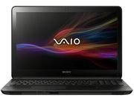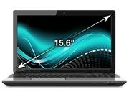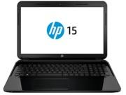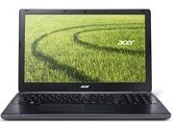

**Contact us**

**Tablets**

**Laptops**

**Home**

Laptops

Toshiba Satellite L50-A111X

- Intel® Core™ i5

- 2.5GHz

- 1TB

- 4GB

- 15.6 Inches

100,000.000 rs

Sony Vaio Fit SVF15323CXB

- Intel® Core™ i5

- 1.60 Ghz

- 750GB

- 6GB

- 15.5 Inches

- Windows 8.1

94,999 - PKR

Sony Vaio Fit SVF15323CXW

- Intel® Core™ i5

- 1.60 Ghz

- 750GB

- 6GB

- 15.5 Inches

- Windows 8.1

94,999 - PKR

Dell Inspiron 5423

- Intel® Core™ i3

- 1.8 Ghz

- 500GB

- 4GB

- 14.1 Inches

- Windows 8

48,499 - PKR

HP15-D002sx

- Intel Core i3

- 2.4 GHz

- 500 GB

- 2 GB

- 15.6 Inches

- Dos

43,999 - PKR

Acer Aspire E1-572

- Intel® Core™ i5

- 1.6 GHZ

- 750 GB

- 4GB

- 15.6 Inches

- Windows 8

51,999 - PKR

Order