Innovation Flash Card OFLAMERON German language 55 PDF Freeware - https://yadi.sk/d/Qb4AhHnt8cLwug

Intelligent flash cards OFLAMERON more difficult, interesting and more effective classic flash card to memorize foreign words.
In German words and phrases rearranged letters (except the first and last). Enter the letters in the cells in the correct order.
German language – to English, Russian and Czech
- MISCHUNG (DE) - MIXTURE (EN), СМЕСЬ (RUS), SMĚS (CZ)
M | I | S | C | H | U | N | G

Rearrange the letters (except the first and last) to get the word in German
55
Tape (Flash Card) for lesson 

MIXTURE (EN) |  |  |  |  |  | oflameron.ru
M |  |  |  |  |  |  |  | G
M | C | N | I | H | S |  | U | G

Full Download List – Text File – Direct Links
http://geocities.ws/frenchfree/GOOGLE_DRIVE_PDF.txt

Demo
TWENTY-TWO (EN) |  |  |  |  |  |  |  |  |  | oflameron.ru
Z | W | E | I | U | N | D | Z | W | A |  | N | Z | I | G
Z | U | W | I | E | I | D | A | N | W |  | Z | N | Z | G

- NIEDERLEGEN (DE) - TO RESIGN (EN), УЙТИ В ОТСТАВКУ (RUS), REZIGNOVAT (CZ)
Best language learning apps for Android
Duolingo - fait un grand émoi. Son principe de base est que l'apprentissage des langues devrait être gratuit. Ainsi, toutes les langues qui prennent en charge, sont disponibles gratuitement du début à la fin. Concept de jeu utilisé, où vous apprendrez de nouvelles langues en jouant à quelques jeux, qui vous montrera le nouveau vocabulaire et la grammaire. Cela ne semble pas si grave, mais les développeurs se vantent que 34 heures de gameplay est à peu près égale à un semestre à l'école secondaire. C'est un excellent point de départ pour les débutants sur un budget. C'est certainement l'une des applications d'apprentissage linguistique à essayer absolument.
N | I | E | D | E | R | L | E | G | E | N

Tape (Flash Card) for lesson 
TO RESIGN (EN) |  |  |  |  |  |  | oflameron.ru
N |  |  |  | E |  |  |  | G |  | N
N | E | D | E | I | E | G | E | R | L | N

- ABENTEUER (DE) - ADVENTURE (EN), ПРИКЛЮЧЕНИЕ (RUS), DOBRODRUŽSTVÍ (CZ)
A | B | E | N | T | E | U | E | R

Tape (Flash Card) for lesson 
ADVENTURE (EN) |  |  |  |  |  | oflameron.ru
A |  |  |  |  |  |  |  | R
A | T | E | B | U | E | E | N | R

You can adjust the difficulty level of the lesson. Just use a long phrase.

- BEGABT (DE) - GIFTED (EN), ОДАРЕННЫЙ (RUS), NADANÝ (CZ)
B | E | G | A | B | T

Tape (Flash Card) for lesson 
GIFTED (EN) |  |  | oflameron.ru
B |  |  |  |  | T
B | G | B | E | A | T

© by Valery Shmeleff http://www.oflameron.ru
Publication: http://flashcards.boards.net/board/1/general-discussion/
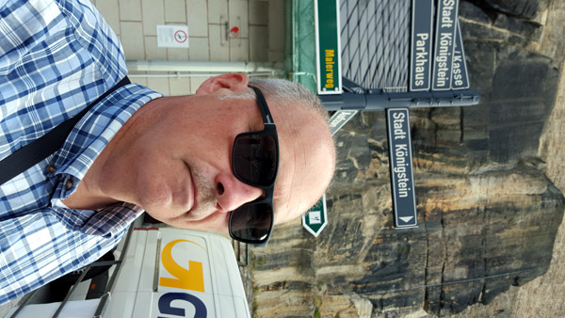
Quote: Tysk er offisielt språk i Tyskland, Osterrike, Liechtenstein, så vel som et offisielt språk i Luxemburg og Sveits. Det er også lommer av tysk talende samfunn i nord-Italia og Belgia. Tysk kan også hjelpe deg i mange deler av Ost-Europa, der språket brukes til å bli undervist som første fremmedspråk på skolen.
Valery Shmeleff - http://oflameron.ru/

