OFLAMERON - technology for learning foreign words http://www.shmeleff.com
Print the tape with the text (text box). The student must correctly divide the tape into fragments and make of them a phrase in French
tourner à droite - turn right
English
French
tourneràdroite - remove spaces
urnetoràitedro - rearrange the fragments of words
Tape for printing
urnetoràitedro
- tape

You need to cut the tape into fragments, and to make a phrase “tourner à droite”
composer une phrase - to make a phrase
composerunephrase - remove spaces
posecomrphrunease - rearrange the fragments of words
Tape for printing
posecomrphrunease

You need to cut the tape into fragments, and to make a phrase “composer une phrase”
venir dans le bureau - to come to the office
venirdanslebureau - remove spaces
lebuvedanirnsreau - rearrange the fragments of words
Tape for printing
lebuvedanirnsreau
- tape

You need to cut the tape into fragments, and to make a phrase “venir dans le bureau”
envoyer un message - send a message
envoyerunmessage - remove spaces
sageyerunenvomes - rearrange the fragments of words
Tape for printing
sageyerunenvomes

You need to cut the tape into fragments, and to make a phrase “envoyer un message”

How to learn. Example
sageyerunenvomes
envoyer un message

faire le travail - to do the job
faireletravail - remove spaces
vailelefairtra - rearrange the fragments of words
Tape for printing
vailelefairtra
- tape

You need to cut the tape into fragments, and to make a phrase “faire le travail”
l'arrêt de bus - bus stop
l'arrêtdebus - remove spaces
rêtl'arusdeb - rearrange the fragments of words
Tape for printing
rêtl'arusdeb

You need to cut the tape into fragments, and to make a phrase “l'arrêt de bus”
s'il vous plaît, montrez-moi - please show me
s'ilvousplaîtmontrez-moi - remove spaces
vouss'ilplaîtrezmont-moi - rearrange the fragments of words
Tape for printing
vouss'ilplaîtrezmont-moi
- tape

You need to cut the tape into fragments, and to make a phrase “s'il vous plaît, montrez-moi”
comment se rendre à - how to reach
commentserendreà - remove spaces
mentcomdreàseren - rearrange the fragments of words
Tape for printing
mentcomdreàseren

You need to cut the tape into fragments, and to make a phrase “comment se rendre à”
j'ai besoin d'un billet - how to reach
j'aibesoind'unbillet - remove spaces
letj'aibes'unbiloind - rearrange the fragments of words
Tape for printing
letj'aibes'unbiloind
- tape

You need to cut the tape into fragments, and to make a phrase “j'ai besoin d'un billet”
ouvrir un dépôt - to open a Deposit
ouvrirundépôt - remove spaces
ouundévrirpôt - rearrange the fragments of words
Tape for printing
ouundévrirpôt

You need to cut the tape into fragments, and to make a phrase “ouvrir un dépôt”
le taux d'intérêt - the interest rate
letauxd'intérêt - remove spaces
tauxled'rêtinté - rearrange the fragments of words
Tape for printing
tauxled'rêtinté
- tape

You need to cut the tape into fragments, and to make a phrase “le taux d'intérêt”
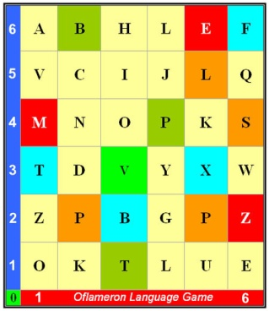 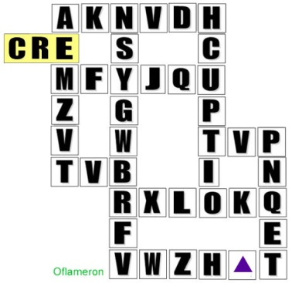 See http://www.shmeleff.com

réserver une chambre d'hôtel - book a room at the hotel
réserverunechambred'hôtel - remove spaces
telrverréseunebrechamd'hô - rearrange the fragments of words
Tape for printing
telrverréseunebrechamd'hô

You need to cut the tape into fragments, and to make a phrase “réserver une chambre d'hôtel”
appeler un taxi - to call a taxi
appeleruntaxi - remove spaces
ntapeleapruxi - rearrange the fragments of words
Tape for printing
ntapeleapruxi

You need to cut the tape into fragments, and to make a phrase “appeler un taxi”

How to learn. Example 2
ntapeleapruxi
appeler un taxi

- cut the tape

- make a phrase

You need to cut the tape into fragments, and to make a phrase “appeler un taxi”
déjeuner sur trois- lunch for three
déjeunersurtrois - remove spaces
jeunedérsuisrtro - rearrange the fragments of words
Tape for printing
jeunedérsuisrtro

You need to cut the tape into fragments, and to make a phrase “déjeuner sur trois”
envoyer un mail- to send by post
envoyerunmail - remove spaces
voyeenruilnma - rearrange the fragments of words
Tape for printing
voyeenruilnma

You need to cut the tape into fragments, and to make a phrase “envoyer un mail”
© by Valery V Shmeleff http://www.shmeleff.com http://www.oflameron.ru
Blog http://bretell.blogspot.com/

