OFLAMERON - technology for learning foreign words http://www.shmeleff.com
Print the tape with the text (text box). The student must correctly divide the tape into fragments and make of them a phrase in Spanish
cómo estás - how are you
English
Spanish
cómoestás - remove spaces
táscóesmo - rearrange the fragments of words
Tape for printing
táscóesmo
- tape for print

You need to cut the tape into fragments, and to make a phrase “cómo estás”
cuál es tu nombre - what is your name
cuálestunombre - remove spaces
lestcubreáunom - rearrange the fragments of words
Tape for printing
lestcubreáunom

You need to cut the tape into fragments, and to make a phrase “cuál es tu nombre”
donde estación de tren - where is the train station
dondeestacióndetren - remove spaces
trenestadondeciónde - rearrange the fragments of words
Tape for printing
trenestadondeciónde
- tape

You need to cut the tape into fragments, and to make a phrase “donde estación de tren”
Cuál es la especial del día? - What is today’s special?
cuáleslaespecialdeldía - remove spaces
díaslaescuálepecialdel - rearrange the fragments of words
Tape for printing
díaslaescuálepecialdel

You need to cut the tape into fragments, and to make a phrase “Cuál es la especial del día”

How to learn. Example
sageyerunenvomes
envoyer un message

Qué hora es? - What time is it?
quéhoraes - remove spaces
horaesqué - rearrange the fragments of words
Tape for printing
horaesqué
- tape

You need to cut the tape into fragments, and to make a phrase “Qué hora es”
No me siento bien - I don't feel good
nomesientobien - remove spaces
entonobienmesi - rearrange the fragments of words
Tape for printing
entonobienmesi

You need to cut the tape into fragments, and to make a phrase “No me siento bien”
Me siento enfermo - I feel sick
mesientoenfermo - remove spaces
ferentomesienmo - rearrange the fragments of words
Tape for printing
ferentomesienmo
- tape

You need to cut the tape into fragments, and to make a phrase “Me siento enfermo”
Mi nombre es - My name is
minombrees - remove spaces
breminomes - rearrange the fragments of words
Tape for printing
breminomes

You need to cut the tape into fragments, and to make a phrase “Mi nombre es”
De donde eres? - Where are you from?
dedondeeres - remove spaces
eresdedonde - rearrange the fragments of words
Tape for printing
eresdedonde
- tape

You need to cut the tape into fragments, and to make a phrase “De donde eres”
estancias de una semana - I am staying for one week
estanciasdeunasemana - remove spaces
manaestaunasenciasde - rearrange the fragments of words
Tape for printing
manaestaunasenciasde

You need to cut the tape into fragments, and to make a phrase “estancias de una semana”
Muchas gracias - Thank you very much
muchasgracias - remove spaces
gramuciaschas - rearrange the fragments of words
Tape for printing
gramuciaschas
- tape

You need to cut the tape into fragments, and to make a phrase “Muchas gracias”
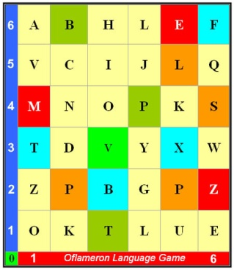 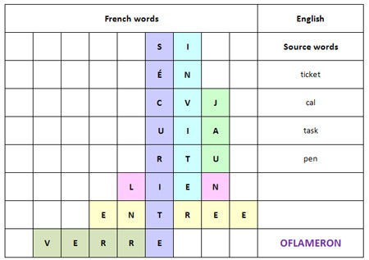 See http://www.shmeleff.com

Usted está aquí - You are here
ustedestáaquí - remove spaces
ustaquíedestá - rearrange the fragments of words
Tape for printing
ustaquíedestá

You need to cut the tape into fragments, and to make a phrase “Usted está aquí”
Cuántos? – How many?
cuántos - remove spaces
ántoscu - rearrange the fragments of words
Tape for printing
ántoscu

You need to cut the tape into fragments, and to make a phrase “Cuántos”

How to learn. Example 2
ntapeleapruxi
appeler un taxi

- cut the tape

- make a phrase

You need to cut the tape into fragments, and to make a phrase “appeler un taxi”
Entiende usted? – Do you understand?
entiendeusted - remove spaces
deuentiensted - rearrange the fragments of words
Tape for printing
deuentiensted

You need to cut the tape into fragments, and to make a phrase “Entiende usted”
Me llaman - Call me
mellaman - remove spaces
melmanla - rearrange the fragments of words
Tape for printing
melmanla

You need to cut the tape into fragments, and to make a phrase “Me llaman”
© by Valery V Shmeleff http://www.shmeleff.com http://www.oflameron.ru
Blog http://bretell.blogspot.com/

