ñlH. Write a program in Scilab to find cardinality of the following eeta
- A = (1, 3, 5 7, 9}
(n) B = {x, y, z}
{iiiJ C = {Apple, Acer, Sony, Dell, Lenovo}

A-| 1,3,5,7,9];
a=1engt (A);
disp(a,’Cardirtality of set A is:') 1 ›
y=2;

B=|x,y,z];
b=length(B);
disp(b,'Cardinality of set B is:'};
Apple=2;
Acer=4;
Sony=6;
Dell=8;
Lenovo-10;
C=|App1e, Acer, Sony, Defl, LenovoJ;
c=length(C);
disp(c,’Cardinality of set C is:');

OUTPUT:
execJ'E:\Scilab program filea\cardinality.see');
Cardinality of set A ia:
s.
Cardinality of act B ie:

Cardinality of set C ie: s.

A2H: Write a program in Scilab t« r»id »umber of proper subsets of A whern
til i^i- s.

(iiJ A - {Strangle, Rectangle, Squarn, Pentagon, Hexagon, Star).

ri-5;//number of elements of act A
m=2^n- 1;//numf›er of elements ofpo r meet of A excluding A Coeff
disp(m,'Number of proper subsets A ='};

OUTPUT:
enecJ'R:\Scilab program fdea\power aetl.ace'); Number of proper aubaeta A -
3i.

Rectang1e=2;
Square-3;
Pentagon=4;
Hexagon=5;

A-(Triangle, Rectangle, Square, Pentagon, Hexagon, Star);
n-length[A);//number of members in A
in=2°n- 1;//number of elements of power set of A excluding A itself
disp(tn,'Number of proper subsets of A =’J;

exec('E:\Scilab program filea\power aetl.ace')i

Number of proper aubaete of A -
63.

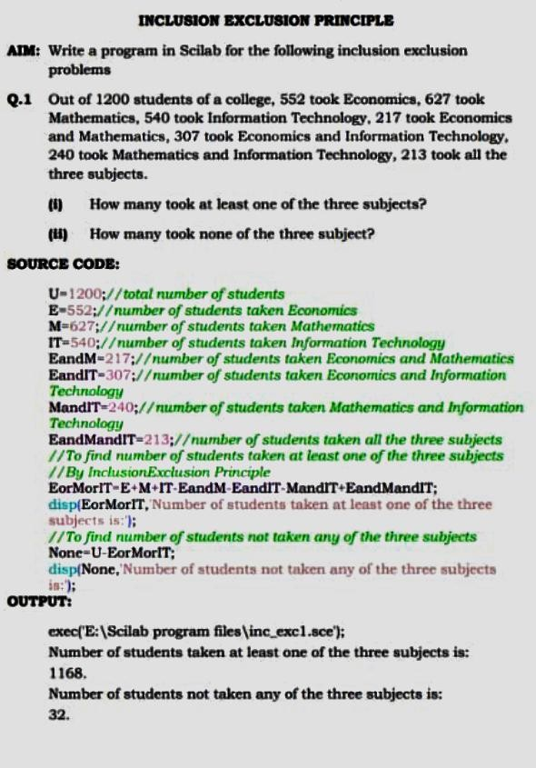

Q.h A survey of 550 T.V. watchers produced the following information: 285 watch football, 195 watch hockey, 115 watch baseball, 45 watch football and baseball, 70 watch football and hockey, 50 watch hockey and baseball, 100 do not watch any of the three gamea.
{IJ How many people in the aurrey watch all the three gamea7

{IU How many people watch exactly one of the three gamea9

8OURDB CODB:
U=S50;//total number of geople surqed F--’285;//numf›er of people etch football H- I O6;// number of geople munch hockey B- 115;//number ofmopIe •••t•h b•••e*••Il
FandB=4S’,//nurnt›er of people etchfoothold nod baseball
FandH=70;//ntimber of people snatch netball rind hockey HandB-TO;// number of people match hockey and baseball None- 1 OO,//number of people ii›atch none of the three
//TO find number of i•• R!e *•*•t•* all the three games
ForHorB-U-None;//number of OR!e •••••^ at hast one of the three
//**u*•*!••’••• *** n ’ !R!e
FandHandB-ForHorB-F H B+FandH FandB+HandB;
disp{FandHandB, Nuniliti i of people wat cli all the t hree fumes is:');
//To find number of OR!e •••••^ exactly One of the three games
OnlyF-F-FandH-FandB+FandHandB;
On1yH-H-HandB-FandH+FandHandB; On1yB-B-HandB-FandB+FandHandB;
ExactlyOne-On1yF+OnlyH+OnlyB;//number fp'e•Rle etch exactly
one of the three games
clisp{ExactlyOne,'Number oi’ people watrli exactly onr of the threr
gRmtn.is:');

OU'2'PUT:
exec('E: \Scilab prograzri fi1ea\inc exc2.ace'J; Number of people watch all the three gamea ia: 20.
Number of people watch exactly one of the three games.ia:
325.

AIH: Write a program io Gcilab to esaluate the following polynomiala:
(I) /(x) = x* —2x -I- 1 atx 2 .
- g(z) = x* - 1 at x = 3.
(ìiì) A(x} - Zx* —7x² -‹- 4x — 15 ot x = 5.
BDDBCB CODB:
f'poly([1 ,-2,0, 1],'x','c'};
disp(f,’the polynomial f is ’J; k=horner{f,2J;
disp(k,'value of polynomial f at x = 2 is ’};
g=po1y(| 1,- 1],'x’,'r’); disp(g,'the polynomial g is ’); 1-horner(g,3J;
disp§,'value of polynomial g at x - 3 is '); x - po1y{0, 'x');
h - 2*x^3-7*x^2+4*x-15; disp{h,'the polynomial h i9') z -homer(h,5);
diep(in,’value of the polynomial h at x - 5 is 'J;
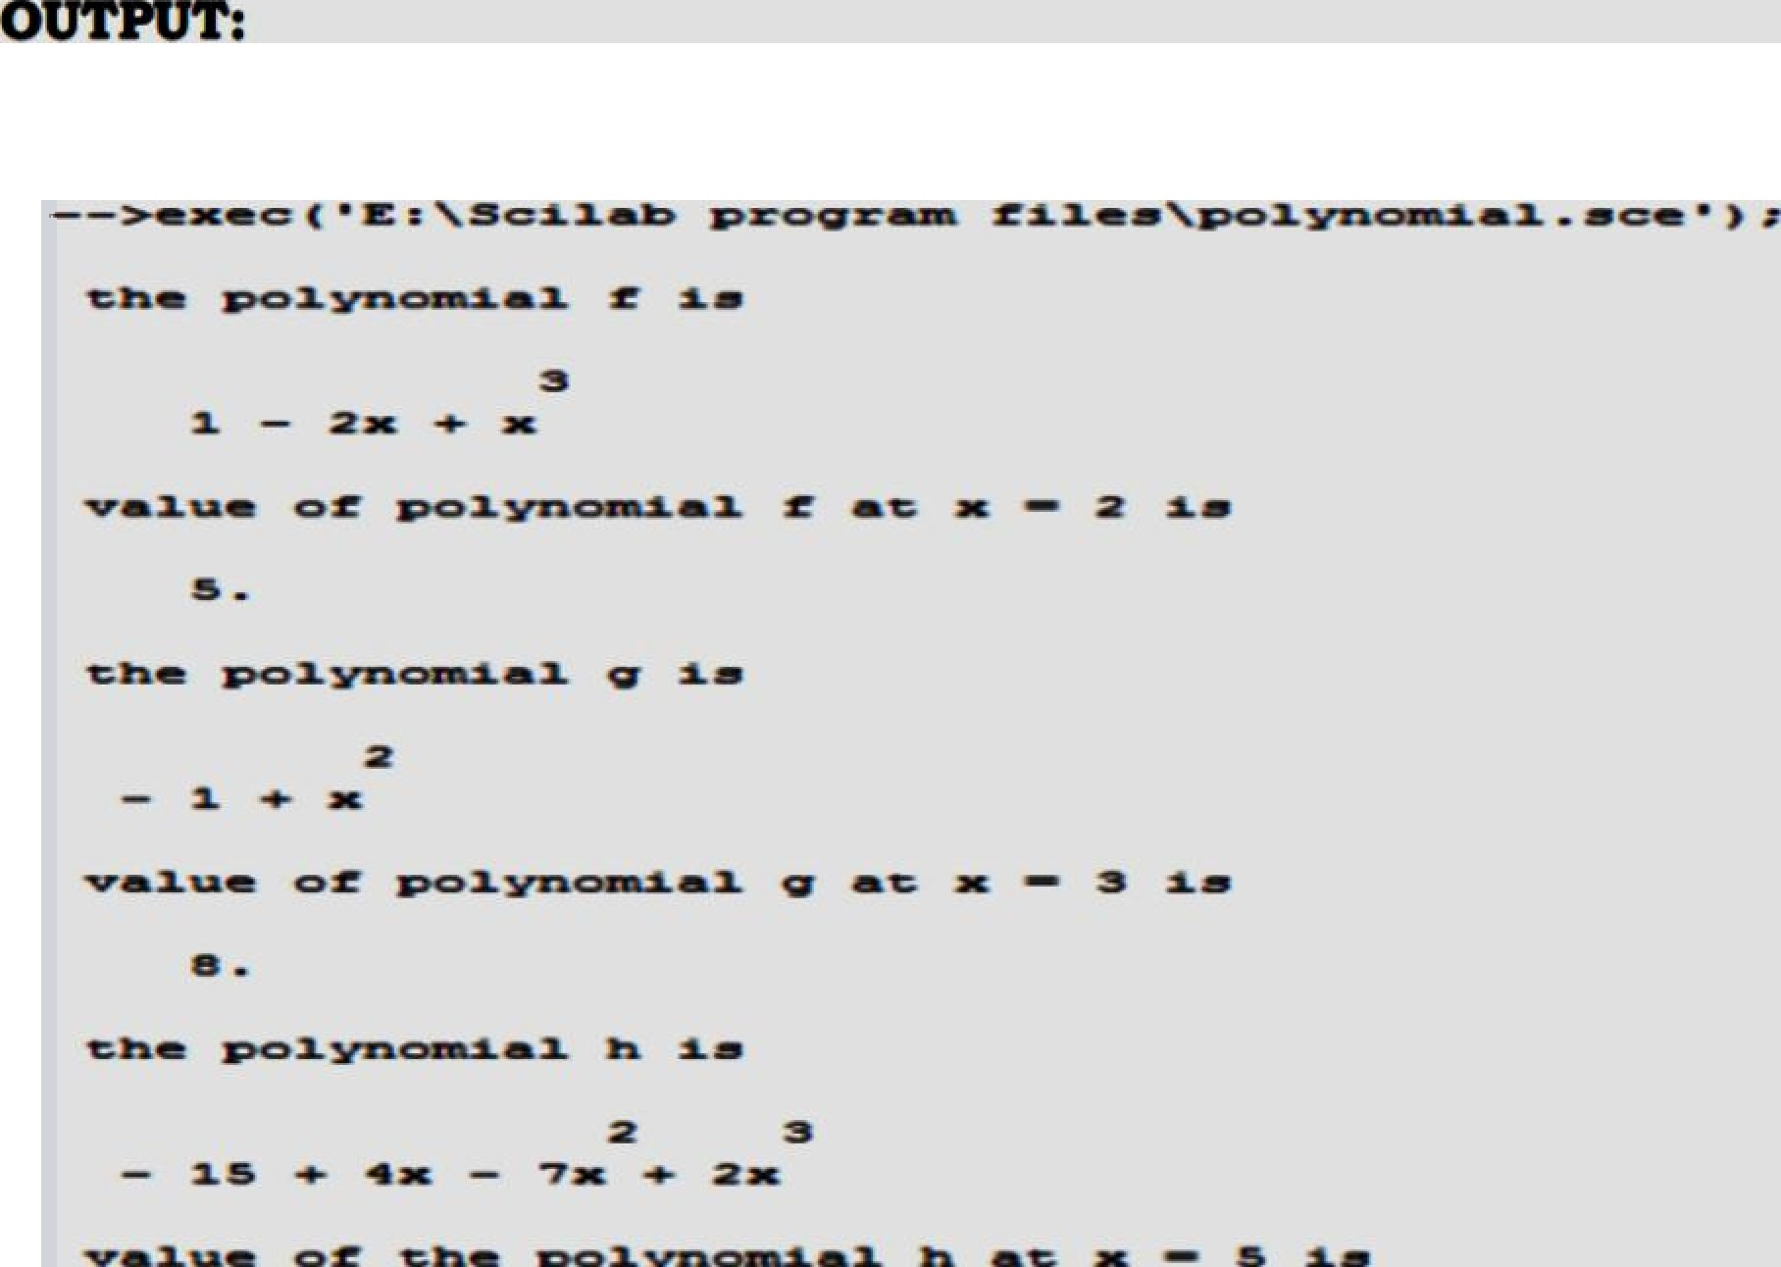

PAG2'O ROTATION
AIM: Write a program in Scilab for the following

Q.1 Find firat six factorial valuee by using n! = n x (ii - 1)! without using inbuilt factorial function.
- fl Compute (i) 61 {ii) 6!/41 {iii) 101/71 , by uaing inbuilt factorial
function.
aouRcB coDB:
7/ finDirig some initial factorial vnfues ithout using inbu'dt factorial

function
//ca/cufañân by using n!=n”(n-1)!
'#i dispfD,0!=) f1=1*fD; disp(fl,'l!-'}; f2=2*fl; disp(f2,'2!-’J;
f3=3*f2; disp(f8,'3!=’}; f4=4*f3; disp(f4,'4!='J; f5=5*f4; disp(f5,'5!=’};
//6/ by usinp inbuilt factorial function
f6=factorial(6); disp(fB,'6!-’};
//flozg 6!/4! aru 10!/ 7! k1=factorial(6)/factorial(4); disp(kl,’value of 6!/ 4! is:'); k2=factorial(10J/factorial(7); disp(k2, value of 10!/7! is:');

exec('E: \Scilab program files \counting_factorial.ece'); 0!=

1.

2!=

2.
3!=
6.

4l=

24.
51=
120.

61=

720.

vMueof6!/4Ms:
30.

value of 10!/7! is:

720.

PRfi TA to. 3 {B PHRMBTATIOH8
AIH: Write a program in Scilab for the following:
  - A teacher ia preparing an examination time table for 5 papera to be

held on 5 consecutive daya. How many different time table can ahe

Q.0 A manager haa 10 persons working under him and he is expected to award 3 prizea to the peraone whom he ranka are the top three achievere in the previous year. How many choices doea he have7

BOURCB CODE:
function [h]- turn, r)
k=factorial|n)/factorial(n-rJ; endfunction
n=5;//number of days available
r-ñ;/7number of papers to :schedule
ana I -pt (n,r)i
disp(ans 1,'Number of ‹different time taliles:'); a= 10;//total number of people available b=3;Z/number people to select
arise= tn(a,b);
disp(ana2,’Number of’ choices manager has:');

OUTPUT:
exec('E:\Scilab program filea\prmtn aci’Ji Number of different time tablea:

120.
Number of choices manager haa:

720.

us: Write a program in Scilab for the following:
q.z In how many waya can a committee of 8 people be formed out of a group of 10 men and 5 woo end

q.a In how many waya can a committee of 6 men and 2 women be formed out of a group of l0 men and 5 women7

function (kJ-cmbntn(n, r)
k=factorialJn)/{factorialJr)*factorial(n-rJ);
endfunction
m= 10;/Ztotnl number of men w=5;//totol number of ux›men r=8;// ntimf›er of people to :select ana1=cmbntnJm+w,rJ;
disp(anal,'Number of ways to form a committee of 8 out of a group of
10 men and 5 women is:');
z I -6;7/number of men to be :seIected r2——2,//number of ux›men to be selected ana2=cmbtztn(m,r1)”cmbntn(w,r2);
disp(an82,’Number of ways to form a committee of 6 men anal 2
women out of a group of 10 men and 5 women is:'J;

exec('E: \Scilab program filea\cmbntn.aci'J;
Number of waya to form a committee of 8 out of a group of 10 men

and 5 women is:
6435.
Number of waya to form a committee of 6 men and 2 women out of a group of 10 men and 5 women ie:
2100.

AIM: Write a program in Scilab for the following:
q.i Two uniform dice are rolled. Find the probability of Ji) an event A that aum of the numbers ia at moat 6.
(iiJ an event B that aum of the numbers ie at least 10.
BOU tCB CODB:

disp(’Two uniform dice are rolled and sum of the outcomes are observed:');
S-|2,3,4,5,6,7,8,9,10,11,12];//all po:sBibte outcomes for ttie expeMrnent
disp('The probability space is as follows:'};

//f'n - pmbab“City of gening n as cum of the outcomes
P2=1/36, P3=2/ 36, P4=3/36, P5=4/36, P6=5/ 36, P7=6/36, P8=5/ 36,
P9=4/36, P10=3/36, P11=2/86, P12= 1/36
disp{'A is the event that sum of the outcomes is at most 6 and B is the
event that sum of the outcomes is at least lO.'); PA=P2>PS>P4<P5>P6;//probot›ifity of emnt A disp(PA,'Probability of event A:'};
PB=PI0 Pl 1+PU,//probofi’d'itp of client B
disp(PB,'Probability of event B:'};

OOTPOT:
exec('E: \Scilab program filea\prnbability_apacea.ace’J;
Two uniform dice are rnlled and aum of the outcomea are obanrved: The probability space is aa follows:

0.0277778

0.0555556

0.0833333

0. l lll 111

0.1388889

0.1b6ñbb7

0.1388889

0.L 1 11 1 11
P1O =
0.0833333

0.055555f:i
PU -
0.0277778
A ia the event that aum of the outcomes ia at moat 6 and B ia the
event that aum of the outcomea ia at leaBt 10.

Probability of event A:
0.4166667

Probability of event B:
0.1666667

