Data Set II: Newton’s Law of Cooling – Graphs Generated by Excel – A Linear Regression Is Determined

Time | Temp
(min) | (°C)
0.00 | 115.00
1.00 | 112.00
2.00 | 108.00
3.00 | 105.00
4.00 | 101.00
5.00 | 98.00
6.00 | 95.00
7.00 | 92.00
8.00 | 89.00
9.00 | 86.00
10.00 | 83.00
11.00 | 81.00
12.00 | 78.00
13.00 | 75.00
14.00 | 73.00
15.00 | 71.00

Data Set II: Newton’s Law of Cooling – Graphs Generated by TI-83 Plus – A Linear Regression Is Determined

 | 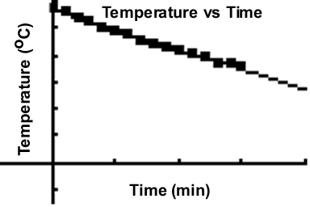  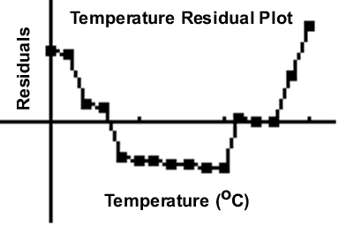
  Time | Temp
  (min) | (°C)
  0.00 | 115.00
  1.00 | 112.00
  2.00 | 108.00
  3.00 | 105.00
  4.00 | 101.00
  5.00 | 98.00
  6.00 | 95.00
  7.00 | 92.00
  8.00 | 89.00
  9.00 | 86.00
  10.00 | 83.00
  11.00 | 81.00
  12.00 | 78.00
  13.00 | 75.00
  14.00 | 73.00
  15.00 | 71.00
Data Set II: Newton’s Law of Cooling – Graphs Generated by Excel and the
TI-83 Plus – A Second Degree Polynomial Regression Is
Determined

 | 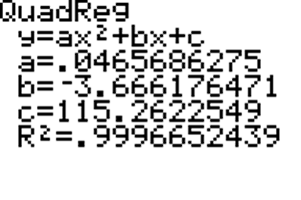
  Temp | Press
  (°C) | (mm Hg)
  0.00 | 4.580
  5.00 | 6.543
  10.00 | 9.209
  15.00 | 12.788
  16.00 | 13.634
  17.00 | 14.530
  18.00 | 15.477
  19.00 | 16.478
  20.00 | 17.535
  21.00 | 18.650
  22.00 | 19.827
  23.00 | 21.068
  24.00 | 22.377
  25.00 | 23.756
  26.00 | 25.209
  27.00 | 26.739
  28.00 | 28.349
  29.00 | 30.044
  30.00 | 31.823
  31.00 | 33.696
  32.00 | 35.663
  34.00 | 39.899
  36.00 | 44.563
  38.00 | 49.692
  40.00 | 55.324
  45.00 | 71.882
  50.00 | 92.511
  55.00 | 118.030
  60.00 | 149.370
  65.00 | 187.550
  70.00 | 233.710
  75.00 | 289.100
  80.00 | 355.110
  85.00 | 433.620
  90.00 | 525.770
  95.00 | 633.910
  100.00 | 760.000

