Conversion Tutorial: Introduction Green Stuff
Submitted by: Cento
Comment: The following is an article a good friend of ours has written. He's been kind enough to allow us to submit it to our site prior to posting it up on his own. For more painting tips and excellent paint jobs, take a look at Cento Industries.

What is Green Stuff?
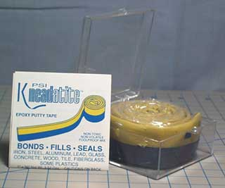
Green Stuff is the standard modelling compound for the gaming miniature industry. Most figures are actually sculpted in Green Stuff before they are cast for mass production. Green Stuff is the common name for Polymeric's Kneadatite (Blue/Yellow) Sculptors Epoxy Putty. It is the same stuff that GW used to repackage (and sell for a markup) in blister packs. Currently, Games Workshop US sells a blue/white epoxy putty instead, but it is quite similar to Green Stuff, and it is in fact made by the same company as Green Stuff (see below for more information on White Stuff).
Green Stuff can be a very challenging medium to work in. Former GW sculptor Chris Fitzpatrick reportedly once compared it to trying to sculpt in chewing gum. This is by no means an exhaustive document on how to sculpt in Green Stuff, but is instead intended as useful introduction for those looking to go to the next step in figure conversions.
Care and Preparation of Green Stuff
Fresh Green Stuff is important. If Green Stuff gets too old, it will become crumbly or not mix smoothly, making it very difficult to work with. If you buy it from any sculpting supply dealer, they will know this and are pretty good about keeping their stock fresh. You can help maintain the freshness of your Green Stuff by keeping it in a cold place, preferably the freezer.
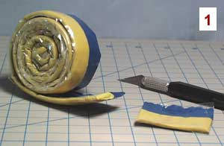
To mix up some Green Stuff, use a hobby knife to cut off the amount you need to work with (1). Again using the hobby knife, remove the center section of the putty ribbon where the blue and yellow meet, since the curing process will have already started here, and the cured bits will not mix in smoothly (2). Finally take the two pieces and thoroughly knead them together until the Green Stuff is a smooth, uniform shade of green (3).
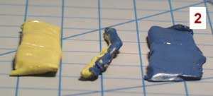
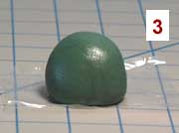
By varying the mixture ratio of blue to yellow, you can affect the working properties of the Green Stuff. Using more blue (the hardener) in the mixture, the Green Stuff will cure faster and slightly harder. More yellow (filler) in the mixture creates a softer blend that will take detail better and harden slower. Many sculptors will use a blue heavy mixture to bulk up the figure and more of a yellow ratio for surface detail. Remember that the yellow strip is the sticker half, and that will also affect the final working properties of your mixture. Finally, Green Stuff is extremely soft right after it is mixed, and many people find it too difficult to use while it is so soft, so you may want to let your mixed Green Stuff sit for 15 minutes or so before trying to sculpt with it. Experiment a little and see what works best for you.
If you have really sensitive skin (as I do), mixing the Green Stuff can cause some discomfort. If you notice this, you should try wearing rubber or latex gloves while mixing the Green Stuff. The mixing process is when your skin gets the most exposure to the Green Stuff, so once it is mixed, you should be able to work with your bare hands without any extra discomfort.
Working with Green Stuff
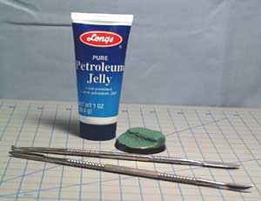
The most important thing when working with Green Stuff is lubrication. Keep your tools (and finger tips) lubricated to prevent the Green stuff from sticking all over them. The conventional wisdom suggests water, but water is problematic since it needs to be constantly reapplied and the water droplets tends to obscure details. Instead, I recommend Vaseline (or some other petroleum jelly). I small amount applied to your tools makes working with Green Stuff much easier. The only drawback to Vaseline is that you must thoroughly wash what you have worked on with soap and water before you can apply any more Green Stuff (or paint) to the figure. Other professional sculptors use all sorts of other lubricants, including olive oil, saliva, ear wax, and oil from their foreheads (eew!).
Work with small amounts of Green Stuff at a time, and build up what you are working on. To sculpt a large area, bulk it up first with Green Stuff into the rough shape of what you want. Fine surface detail is not important yet. Any large or freestanding sections (such as limbs or weapons) should be supported by a wire armature. When applying surface details, again add a little bit at a time. Since Green Stuff is so soft and flexible, try to push putty into the shape you want rather than carve it with cutting motions. Cutting motions tend to deform the putty when it is soft rather than cutting cleanly. Once it is cured, Green Stuff cuts easily, but while you CAN sand and carve it after curing, the "give" it has makes this difficult and not all that effective. Once you have an area you are happy with, set it aside and let it cure. Everyone who has used Green Stuff has at some point accidentally pressed a finger print into an area that they had already finished sculpting.
The normal working time for Green Stuff is 90 minutes after it has been mixed, though this will be affected by the temperature of your work area. If you want to accelerate the cure time, placing the figure in a warm area will help. The easiest way is to place it under a desk lamp. Some sculptors make little Green Stuff ovens using an old coffee can and desk lamp. If you have used any plastic bits in your figure, be warned that too high of a temperature, even from a desk lamp, will melt or warp your plastic bits and ruin your work (I've done it). Conversely, if you wish to slow down the sure time of some Green Stuff that you have already mixed up, you can place it in the refrigerator or freezer to delay it hardening. When you pull it out, work it in your hands to soften it up again. In any case, do not expect full cure strength for at least 24 hours after mixing the Green Stuff.
Hybrid Putty Mixtures
While Green Stuff is a flexible putty, and retains a lot of "give" even when hardened, these properties can be modified by blending different types of putty together. For example, many sculptors will use a blend of Green Stuff and White Stuff or Green Stuff and Brown Stuff. The most famous blend is actually Green Stuff and Milliput (for more information on Milliput, refer to "Other Modelling Materials" below).
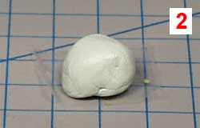
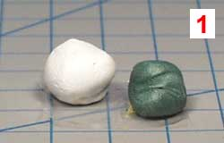

To mix up the hybrid, first mix some of each putty type separately then mix the two putties together (as shown above). The normal ratio is a 50/50 blend, but you can experiment to find a mixture that works better for you. The resulting blend has some of the resilience of Green Stuff, but is much harder and can be filed and carved more easily. This blend is most often used for more hard edged features, such as machinery or weapons.

Tools
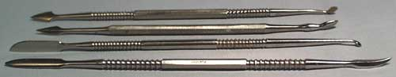
Tools are very much a matter of personal preferences and style. Some sculptors use nothing more then toothpicks, sewing needles, or an old Xacto knife. Others use a staggering array of implements, even going so far as making their own custom specialized tools. I tend to use the following:
- hobby knife
- sculpting tools
- dental probes
- burnishers
- files
All of these should be available at larger hobby stores or ordered online (see Suppliers below). To find out more about these tools, please refer to my Modelling Tools page.
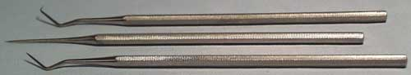
And last, but most certainly not least, have patience. Green Stuff is a difficult medium to work with, and it will not be rushed. There is no replacement for experience and experimentation.

Additional Information and Resources:
Other Modelling Materials
While Green Stuff might be the most common modelling compound used in figures, it is not the only option. Most modelling compounds are either "hard" or "flexible" once cured. Hard putties hold sharp edges well, but tend to be brittle and not very durable. Flexible putties are durable, but don't hold edges as well. Hard putties are ideal for hard, technological details, while flexible putties work much better for organic shapes. Green Stuff is a flexible putty. Here are some other fairly commonly used materials:
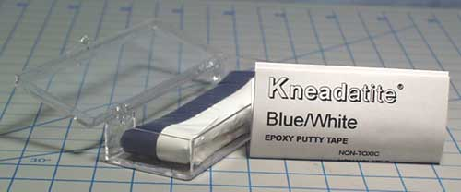
"White Stuff" - Kneadatite (Blue/White) Epoxy Putty
White Stuff is made by the same manufacturer as Green Stuff, and is actually quite similar. It is also what Games Workshop US sells instead of Green Stuff. I do not know why they switched to White Stuff, but GWUS claims it is better. Most professional sculptors prefer Green Stuff still, but many casual users are happy with the White Stuff. I have used both, and while the differences were quite slight, I also preferred the Green Stuff. White Stuff is a flexible putty.
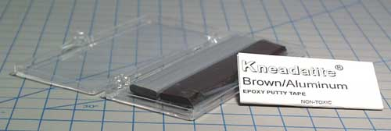
"Brown Stuff" - Kneadatite (Brown/Aluminum) Epoxy Putty
Brown Stuff is made by the same manufacturer as Green Stuff, and has many similar properties. Brown Stuff cures harder than Green Stuff and somewhat bridges the gap between hard and flexible putties. It tends to cost more and is harder to find the Green Stuff. Brown Stuff is often used for weapon blades and other hard-line details.
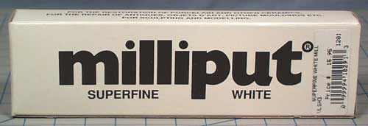
Milliput
Milliput is a two-part epoxy putty that behaves very differently from Green Stuff. It is actually fairly water soluble when wet (like modelling clay) but very hard when cured. It can be filed and sanded easily, but is quite brittle, making it not very durable. Some sculptors actually use a 50/50 mix of Green Stuff and Milliput to get a compromise between the hardness and durability of the two mediums. Milliput actually comes in a few grades, including Superfine (white), Standard (yellow-grey), and course (terracota). I have used Superfine White, but the Standard Yellow-Grey will work just as well for most figure applications (at almost half the cost of Superfine White). Obviously, Milliput is a hard putty.
Magic Sculp
I have not used Magic Sculp, but as I understand it, it is very similar to Milliput (except possibly much cheaper here in the US).
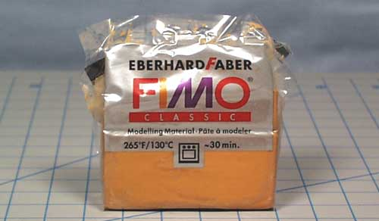
FIMO
FIMO is normally of much more limited use in conversions, and is not often used in figure sculpting. The notable exception is Rackham, which uses FIMO in sculpting their beautiful Confrontation figures. It is a polymer clay and must be baked to cure.

Modelling Material and Tool Suppliers
I always recommend supporting local shops when possible, but many of these items are pretty esoteric for most small shops, so I have provided this list of possible online sources.
Fortress Figures
Fortress Figures sells Green Stuff, White Stuff, and Brown Stuff. This is where I purchase most of my Green Stuff. If you want the direct link to there selection of Epoxy Putty in their on-line store, it is HERE.
Jeff Valent Studios
Jeff Valent is a fairly well known and respected dealer in the figure sculpting industry. Here you can buy Green Stuff, Brown Stuff, and even pre-made figure armatures for sculpting your own figures.
Brookhurst Hobbies
A major hobby and game store in southern California. You can buy Green Stuff as well as an incredible assortment of game and hobby supplies.
Micro-Mark
This is a source of an absolutely staggering array of sculpting tools and just hobby tools in general. You can also buy Milliput here.
eBay
Believe it or not, eBay is a great source of affordable sculpting tools. Just do a search for "sculpting tools" to see what is currently being offered.

Is Green Stuff Poisonous?
Be aware that there is a common rumor as to the toxicity or cancer potential of Green Stuff. Here are Sandra Garrity's comments on the subject as posted to the 1listsculpting mailing list (Sandra is one of the most respected figure sculptors in the world, and has worked for Ral Partha, Reaper, and many other companies):
"The Kneadatite Blue/Yellow (green stuff) is NOT "carcinogenic". That was a rumor started by a competitor back in 1992-3. I have the MSDS on it and anyone can also get it from PSI to see for yourselves what is in the putty.
"After Loctite replaced the PSI formula in 1993, I did work for a year as a consultant to the Loctite Corporation. They had replaced the PSI formula (our "green stuff") with the competitor's product. (I found out later that it was because the competitor priced their product lower) Loctite paid me to work with the competitor to try to bring their product closer to the PSI product---To say that the competitor was totally unsuccessful would be a huge understatement! I finally told the Loctite people not to waste any more money, that the competitor did not have the ability to match the former product.
"I did not know at that time that PSI had been the manufactuer of our "Green Stuff". Loctite Corporation had given me the story that they'd stopped using the original formula because it caused cancer(A LIE!) and that it was made overseas(ALSO A LIE!)
"Later, after I'd given up trying to get Loctite's other manufacturer to match the "green", I contacted PSI to order their Blue/white putty and found out that PSI--Polymeric Systems Inc., was the manufacturer of the "Green". I told them what I'd been told by Loctite and the other manufacturer about the "Green Stuff" causing cancer. They sent me the MSDS on the "green stuff" and it came to light that the competitor and Loctite were spreading a totally false story about the PSI product causing cancer.
"*A note to all*--do not blindly believe rumors! --check it out before you believe what you read or hear. The truth is out there! Look for it!"
Sandra L. Garrity

Advanced Sculpting
This introduction to Green Stuff was written primarily for those wishing to sculpt conversions onto already existing figures. If you are looking to sculpt an entire figure from scratch, I recommend joining the Yahoo! Groups 1listsculpting mailing list. There is a wealth of information stored in their files section, and the list is populated by a number of professional industry sculptors that have shown an overwhelming willingness to help a novice out (but read through the files section first).
So Get to Work!
If you have any further questions, please ask me, and I'll likely even include the answers in this tutorial! Have fun and good luck!

