Conversion Tutorial: Modeling Tools
Submitted by: Cento
Comment: The following is an article a good friend of ours has written. It's a companion article to our Green Stuff Article also written by Cento. For more painting tips and excellent paint jobs, take a look at Cento Industries.

BASIC TOOLS
Hobby Knife
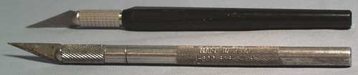
One of the most important tools to have for any modelling project. A hobby knife can be used for a wide array of applications, including shaving off small bits of metal, cleaning flash, cutting plastic figures, and even as a sculpting tool. There are a variety of styles of hobby knives, but I prefer the Xacto style knives. The standard is the handle that uses #11 standard replacement blades. Xacto-style handles can also hold a wide selection of specialty blades, including chisel-tips. I also find it useful to have multiple Xacto knives around - one with a sharp fresh blade, one with a well-dulled blade, and one with whatever specialty blade I am using most often (normally the chisel tip). This way, I do not have to constantly change blades for different tasks.
Average Cost: $1-3 / $1 for five replacement blades

Files
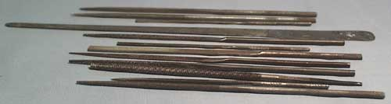
Files are used to smooth surfaces and remove flash. A good selection of files is very useful. Files come in a wide variety of shapes and sizes. Most files suitable for figure work will be thin, fine-grade files (normally referred to as "needle files"), but it is good to keep a couple of coarser, medium-grade files around for removing and smoothing larger amounts of material. My primary files consist of 3 flat files (medium, small, and tiny), 1 round, and 1 half-round. Many hobby companies sell sets of needle files that offer a good selection.
Average Cost: $1-3 each / $4-12 set

Clippers
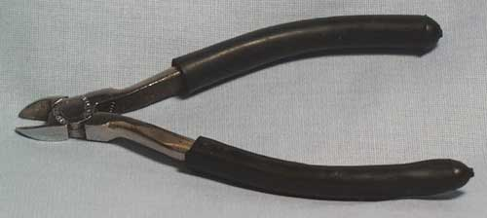
Clippers are important for removing small figure bits from the sprue without damage. Twisting parts off or cutting them loose with a hobby knife puts extra pressure on the bits, possibly resulting in damage. Clippers remove the bits without the extra stress. For the kind of work, the best clippers are "flush-cut clippers". These get a much smoother cut close to the part you want. Failing that, any small pair of clippers should do.
You can also use clippers to cut away parts of figures for conversions, but since the cut is messy and wasteful of material on the figure, a saw is normally the better choice. Do not use hobby clippers for any kind of heavy duty cutting (large areas of metal or any stiff wire), since they are not designed for that kind of use and will bend. Instead use a normal hardware pair of clippers for that kind of rough work.
Average Cost: $2-12 (depending on quality)

INTERMEDIATE TOOLS
Pin Vice
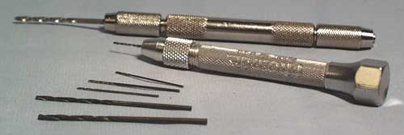
This is essentially a small handheld and hand-powered drill. Make sure you get one that has a free spinning head that rests against your palm, otherwise you'll be developing callouses quickly. I have one from Squadron that I am extremely happy with. You can also buy a whole selection of different drill bits for it. Ask in any well stocked model shop for one. This is a must for any serious conversion artist. Whenever you are combing pieces of any metal figure, drill a hole into both parts so that the holes will line up, then cut a small length of brass wire (available at most good hobby stores for about 30 cents or so) so that it fits inside both halves. Glue the join. This will give the joined area a lot more strength. The drill bits are quite fragile - when you first start using a Pin Vice, do not be surprised if you break bits often. Once you get used to it, however, the bits can actually last for a long time. I think I have broken one bit in the last five years.
Average Cost: $4-8 / $1-2 for replacement drill bits

Jeweler's Saw
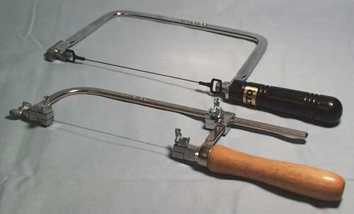
This is another must for any serious figure modeller. A Jeweler's Saw holds a super-fine saw blade under tension. These saws can quickly cut through pewter and do not damage or lose much of the metal around the cut. Because the blades are so thin and held under so much tension, it is quite easy to break these blades, so make sure you keep replacements on hand. Replacement blades are normally sold in groups, since breaking is so frequent.
Average Cost: $12-20 / $3-4 for replacement blades

Brass Rod and Wire
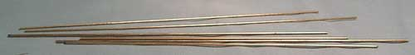
Brass rod and wire are ideal for pinning figure joins. It is flexible, comes in a variety of thicknesses, and is cheap from any hobby shop that carries brass stock. You can also get brass tubing and both the wire and the tubing are good for adding details like wires, antennae, and pipes to figures that you are converting.
Average Cost: 30-50 cents per foot

Pliers
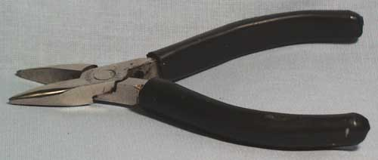
Pliers are useful for getting a strong grip or bending thick pieces of metal. I recommend pliers that come to a point (like needle-nose pliers). Most pliers have heavily textured tips that will easily damage your figure, but you can find some that are smooth (like in the illustration above). In either case, if you are using them on a part of the figure that will be visible, you'll want to pad the tips so that they don't bite into the figure. The easiest way to do this is to wrap tape around the tips. I also often use left over pieces of foam from figure blisters for this purpose.
Average Cost: $1-8 (depending on quality)

Tweezers
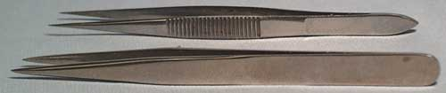
When working with really tiny bits, tweezers are indispensable. Normal tweezers are often to big at the tip for true detail work, so I recommend using a pair that come to a really fine tip, like those shown above.
Average Cost: $1-6 (depending on quality)

Self-Healing Cutting Mat
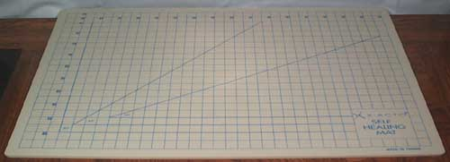
While not a must, a self-healing cutting mat provides a convenient surface for all your hobby knife and saw work without risk of damaging the table or desk underneath. They are sold in a variety of sizes. The ones manufactured by Pro-edge are the best value, and the ones sold by Games Workshop are extremely overpriced.
Average Cost: $16-24

ADVANCED TOOLS
Green Stuff
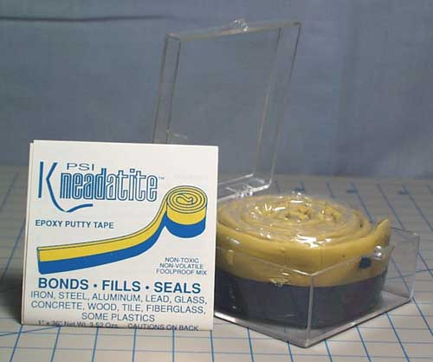
To take figure conversions to your fullest potential, you're eventually going to need to start adding new custom-sculpted details or, at the very least, fill in gaps in a way that matches the rest of the figure. When this happens, you'll want to try using Green Stuff or some other epoxy putty. To find out more about Green Stuff, please refer to my Green Stuff Guide.
Average Cost: $12-14 per 36-inch roll

Sculpting Tools
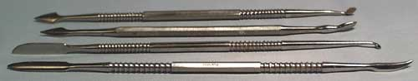
These are the standard sculpting tools when working with modelling compounds, like Green Stuff. The feature a wide array blade, spatula, and burnisher tips for carving details and textures. They can most often be purchased as sets from companies like Squadron. Sets of tools are also commonly found on eBay at good prices.
Average Cost: $12-24 per set

Dental Probes
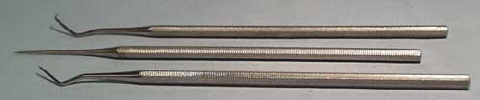
Dental Probes are more sculpting tools originally intended for dental use. Probes come to a needle point and are often bent at odd angles. They are perfect for getting into hard to reach spots. Again, they can most often be purchased as sets from companies like Squadron.
Average Cost: $10-20 per set

Burnishers
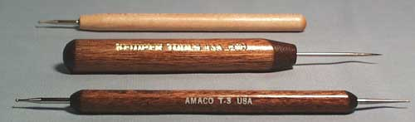
Burnishers are tools with a round metal tip. I have found them very useful for pushing details into Green Stuff, and they are now one of my primary sculpting tools. I purchased all of the ones above at an arts and crafts store (like Michael's).
Average Cost: $3-5 each

Micro-Rasps
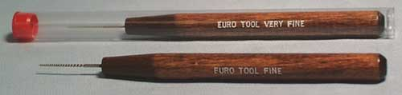
These micro-rasps are tiny, needle-thin spiral cut rasps. They are great for scraping out and widening tiny holes in figures. Most stores don't seem to carry them, but the are easily available from Micro-Mark (and that is where I purchased mine).
Average Cost: $6-8 each

Hobby Pipe Cutter
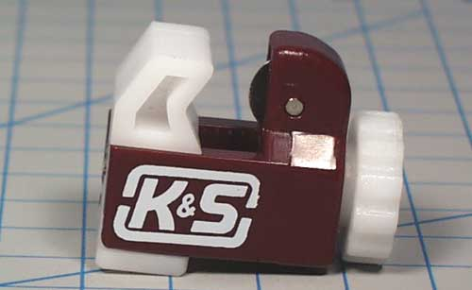
This is really the best way of making an even cut with plastic or brass tubing. Simply lay the tubing in the groove of the lower white piece, and tighten the clamp until there is a little pressure on the tube. Rotate the tube so that the metal wheel scores a groove around the surface. When the tubing spins freely, tighten down the clamp and repeat the process until you cut through the tube. It is incredibly effective. The cut gives a very slight inward curve to the cut end (almost unnoticeable to the eye), so if you want the tubes to slide inside each other (telescope), then you will need to gently file out the inside of the cut. Otherwise, it is already nicely finished for a smooth end-piece. I purchased mine from the same hobby store that I buy all of my brass tubing from.
Average Cost: $4-6

