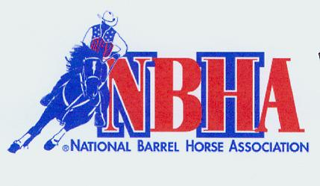

OH~05

NBHA approved for OH District # 00,04,05,06,08

Show to start promptly @ 1:00 PM

Exhibitions Barrels starting 10:00AM ($4/run Exhibition) Finishing up approximately 12:45 PM
Entry Fee Added $ PAYBACK

1. Small fry Barrels (AGES 10) $ 2 100%
2. Warm-Up 4D Barrels $ 20 $525 70 %
*3. Youth NBHA 3D Barrels ~ 18 & under $ 18 $400 70%
(Youth is full second split)
*4. Sr. NBHA 3D Barrels ~ 50 & over (full second splits) $ 10 $ 75 70 %
*5. Open NBHA 3D Barrels $ 25 $1000 70 %
$3.00 Grounds fee per horse.
NBHA RULES WILL APPLY TO THE NBHA CLASSES. Violation of dress code results in $15 fine with points and payback withheld until paid
$3.00 OF EACH ENTRY IN THE 3 NBHA APPROVED CLASSES WILL BE PAID TO NBHA FOR DISTRICT & STATE AWARDS.
CLASS #5 MAY BE CALCUTTA, DEPENDING ON THE NUMBER OF HORSES
~~~~~Entries for class will close before the first horse runs~~~~~
$10.00 NON-MEMBER fee will apply to the three NBHA classes if proof of membership to NBHA isn’t provided. You must present membership card to entry booth.
PRIZE MONEY NOT PICKED UP WITHIN 14 DAYS BECOMES PROPERTY OF SHOW COMMITTEE CONTESTANT’S RESPONBILITY
HILLTOP ARENA, NBHA ASSUMES NO RESPONSIBILITY FOR ANY LOSS OR INJURY TO HORSE, RIDER, EQUIPMENT, OR SPECTATORS. YOU RIDE AT YOUR OWN RISK.
ALL DOGS MUST BE ON LEASH

FOR INFORMATION CALL; Hope Stiteler 740-294-3033
~~~~WE WOULD LIKE TO THANK ALL OUR SPONSORS FOR MAKING THESE SHOWS POSSIBLE~~~~
Directions: 77N to Byesville exit CR 35 (from North) turn right (from South) turn left go 0.16 of a mile turn right on Vocational Road, then turn right on Ideal Road, go to top of the hill turn left into arena.
~~~You must present membership cards to entry booth~~~

