ATR 72-212 Dimensions:
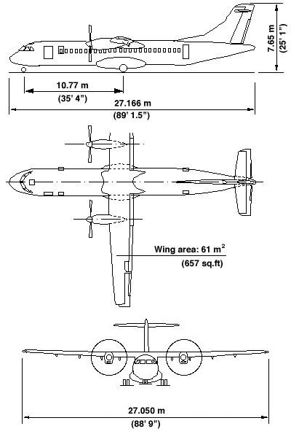
Figure 1: Aircraft Dimensions
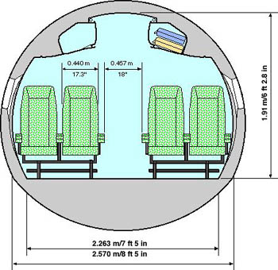
Figure 2: Cabin Cross Section

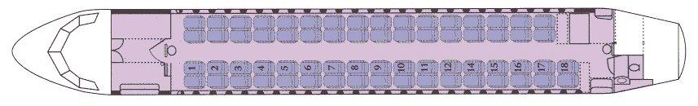
Figure 3: ASA Cabin Layout

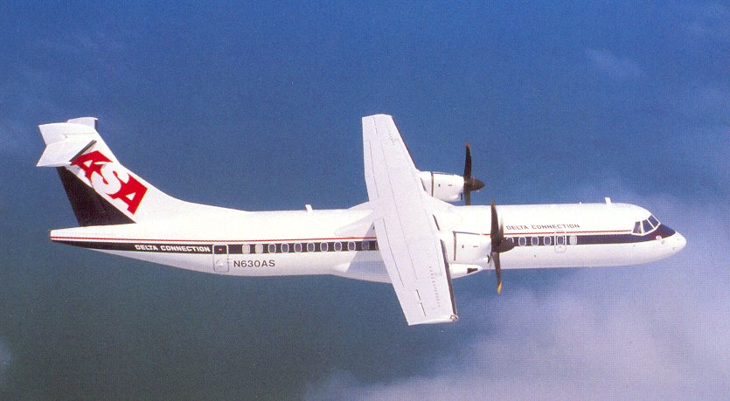
Figure 4: One of ASA’s ATR-72-212’s

ATR 72-212 Systems Description:

Differences from the ATR 42-300 are in italics

Manufacturer: Aerospatiale & Alenia
Model: ATR 72-212
Crew: 4 (2 pilots and 2 flight attendents)
Passengers: 66 + 1 in the jump seat

Construction: The overall structure is mostly aircraft aluminum. Several composites such as Kevlar, Nomex, and Kevlar-carbon/nomex sandwich have been incorporated into the construction for a stronger and lighter aircraft. Composite parts include: wing-to-fuselage fairing, wing leading and trailing edges, engine nacelles, elevators, rudder, and the tail cone.

Doors: Cargo door is on the front left side, and the Passenger door is in left side towards the rear. There is one type I emergency door opposite the passenger door, and two type III emergency exits at the front of the passenger cabin. The cockpit also has an emergency escape hatch in the roof. The passenger door is 68 inches tall by 25 inches wide. The cargo door is electric and the opening is 51 inches wide and 62 inches tall.

Landing lights: There are two landing lights on the nose gear and two in the main landing gear fairings.

Tail Bumper: The ATR 72 is equipped with a small tail bumper to protect the tail in case of over-rotation on takeoff or landing. If the red indicator is showing, a tail strike has occurred and maintenance is required.

Water and Waste: The ATR 72 has one lavatory in the rear of the aircraft; it has both a toilet and a sink. The water tank holds 4 gallons.

Centralized Crew Alerting System: Each aircraft system is equipped with sensors which in case of system failure trigger a local warning and a central alert through CCAS. It is a typical systems monitor, with a panel and Master Warning and Caution lights. Cockpit is a “lights out is good” cockpit light colors mean things: Red = Warning, Amber = Caution, White = setting other than normal, Green = backup or alternate operating, Blue = temp system operating. Aural warnings: most are a repetitive chime, but stall = cricket, overspeed = clacker, Autopilot disconnect = calvary charge, Trim in motion = whooler, altitude alert = c chord, calls = doorbell.

Multifunction Computer (MFC): MFC sometimes stands for something else. The multifunction computer recieves signals from various aircraft systems and performs various logic computations. It monitors, controls and authorizes operations of certain systems. The MFC also helps manage system failures and commands the triggering of associated warnings on the CCAS.

Air System: Consists of two packs, one in each main landing gear fairing. Packs handle cabin air conditioning, cabin pressurization, and avionics cooling. A ground connection is provided to hook up a cart heater or air conditioner. The system has the two packs for sources and two outflow valves in the tail and one outflow valve for avionics cooling.

Autopilot: The ATR 72-212 is equipped with a three-axis digital auto flight control system and a yaw damper. The autopilot is an SPZ-6000 built by Honeywell. The system is made up of four parts: one computer, one control panel, one advisory display unit and the three servos. The autopilot has flight director mode and altitude alert also. The autopilot in the ATR 72-212 does not include auto throttles.

Electrical: The ATR 72-212 has five sources of DC power:
-Two 28 volt DC Generators/Starters, driven from the accessory gearbox; output is 12 Kilowatts each
-Two 24 volt Nicad batteries, 1 for normal operations and one for emergency
-DC Ground power plug in on the right side of the nose
The ATR 72-212 has five sources of AC power:
-Two constant-frequency static inverters that take power from the DC generators and change it to 115 Volts AC 400 Hz and 26 volts AC
-Two 115 volt 3-phase AC wild frequency generators driven by the propeller reduction gearbox
-115 volt AC wild frequency ground power plug in on the right side of the nose

Emergency Equipment: At each crewmember station in the ATR 72-212
-Life Jacket
-Quick donning oxygen mask
-Smoke goggles
-Flashlight
Additional crewmember safety equipment:
-One fire extinguisher and a crash axe on the bottom of the electrical rack
-One pair of asbestos fire gloves behind the captain’s seat
-One first aid kit in the galley
-One crash axe by the service door
-Two portable fire extinguishers in the cabin
-Roof hatch and escape rope
Each passenger seat has a life vest under it

Oxygen: Emergency oxygen is available through a central system to the crew and at least 10 percent of the passengers in case of depressurization. Quick connect outlets for the passenger oxygen are located throughout the cabin in the ceiling. Masks for passengers, (there are eight) are located in the galley and the flight attendant distributes them. There is 30 minutes of passenger oxygen available; passenger oxygen can be shut off by the passenger supply valve. Crew oxygen supply lasts for 120 minutes. There are two additional 15-minute portable supplies that the flight attendants use to distribute the masks and move about the cabin.

Fire Detection and Extinguishing System: There are three optical smoke detectors located throughout the aircraft, one in the forward cargo bay, one in the aft cargo bay, and one in the lavatory. There are three portable fire extinguishers on board, one on the bottom of the electrical rack and two in the cabin. There is also an automatic fire extinguisher in the lavatory waste can. There are two fire loops in each engine nacelle, A and B. The fire loops run parallel to each other. There is also a fire extinguishing system in each engine nacelle with two nozzles. The system has two bottles, one on each side of the aircraft in the wing to fuselage fairing. The bottles contain Halon or Freon at 600 PSI.

Flight Controls: The aircraft is equipped with the following flight controls:
Roll: Two ailerons with automatic tab, mechanically actuated and controlled
Two steering spoilers inboard of the ailerons, hydraulically actuated and controlled
Spoilers deploy after aileron deflection of 2.5 degrees
Blue Spoiler lights come on whenever they are up/deployed
Pitch: Two elevators with automatic tab, mechanically actuated and controlled
Yaw: One rudder with a spring tab, mechanically actuated and controlled
The ATR 72 is equipped with a pitch and roll disconnect feature, it is disconnected by exerting force on the yoke. Disconnect has to be then reset on the ground.

Flaps: There are four flaps, two inboard and two outboard. The flaps are hydraulic. Settings are 0, 15, and 30 degrees; a 45-degree setting is available for emergencies. After a given flap asymmetry condition the flaps freeze in place automatically.

The aircraft is fitted with a stick shaker/ stick pusher and also a gust lock for the ailerons and elevators.

Fuel System: The ATR 72-212 fuel tanks are a wet wing system. The two large tanks are located in the wings between the wing root and the inboard edge of the aileron. The tanks hold 840 gallons each. Each tank is divided into three compartments:
Main Tank – 762 gallons
Feeder Compartment – 52 gallons, similar to the collector tank in the Dash-8
Surge Tank – 26 gallons
The low fuel indicator triggers the low fuel light when there is 59 gallons left in the tank. The fuel tanks are slightly pressurized by a NACA scoop in the bottom of each wing that also serves as a vent through the surge tank. The feeder compartment is closest to the wing root and serves as a collection point for the fuel. It kept full at all times to assure uninterrupted engine feeding. It is divided from the main tank by one way valves and one jet pump (working from pressure from the high-pressure engine pump) that keep the feeder compartment full. If the jet pump fails, gravity is sufficient. The engine high-pressure pump is fed by a jet pump in the feeder compartment or and auxiliary electrical pump. (Aux. pumps needed for starting) Two pipes run between the two tanks through the wing box. These pipes are used for fuel transfer and engine cross feed. The surge tank is located in outer portion of each tank. It is for thermal expansion and in case of overfilling of the tanks. The surge tank drains into the main tank by gravity through one way valves. The fuel tanks can be fueled in two ways: through the ATR 72-212 single-point refueling system or over-wing. The single point receptacle on the ATR 72-212 is on the right hand main landing gear fairing. The refueling control panel is in the right hand main landing gear fairing. Fuel level is indicated to the cockpit by six electro-probes in each tank. There are also two drop-down magna sticks in each tank for determining fuel level on the ground.

Hydraulic System: The hydraulic system on the ATR 72-212 is divided into two systems. Both systems share a common reservoir that is divided into two compartments located on the left-hand side in the main landing gear fairing. The two systems are the Green and the Blue systems. Both systems are capable of cross feed and operate around 3000 PSI. Hydraulic systems on each of the two main systems are:

Green System
-Landing Gear
-Normal Braking System

Blue System
-Flaps
-Spoilers
-Nose Wheel Steering
-Propeller brake on the RH engine
-Emergency Brakes

Ice and Rain Protection: The ice and rain protection can be divided into two groups:
Pneumatic (supplied by the LH and RH de-ice bleed air valves):
Pneumatic boots on the wing leading edges
Pneumatic boots on the horizontal stabilizer leading edges
Pneumatic boot on the vertical fin leading edge (some models don’t have)
The engine air intake is heated by bleed air
Electric (AC wild frequency):
Propeller blades leading edge about a third of the way out (1300 W a blade pair)
Windshield heat
Static and Pitot probes
Flight control horns
The ATR 72-212 is also equipped with windshield wipers and an electronic ice detector on the left-hand leading edge of the wing.

Landing Gear: The ATR 72-212 landing gear are hydraulically operated on the green hydraulic system. The nose gear retracts forward and the main landing gear retract inward. The ATR 72-212 has six tires. The main landing gear are trailing link style, are equipped with anti-skid, multi-disc brakes, and have oleo-pneumatic shock absorbers. The nose gear is equipped with nose wheel steering by use of a tiller; it allows steering up to 60 degrees left and right. The landing gear are extended by gravity in case of hydraulic failure aided by an accumulator. The ATR 72-212 also has a hydraulic parking brake.

Powerplants: (2) Pratt and Whitney 127 turboprop engines rated at 2475 shaft horsepower with automatic power increase of an engine to 2750 shaft horsepower (reserve takeoff rating) These turboprop engines are twin spool triple shaft units. A free turban drives the propeller. Each engine holds 10 quarts of oil. The oil cooler has its own air intake; it is fitted below the engine intake. The engines are outfitted with several accessories:
Driven by the Accessory Reduction Gearbox (driven by the high pressure shaft)
Starter/DC Generator
High Pressure Fuel Pump
Oil Pump
Installed on the Propeller Reduction Gearbox (driven by the free turban shaft)
AC wild frequency generator
Propeller control unit
Feathering pump and overspeed governor
Auxiliary feathering pump (driven electrically)
(The propeller brake is fitted on the RH prop reduction gearbox)

Propeller: The ATR 72-212 is fitted with two constant speed, full feathering, reversible Hamilton Standard 247 F-1 propellers. They are 13 feet in diameter and turn clockwise (when observer is facing the same way the aircraft is). These propellers turn at 1200 RPM at 100% Np. Propeller pitch angle varies from –19 degrees in full reverse to 78.5 degrees in feather. The right hand engine is fitted with a propeller brake on the propeller reduction gearbox, allowing the engine to run without the propeller turning.

Other Equipment: GPWS (Ground Proximity Warning System) and TCAS (Traffic Collision Avoidance System)

ATR 72-212 Limitations:

Vmo 250 knots
Mmo .55 mach
Va 160 knots
Vra 180 knots (rough air)
Vwo 160 knots
Vle 170 knots
Vlo 160 knots
Vfe at 15 deg. 170 knots
Vfe at 30 deg. 150 knots
Vfe at 45 deg. 130 knots
Max tire speed 165 knots
Vs at MGW 74 knots
Vs1 at MGW 104 knots
Vmca 88 knots .

Max operating ceiling: 25,000 feet
Maximum crosswind component: 45 knots, 38 knots for 30 deg. flaps
Maximum tailwind component: 15 knots
Max cabin pressure differential: +6.35 PSI to -.5 PSI
Maximum ramp weight: 48,567 lbs.
Maximum take-off weight: 48,501 lbs.
Maximum landing weight: 47,068 lbs.
Maximum Zero fuel weight: 43,430 lbs.
Basic operating weight: 28,953 lbs.
Maximum payload: 14,477 lbs.
Cargo compartment capacity: 3739 lbs.
Minimum Flight Crew: 2 pilots

