Characteristics of
Functions
Polynomial

An important characteristic of Polynomial Functions is ______ behavior. This describes the behavior of the function, f(x), as x takes on values approaching positive & negative infinity. Given the functions:

f(x) = 5x³ –5x² – x – 1 f(x) =-5x³ –5x² –x – 1

As x→ , f(x)→ As x→ f(x)→
As x→ , f(x)→ As x→, f(x)→

Since the degree is odd the functions are called _____ ____________. f(x) has opposite ____ _____________.
Even functions have even degrees.

f(x) = x⁴ – 2x² f(x) = -x⁴ – 2x²

As x→ , f(x)→ As x→- , f(x)→
As x→ , f(x)→ As x→ , f(x)→

Since the degree is even f(x) has the _____ end behaviors. And the a leading ___________ ____________ makes both end behaviors change direction.

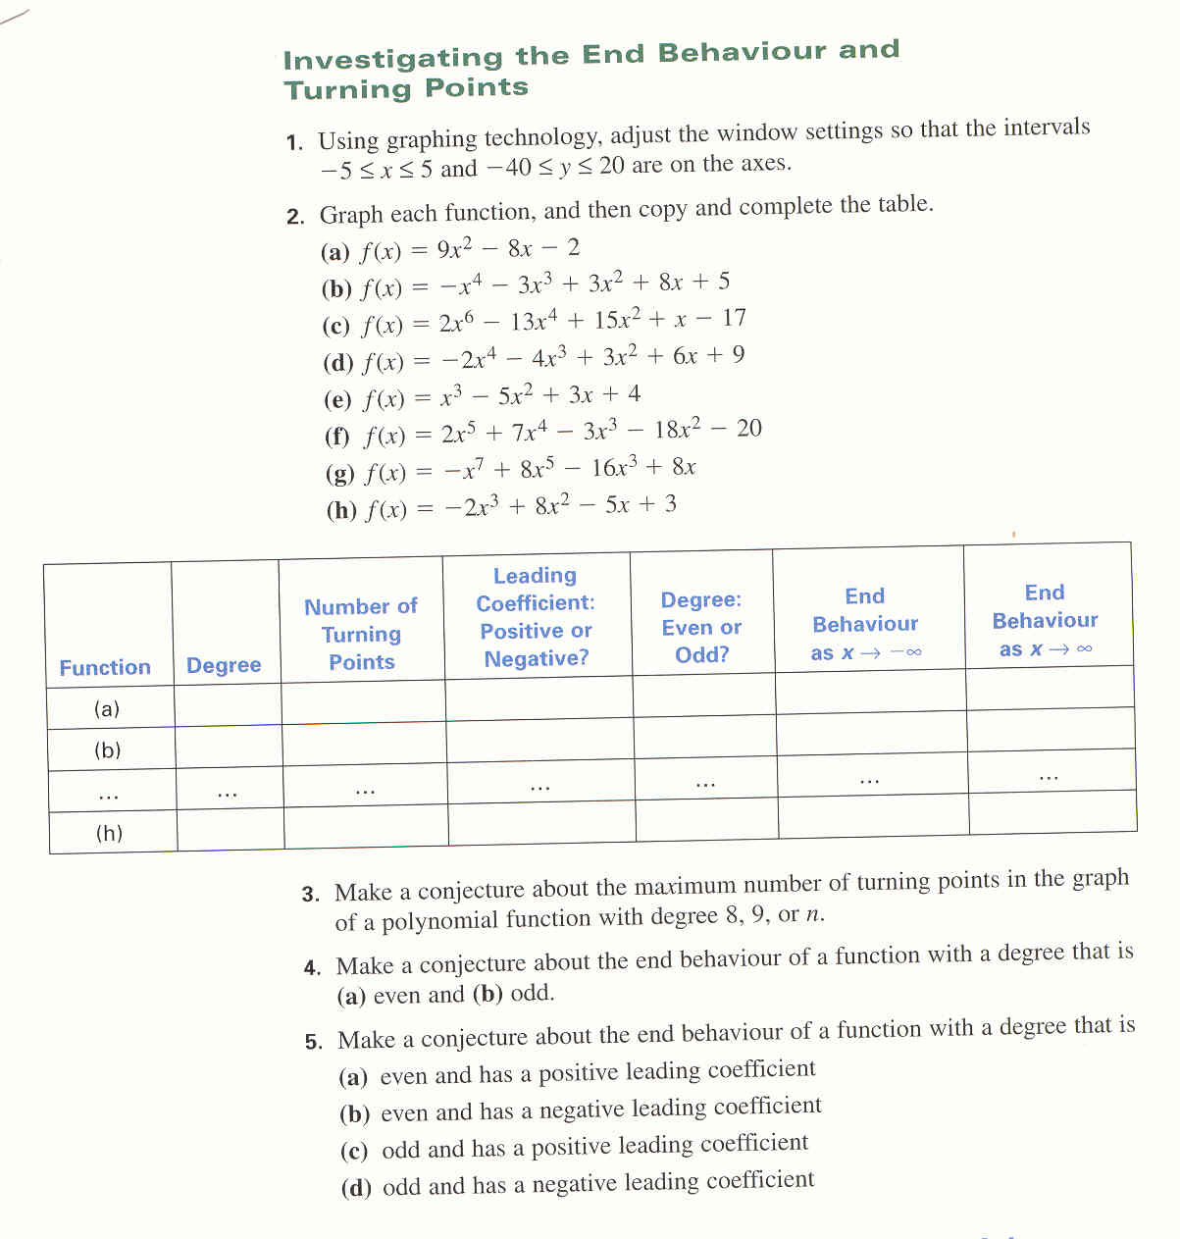

Finite Difference Tables

Given that the x values go up by a constant amount, then if the 1st differences in the y values are the same, the function is linear. If the 2nd differences are the same, then the function is quadratic. If the 3rd differences are the same then the function is cubic.

Determine what polynomial Function represents this relationship.

x | 0 | 1 | 2 | 3 | 4 | 5 | 6
y | 0 | 1 | 16 | 81 | 256 | 625 | 1296

