MAX
MIN
Problems

A newly built factory needs a power a power line run from the power plant across the river. The distance to the factory shore from the power plant is 100 m, and the distance from the factory shore to the factory is 2 km. The cost of laying the power line underwater is twice the cost than laying it over land. How much cable should be laid underwater and above land to minimize the cost of the cable?

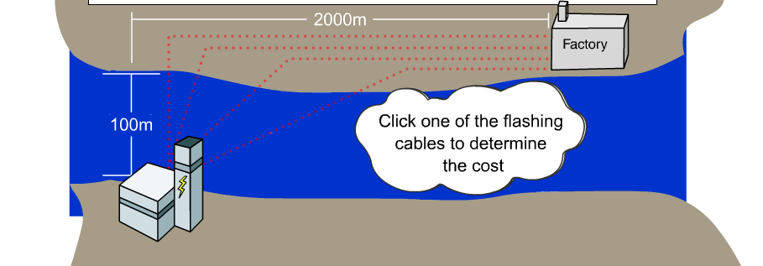

There are two equations in this example.
1. ___________: ___________
2. Distance: D___ = d____ + d____
Cost: C = ( minimized)

You’ll need the __________ _________ to find the distance in the water.
Let x rep. the horizontal distance from the shore of the factory, to the power line.

1) d_{land} =
1) d_{water} =

d_{water} =

2) C = 2d_{water} + d_{land}

C(x) =

The rest is Algebra and Calculus.
Two hikers, Mauro and Bob, head out from different locations to do some hiking. Mauro is 10 km west of an intersection and hikes east at 6 km/h. At the same time, Bob leaves the intersection hiking north at 8 km/h. How much time elapses before the distance between them is a minimum? What is the minimum distance?
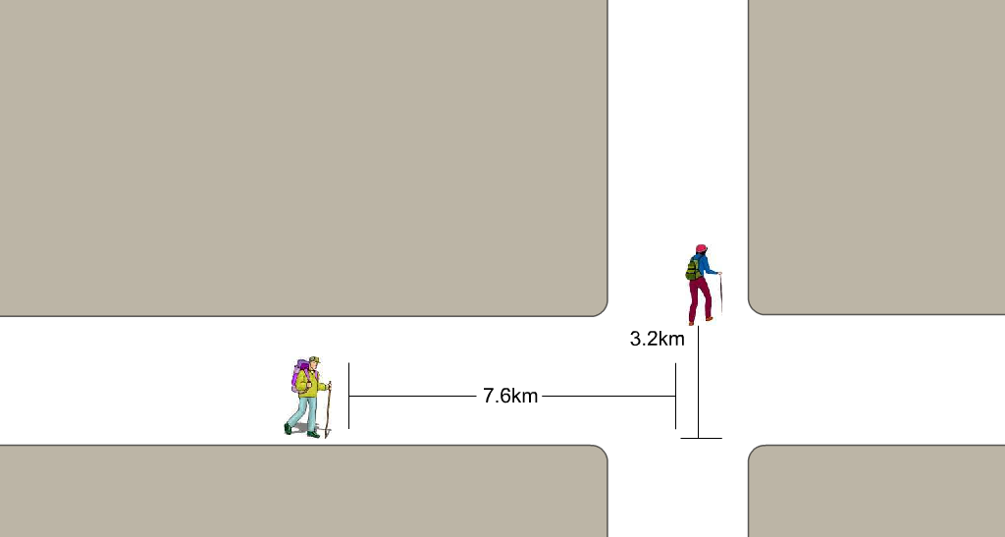

There are two equations in this example.
1. _____________: _____________
2. Distance: D = vt
D² = _______+ _________( minimized)

You’ll need the Distance formula to find d_{Mauro} and d_{Bob .}
Let t rep. the time that both hikers left at.
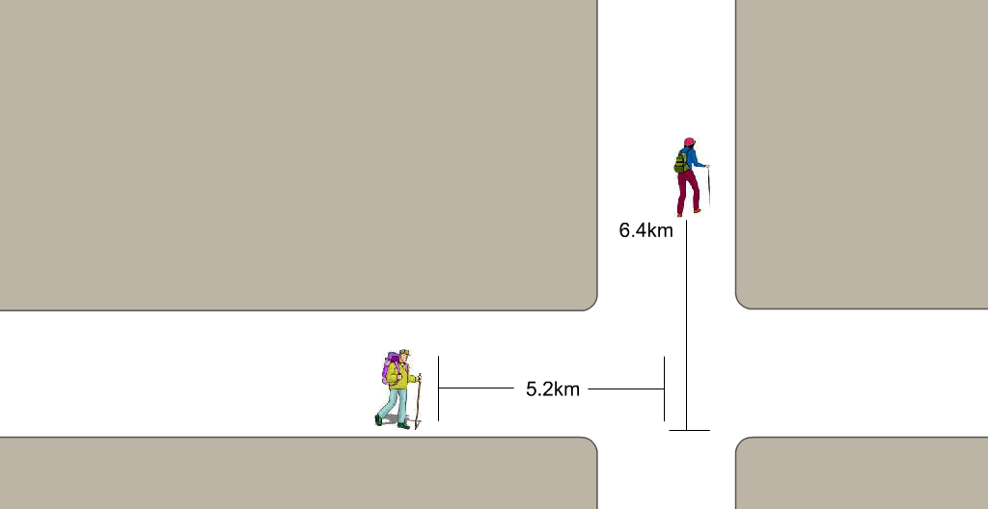

D

1) d_{Mauro} = ___
1) d_{Bob} = ___

2) D² = ( )² + ( )²

D =

D =

The rest is Algebra and Calculus.

