Given the parabola y = x² – 3x + 5, what is the rate of change at x = 3.

y = x² – 3x + 5

= (x² – 3x + 5)
d
y
d
X
d
d
X
d
y
d
X

= _________
d
y
d
X

= __
d
y
d
X

This means that the rate of change of y on the parabola with respect to x is ___ at x = __.
But, what if x is moving at a speed of 4 units/s from left to right. What would the speed of y be when x = 3. Would y be going up or down?

d
y
d
t

x
d
d
t

As you can see, y and x are both ______ to time, so we have to ___________ both sides of our equation im_______ with respect to ____.

y = x² – 3x + 5

= (x² – 3x + 5)
d
y
d
t
d
d
t

d
y
d
t

x
d
d
t

y = x² – 3x + 5

= (x² – 3x + 5)
d
y
d
t
d
d
t

eg. A spherical balloon has a hole that is leaking in such a way that its volume is decreasing at a rate of 1 cm³ /s. At what rate is the radius decreasing when the radius is 5 cm?
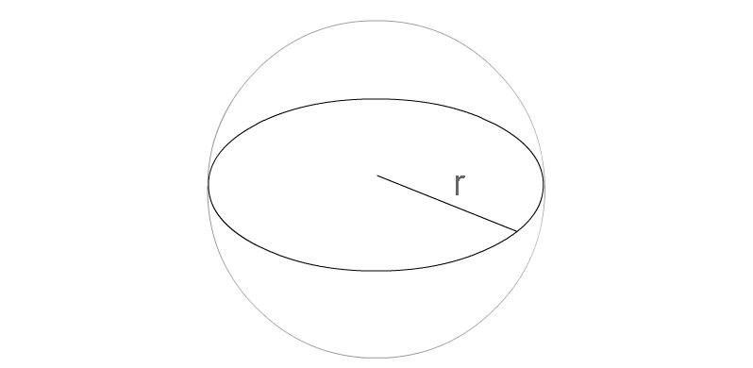

equation: V =$\frac{4}{3}$πr³
d
V
d
t
given rate: = -1 cm³/min

= ($\frac{4}{3}$πr³)
d
V
d
t
d
V
d
t
=

Lets do the rest on the board.
eg. A coffee filter has the shape of a circular cone with height 18 cm and a diameter 12 cm at the top. Coffee is being filtered through the cone at a rate of 2 cm³/s. Find the rate at which the height of the coffee is changing when it is 6 cm high.

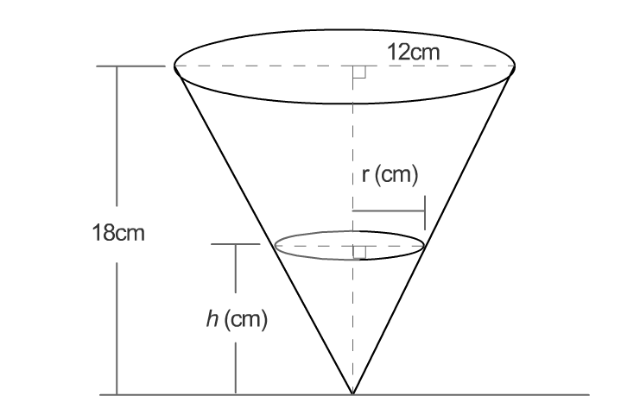
Sketch:

equation: V =$\frac{1}{3}$πr² h
relation: V & h will be the related rates.
$∴$, we need to find r in terms of h.

To express r in terms of h we need to
examine the triangle that makes up the cone
and compare it to the triangle that makes up
the coffee. Since they are proportional then:

Coffee Triangle Cone Triangle

6 cm

r cm 18 cm

h cm

or

equation: V =

Let’s do the rest on the board.

