eg. A spotlight on the ground shines on a wall 20 m away. A man 2 m tall walks from the wall toward the spotlight at a speed of 3 m/s. How fast is his shadow on the wall increasing when he is 6 m from the spotlight?

Sketch:
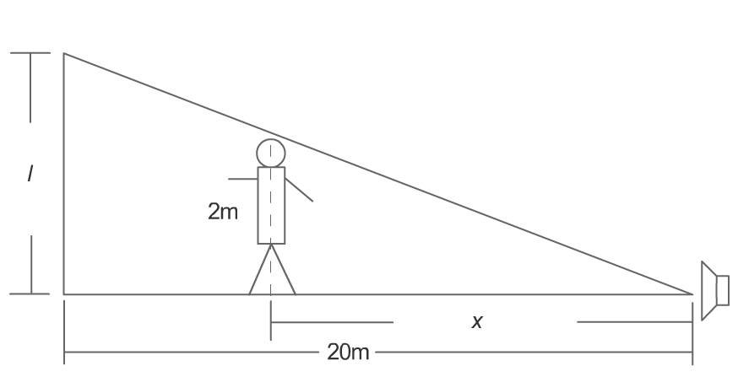

Relate y to x: similar triangles

equation:

given rate: $\frac{\text{dx}}{\text{dt}}\text{ = }3\text{ m /s}$
find: $\frac{\text{dy}}{\text{dt}}$
eg. Ship A is sailing due south at 16 kmt/h and ship B, 32 km south of A, is sailing due east at 12 km/h.
- At what rate are they approaching each other at the end of one hour?
b) When do they stop approaching each other, and how far apart are they at that time?
Sketch:
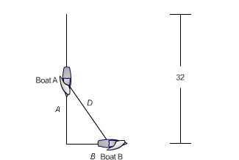

equation: Pythagorean Theorem

D² = A² + B²

given: $\frac{\text{dA}}{\text{dt}}\text{ = }−\text{16}\text{ km /h \& }\frac{\text{dB}}{\text{dt}}\text{ = }1\text{2 km /h}$
find: $\frac{\text{dD}}{\text{dt}}$when t = 1 hour

