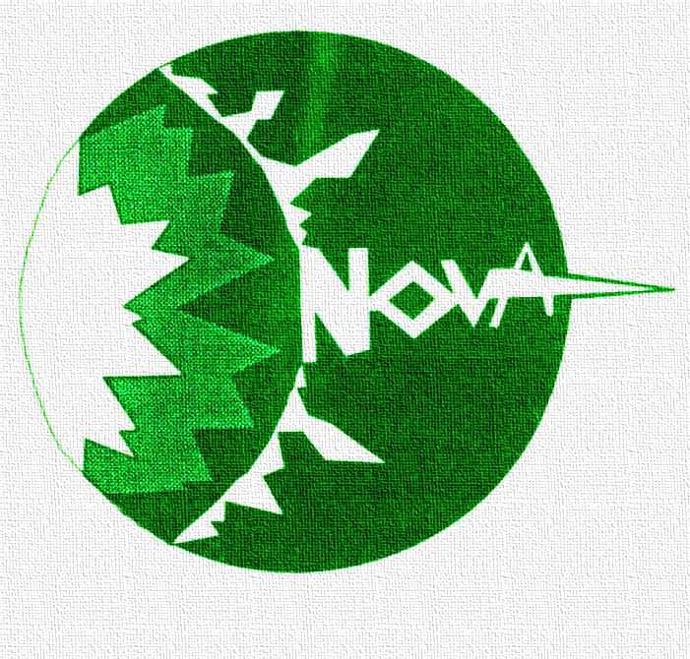

NOVA
BUSINESS AND PROFESSIONAL WOMEN'S ORGANIZATION
LINCOLN, NEBRASKA

INVITATION TO MEMBERSHIP

NOVA/BPW is an organization, which promotes the personal development and career enhancement of women in the workforce.

Women who are active in NOVA have the opportunity to develop their leadership potential through skills, which mature with responsibilities in the local organization and interaction in our community. They also have the opportunity to promote and share job related information through networking.

Dues for twelve (12) calendar months are $85, with $65 of that amount supporting state and national activities. Many employers offer this as an employee benefit.

WE INVITE YOU TO COMPLETE THIS FORM
AND BECOME A MEMBER OF NOVA/BPW

Name________________________________________________________________________________

Title_________________________________________________________________________________

Company Name______________________________________________________________________

Company Address____________________________________________________________________

Company Phone______________________________ Home Phone__________________________

Home Address________________________________________________________________________

Email Address_________________________________Fax_____________________________

I was recruited by (NOVA Member Name)_____________________________________________

I prefer to have my mail sent to my company_______ Birthday (Month/Day) ________
my home___________

Make your check payable to NOVA and send to: Deb DeGarmo
Membership Chair
U.S. Bank
233 S 13th Street
Lincoln, NE 68508

