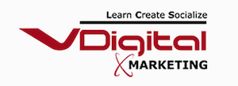
INSTAGRAM PROMOTION PACKAGES
Rs. 28,000/Monthly

Instagram Marketing

- Business Profile Creation
- Optimization Of Business Profile
- Instagram Stories Creation – 4 per week
- Post Creation For Instagram Profile (3 per week)
- Hashtag Research
- Competitors Analysis
- Responding to comment
- Engagement Strategy
- Instagram Analytics & Monitoring
- Monthly Reporting

Instagram Ads

- Instagram Ads Campaign – 3
- Ad Set – 6
- Ads – 10
- Audience Research
- Instagram Ads Campaign Set up
- Instagram Ads Creative Creation & Design
- Instagram Ads Monitoring And Management

Contact Us (+91 9320957717)
Address: 4th floor, BEST complex, behind McDonald's, opposite Railway station, Railway Colony, Andheri West, Mumbai, Maharashtra 400058

