Shenell Ferguson

GRA 410 Process Book

[shenell.ferguson@snhu.edu](mailto:shenell.ferguson@snhu.edu)

Sitmap

Wireframe

Tablet 768px

Mobile 320px

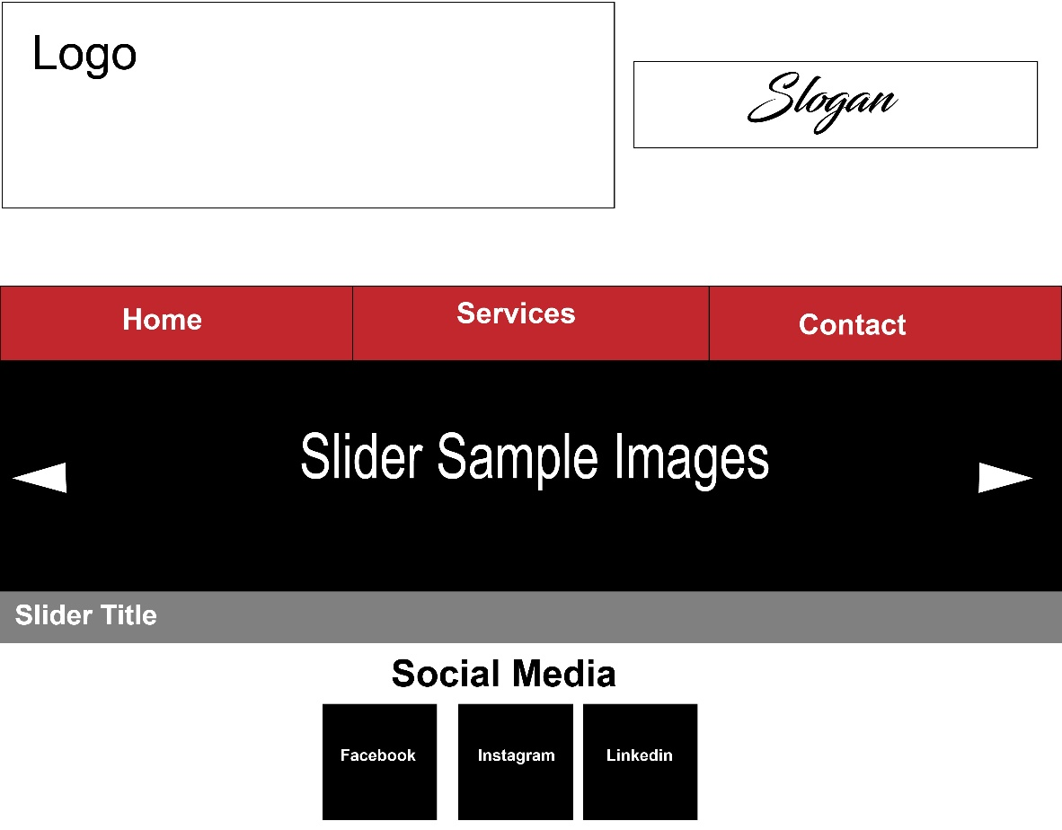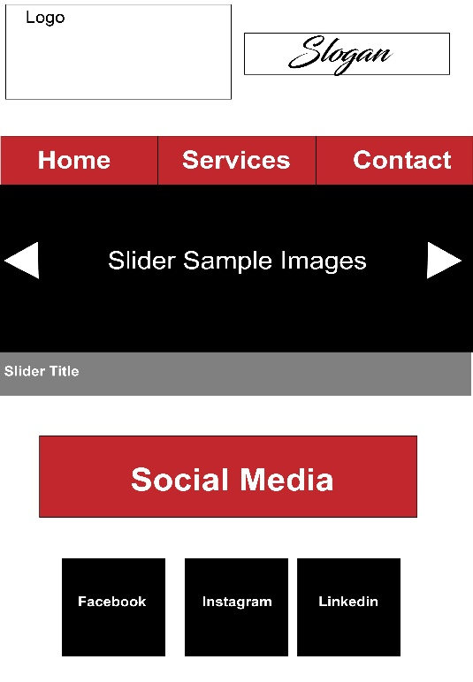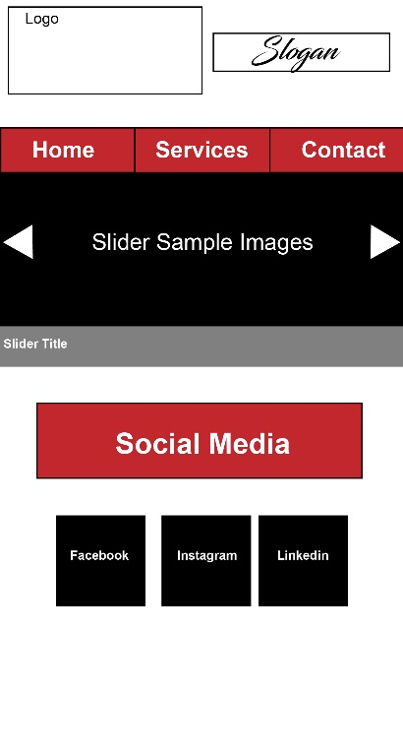

Widescreen 1024px