Shenell Ferguson
GRA 410 Process Book
shenell.ferguson@snhu.edu

Sitmap

Wireframe
Tablet 768px

Mobile 320px

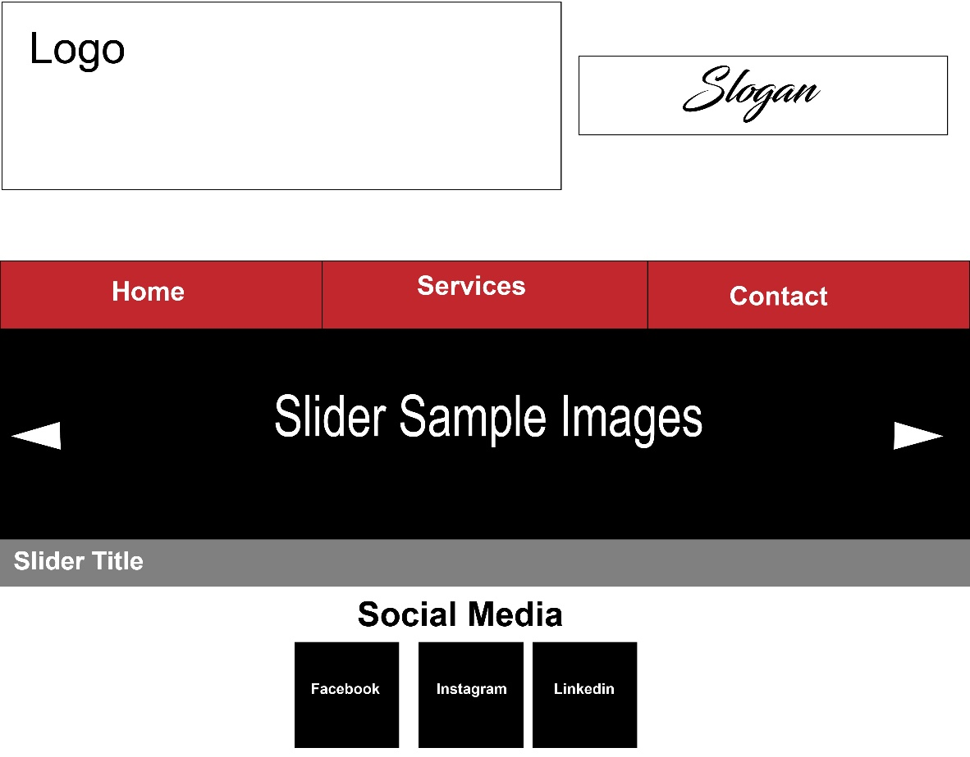
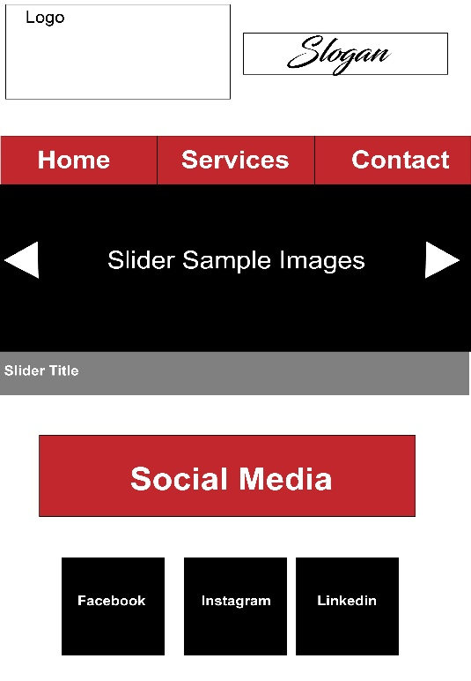
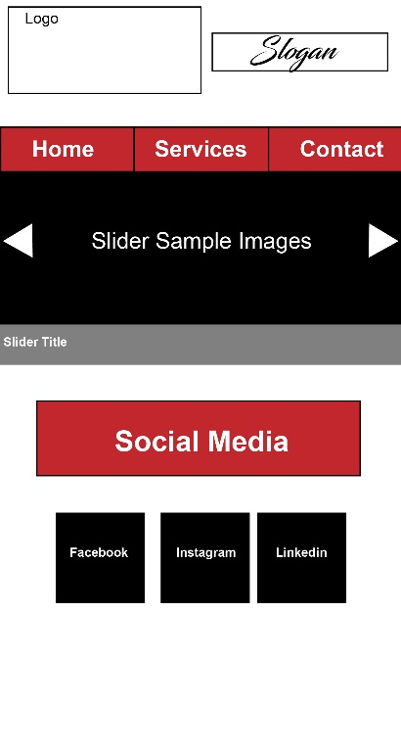
Widescreen 1024px

Short Paper
User Experience

In this short paper I will be discussing user experience along with its principles and concepts. User experience is how a person feels when interfacing with a system. It used to be there was only two thing that was being considered when creating a website. They were what the designer thought looked awesome and what the client wanted. Now you have to take in account not only aesthetics and client needs but is the website user friendly and engaging. Storytelling is a great example of enhancing user experience. Knowing your audience is a key element of audience interaction. Understanding how your audience use the internet is one of the most important principle elements. For example, users prefer quality and credibility. Users are impatient and because of this they don’t read they scan. They also want instant gratification and have a tendency move away from websites that that don’t provide this. If your website can’t provide this it is almost impossible to have a positive user experience. Once you have a clear understanding of your audience, you can then tap into your audience’s emotions. Tapping into your audience’s emotion gives you the ability to draw on elements that are familiar to them. Design patterns is an important element of audience interaction. Once you know your audience you can design a pattern that keeps your audience engaged.
As I sit back and reflect on user experience I realize there is a lot that goes into making sure your website is engaging to your audience. It’s no longer about aesthetics and what the client wants; you know have to take in account design patterns, storytelling, your audience’s emotion, user friendliness and the small window of time you have to get your audience’s attention. Without taking these things in to account you will more than likely not have a successful website.

