Hi Harmoc Members, Dearly Invited Guests and strangers who happened to chance upon this site!!!

If you’re wondering why the font is so small, it is because I believe that large fonts in a paragraph look extremely unsightly and clunky. Therefore, for aesthetic purposes, I have chosen a comfortable size 10. If you feel it is too small, then enlarge it yourself lah duh.

Anyway I think I can safely confirm the booking for chalet on the 9th June, which is next Thursday. Check-in time will be at 2pm, and I will probably be checking in lah… then right… someone must pay because I’m trying to tie up loose ends in the fund so which means I do not wish for it to be touched ie Hong Jun pay first with the money not enough then borrow from me MUAHAHA.

The Chalet

The 2-storey 2-bedroom with living room and kitchen and 2 toilet BUNGALOW which comes with 2 single beds, 1 double bed, a microwave oven, bbq pit and free to use → mahjong set ← is located at the National Service Resort and Country Club
(NSRCC), 10 Changi Coast Walk. This is what it looks like from the top view:

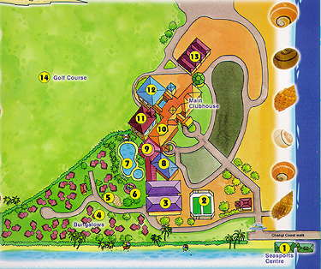

1 Sea Sports Centre 8 Fitness Centre 11 The Resort Garden
2 Tennis Courts 8 Video Games Arcade 11 Chinese Restaurant
3 Bowling Centre 8 Social Room 12 D'Turret Lounge
4 Bungalows 8 Squash Court 12 The Deck-Golfer's Terrace
5 Reflexology Walkway 9 Food Lane 13 Driving Range
6 Playground 10 Billiards Room 14 Golf Course
7 Swimming Pool 10 Darts Corner 10 Fruit Machine Room

The Club is quite easy to find. Just stroll along this river I donno which river but is more like a longkang but anyway, as you can see from the map, large, conspicuous looking sea shells line the banks of this longkang so once you see them, you know you have arrived. If you don’t see them, it might be because some giant hermit crabs might have swiped them away.

Anyway, I booked (more like was forced to accept) bungalow number 2 so just follow the map shown below to the unit. (Woohoo! Maps maps and more maps!) The map below is the enlarged version of the little red square shapes on the bottom left-hand corner of the map on top. So you know where the bungalows are relative to the rest of the club. Good things about bungalow number 2 is that it is near the entrance, so no need to walk so far in (woohoo!) near the playground (woohoo!) near the bowling alley (woohoo!) and near the reception so it’s easy to get bicycles and basically near most of all the facilities lah.

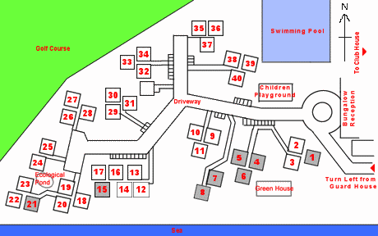

How To Get to NSRCC

It’s very easy to get there. Various methods include a thirty- to sixty-minute cycling trip starting from VJC along East Coast Park all the way to the end, a 4 hour relaxing stroll along the same route, or the method which I believe most will use: MRT.

First, stop at Tanah Merah MRT. Go down the escalator, and proceed to the gantries. Tap your ez-link card on the reader otherwise the two red door things will kiap you in the middle and it will be very embarrassing. As you can see, the map below makes absolutely no sense at all since by simply standing on one point on the side of the road, it is quite impossible to tell which side leads to Bedok or Tampines. So it’s very simple: just get out through EXIT A. If you don’t see a taxi stand anywhere, you’re on the wrong side of the road and probably because you didn’t follow the instructions.

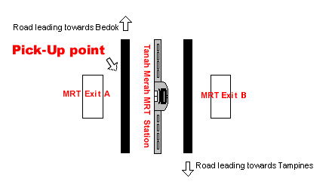

Anyway, if you exited through the correct, erm, exit, then you should see a taxi stand, as well as a NewWater thingy pick up point thingy. Wait at the taxi stand because even though the bus stops at the NewWater pick up point thingy, it’s for alighting only. Boarding will be at the taxi stand, so do not be fooled if the bus stops 10m away from the taxi stand, because if you walk there and try to board it, the stupid uncle will tell you to walk back the 10m to the taxi stand.

The bus is white and has the logo of NSRCC on it.



That was the logo, by the way. I think. If I remember correctly. Aiyah if anybody miss the bus just take taxi lor. At the taxi stand already what. Might as well. Oh yes, of course, unless you really are waiting for a taxi, don’t enter the queue in the taxi stand ok. It’s a real taxi stand, not a disguise for nsrcc pick up point. Taxis will stop there and if you queue up there taxi-drivers will assume you’re waiting to be driven off. Just wait near the stand.

Anyway when you arrive, just follow the signs to reach the chalets.

How to Leave NSRCC (but why? Aren’t you enjoying yourself?)

Leaving the place will also be by bus (or bicycle, whichever way you came in). Again, the kuku driver will pick up and drop passengers off at different locations. Do not wait for the bus where you previously alighted. This time, there is a real bus stop located very near the entrance to the bungalow.

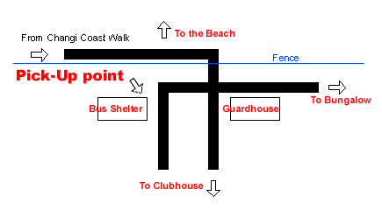
The makers of this map have proven themselves quite forgetful yet again by failing to include a legend for what the symbols mean. The thick black lines are the roads. The bus will enter from Changi Coast Walk, through the fence (??) and proceed to drop passengers off at the Main Clubhouse (see the first map) further down. HOWEVER! The bus stop (or bus shelter) to wait for the bus to bring you out is beside the hole the bus made when it crashed through the fence so wait there. Wait anywhere else, and the driver will be glad to just drive off without you.

Transport Schedule

There is a timetable for when the bus leaves NSRCC or the MRT station.
Transport Schedule
All days
From Tanah Merah MRT Station | From NSRCC
10.00am | 10.15am
10.30am | 11.25am
11.00am | 1.15pm
1.30pm | 3.15pm
2.30pm | 3.45pm
3.30pm | 4.30pm
5.00pm | 5.15pm
6.00pm | 7.15pm
7.30pm | 8.45pm
8.30pm | 9.45pm
 | 10.30pm
The driver will leave quite punctually so try not to be late, especially if you’re coming to the club, or if you’re catching the last bus. If you’re waiting at the MRT station and you missed the bus, then good luck. It’ll be an hour later before the bus comes back and in the meantime, you’ll be bored to death as Tanah Merah is void of any exciting activities nearby.
Anyway, if you’ve read through everything, hurhur! What a waste of your time. Summary of the details for the chalet are below. Basically what’s below is very important.

Details in Summary
Date: 9th June to 10th June
Check-in Time: 9th June, 2pm, but please try not to come before 2.30pm to give time to check in and for staff to do an inventory check.
Check-out Time: Before 11am, or a charge will be levied.
Bungalow unit: Number 2

Miscellaneous

The following items are available for rental/purchase:
- Mattress with Linen / Pillow / Blanket $2.00 per day
- Charcoal (3kg) / 5 Starters / 1 Matchbox $5.00 per set
- 8 Skewers / Wire Mesh (set) $5.00 per day
- 1 Chair $1.00 per day Iron & Board set $1.00 per day

Activities there include:
- 1 Outdoor table tennis table
- A very pok arcade with very pok games but suitable for people who get a sense of nostalgia from playing some of the oldest arcade games in the world.
- A bowling alley that charges an extremely reasonably priced $1.80 per game
- 1 Basketball court
- 2 Tennis courts
- Bicycle Rental
- A Swimming pool
- Lots of grass to play monkey, badminton etc etc.

Note: to use basketball and tennis courts you have to book with the reception.

Pictures and more info from:
http://www.esrcc.com.sg/bungalow/index.html

