

Department of Information & Communications Technology

Project Work 1: Laboratory Sheet

Student name: _______________________ Course/Year: __________ Date: __________

Oscilloscope – Additional Measurement Techniques

Objectives
- Measure rms values of sinusoidal voltages
- Measure superimposed ac and dc voltages
- Display two waveforms simultaneously on a dual channel oscilloscope
- Measure phase displacement with a dual channel oscilloscope
- Measure ac current using a sensing resistor (Optional)
- Measure voltage using differential measurement techniques

Equipment
- Digital multi-meter (DMM)
- Dual channel oscilloscope
- Function generator
- Bread board

Components
Resistors: 82Ω, 11Ω, 150Ω, 1kΩ, 2kΩ, 3.3kΩ, 5.6kΩ, 6.8kΩ, 10kΩ (1/4W, 5%)
Capacitor: 0.01μF 25V

Reference
User’s Manuals of the oscilloscope and the function generator
Part A - Background

Measuring the rms voltage of a sine wave
An oscilloscope may be used to determine the rms value of a sinusoidal voltage since, for a sine wave, V_{rms} = $\frac{1}{\sqrt{2}}$V_{m} and V_{m} can be measured directly from the CRO screen. One of the reasons you might do this is for convenience – if you have a waveform already displayed on the screen, it is not necessary to have a voltmeter for taking measurements. Furthermore, there is a good reason for using a CRO to take measurements. Most meters have a very limited frequency range, they can measure to only a few kHz. On the other hand, even inexpensive oscilloscopes can measure to the tens of MHz, while top of the line units can measure to hundreds of MHz, or even to the GHz range with digital units.

Measuring Current (Optional)
Oscilloscopes can also be used to measure current, although not directly. There are however, two indirect ways in which you can measure current.
- Insert a known resistor (a sensing resistor) into the circuit, measure the voltage across it using an oscilloscope, then use Ohm’s law to compute the current.
- Use a current probe, which is an accessory that has to be bought separately.

Here, we only concentrate on the current sensing resistor. For a purely resistive circuit, v = Ri. Thus, if voltage is sinusoidal, current will be sinusoidal also and vice versa – that is, v and i are in phase. Therefore, if voltage v is
v = V_{m} sin ωt
then
i = I_{m} sin ωt
Current can thus be determined by measuring V_{m} and computing I_{m} from I_{m} = V_{m}/R. If the rms value of current is needed, it may be determined from the equation I_{rms} = $\frac{1}{\sqrt{2}}$I_{m}.

For example, consider Figure 1(a). The load current I_{L} is given by $I_{L}=\frac{E}{R_{L}}$ where E and I_{L} are the rms values of the source voltage and load current respectively. To measure this current using an oscilloscope, add a sensing resistor R_{S} as in Figure 1(b), measure the voltage across it, convert to rms, then compute current as $I_{L^{'}}=\frac{V_{S}}{R_{S}}$. As long as R_{S} << R_{L}, the accuracy will be good.

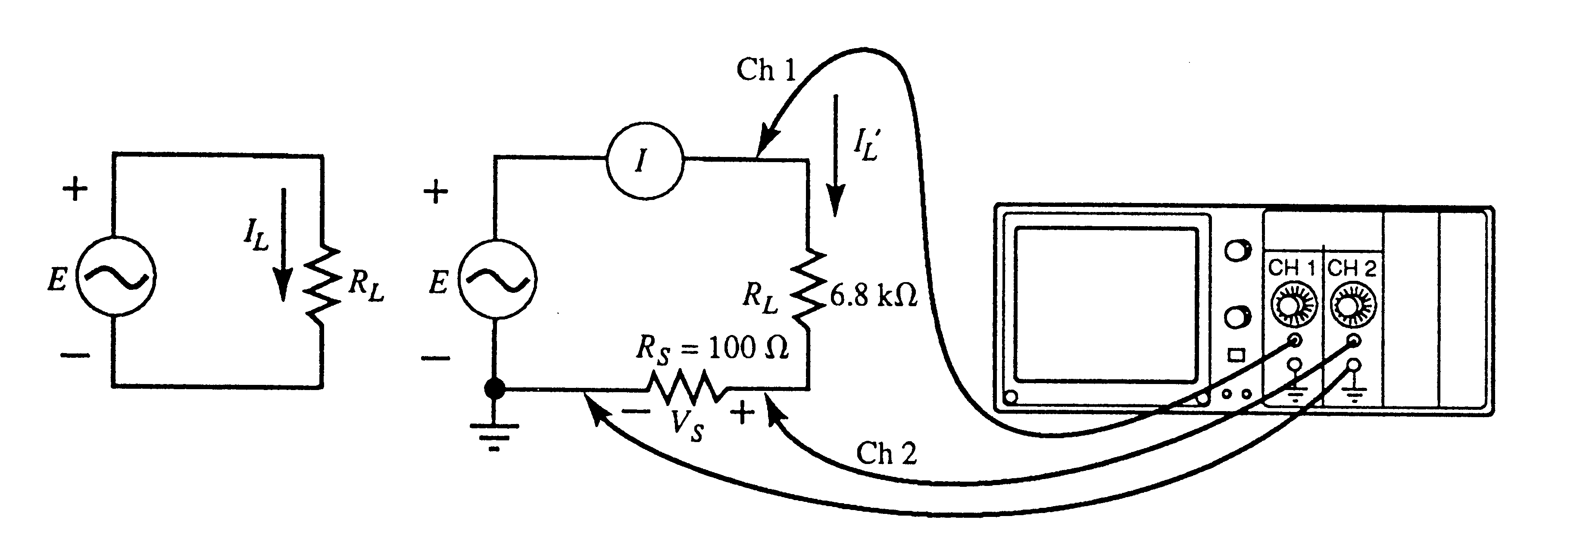
(a) Circuit (b) Measuring current with sensing resistor
Figure 1 Measuring current with an oscilloscope

Dual channel measurements
With a dual channel oscilloscope, you can display two waveforms simultaneously. This permits you to determine phase relationships between signals, compare wave shapes, and so on.

Differential voltage measurements
Lets consider an earthed circuit, if we need to measure the voltage across a component, we have to place the probe tip at one end and the ground clip at the other end of the component under normal measurement. However, the ground clip may short out part of the circuit because we connect two points to the ground reference in a circuit. Differential measurement technique can be used to solve this problem.

Part B –Procedures

RMS values and the frequency response of ac meter and the oscilloscope
- Connect the circuit as shown in Figure 2. Adjust the function generator to 100Hz sine wave with 12V_{peak-to-peak}. Measure and record the rms voltage using the DMM.

Figure 2 Comparison of RMS values and frequency response of DMM and oscilloscope.

- Following the frequency settings below and record the magnitude of the waveform on screen and the DMM’s readings.

Frequency (Hz) | Scope reading (V) | Actual rms value (Vrms) | DMM reading (Vrms)
100 | 6 | 4.24
1k
10k
100k
1M

Superimposed ac and dc voltage
- Set the dc offset of function generator to +1.5V. (If your function generator do not have dc offset, just connect a variable dc power supply or a 1.5V battery in series with the function generator.) Select ac coupling (to temporarily block the dc component while letting the ac component passes) and adjust the output of the generator to 4V_{peak-to-peak} (i.e. V_{m} = 2V). Return the coupling to dc.

- You have superimposed ac and dc voltages. Record the waveform on the screen. You should also mark the ground position in Figure 3.
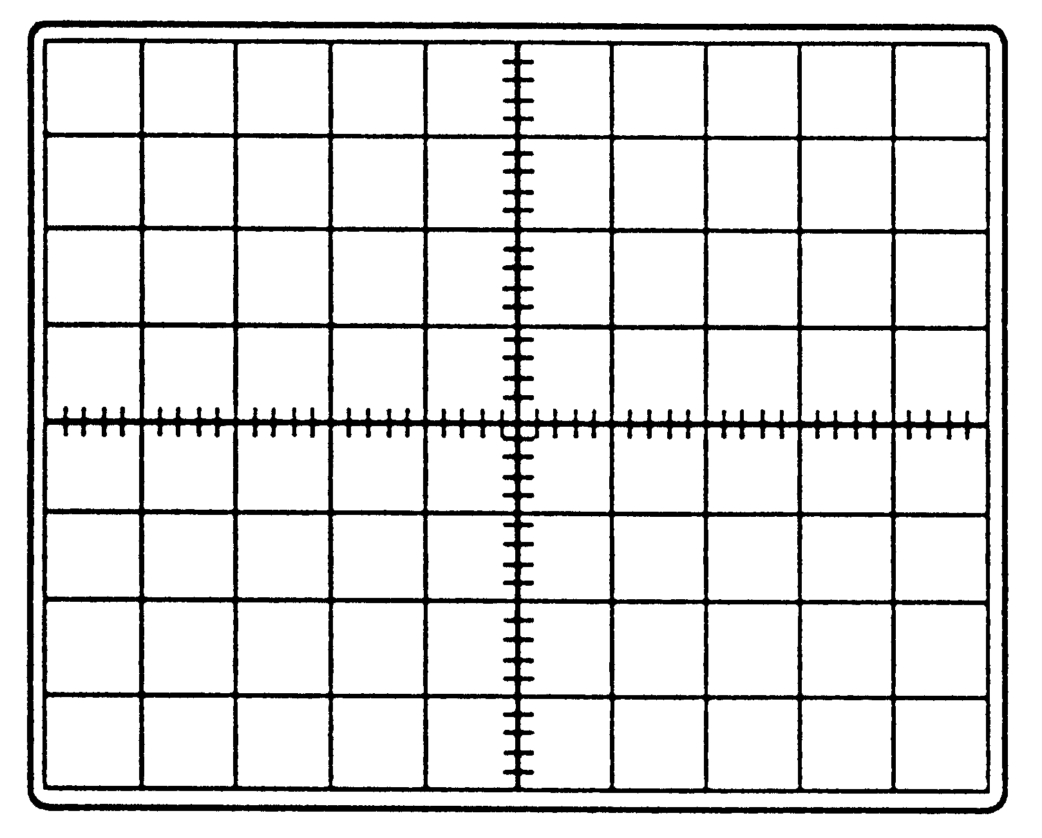
Volts/Div =
Time base =

Figure 3

- Compute the rms value for this waveform from $V=\sqrt{V_{{\text{dc}}^{2}}+V_{{\text{ac}}^{2}}}$ where V_{dc} is the dc component of the waveform and V_{ac} is the rms value of its ac component.

 | 100 Hz | 100 kHz
V_{dc}
V_{ac}
V

- Set the DMM to ac voltage measurement and record the reading. Set the DMM to dc voltage measurement and record the reading. Are the readings of the DMM in the two mode indicate a correct and steady reading. Note your observation.
__________________________________________________________________________________________________________________________
_____________________________________________________________

Dual channel measurements
- Connect the circuit as in Figure 4. Set the channel select switch to Alt and trigger mode to Auto.
- Establish the 0V baseline for CH1 by moving its ac-ground-dc switch to ground and adjust its vertical position control until the trace is centered. Repeat for Ch2.
- Return both CH1 and CH2 to the ac position and set the triggering to Ch1, positive slope. Set time base to 20μs/Div.
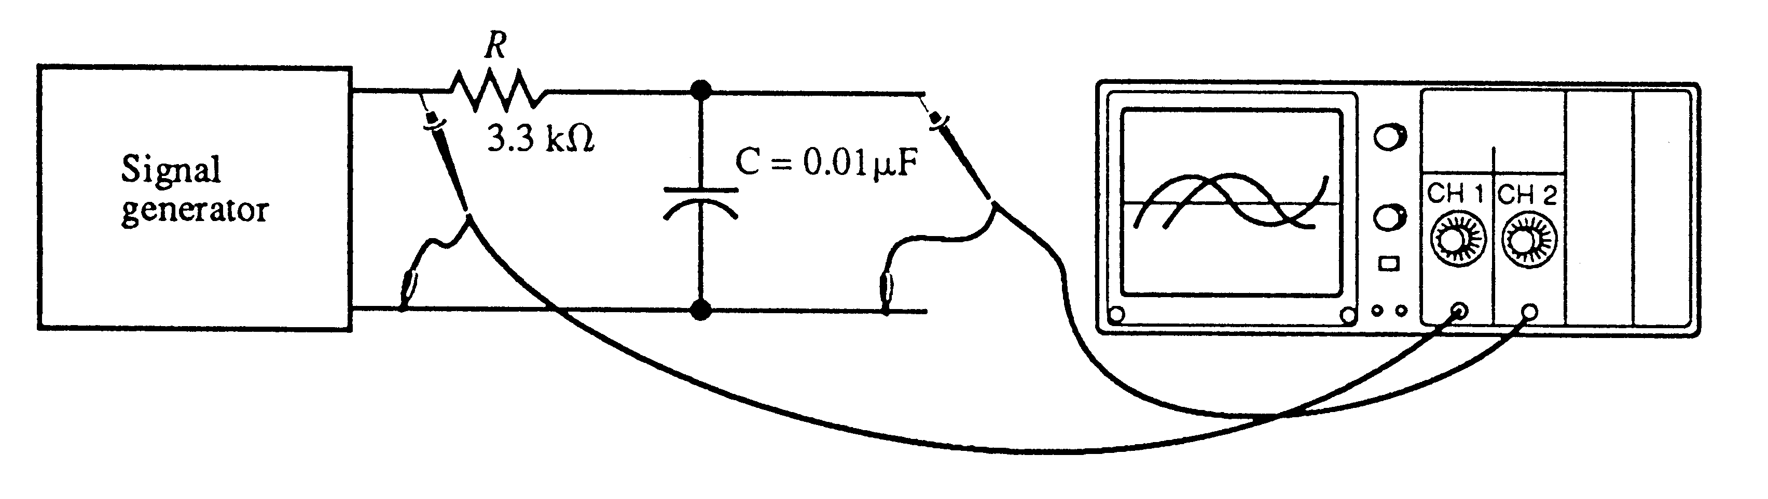
Figure 4 Dual channel measurements

- Set the function generator to a 2.5kHz sine wave with 6V_{peak-to-peak}. Select appropriate settings for vertical scale of CH1 and Ch2.
- Using the time base variable control if necessary, spread one half cycle of the reference waveform (CH1) over the entire screen. Measure the displacement between waveforms at their zero-crossover points and convert this displacement to degrees.
Volts/Div =
Time base =
Phase displacement =

Figure 5
__________________________________________________________________________________________________________________________
_____________________________________________________________

- The theoretical displacement is $θ={\text{tan}}^{−1}\frac{1}{ω\text{RC}}−\text{90}°$. Compute θ and compare to the result in step 11. (ω = 2πf)
__________________________________________________________________________________________________________________________
_____________________________________________________________
__________________________________________________________________________________________________________________________
- Measure the magnitudes of each waveform and write the time varying equation for the two voltages.
V_{1m}
V_{2m}
v₁(t)
v₂(t)

- Set the frequency of the function generator to 10kHz and repeat step 11 and 12.
Volts/Div =
Time base =
Phase displacement =

Figure 6
__________________________________________________________________________________________________________________________
_____________________________________________________________
__________________________________________________________________________________________________________________________
_____________________________________________________________
__________________________________________________________________________________________________________________________
_____________________________________________________________

Current measurement with an oscilloscope (15 to 18 Optional)
- Connect the circuit as in Figure 1(b). You should note the placement of the sensing resistor. With the resistor placed as shown, you can connect both ground clips of the oscilloscope directly to the ground of the function generator without fear of ground problems. Set the output of the function generator to 100Hz sine wave with 6V_{peak-to-peak}.

- Measure the voltage across the sensing resistor using CH2, then convert to rms.
Volts/Div =
Time base =

V_{S} = _______________(rms)

Figure 7

- Using Ohm’s law, determine the rms value of the measured load current and compare this current to that measured by the DMM ammeter.

I_{L}’ (DMM reading)
$$I_{L^{'}}=\frac{V_{S}}{R_{S}}$$

__________________________________________________________________________________________________________________________
_____________________________________________________________

- The load current that you are trying to measure is $I_{L}=\frac{E}{R_{L}}$ as shown in Figure 1(a). Using the measured values of R_{L}, compute I_{L} and compare it with the result in step 17.
__________________________________________________________________________________________________________________________
_____________________________________________________________
__________________________________________________________________________________________________________________________
_____________________________________________________________

Differential measurements
- Connect the circuit of Figure 8. Set the function generator to 1kHz sine wave with 6V_{peak-to-peak}.
Figure 8 Differential measurement

- Set Volts/Div to the same value for both channels and ensure that they are in the Cal. position. Center the traces.
- Set the coupling to ac for both channels.
- Select the differential mode for your oscilloscope. If your oscilloscope does not have differential mode, use the Add mode and invert CH2.
- Record the waveform of the difference of Ch1 & Ch2. What is the ratio of V_{ab} to the function generator’s output voltage. Does it agree with the theoretical value?
Volts/Div =
Time base =

Figure 9

__________________________________________________________________________________________________________________________
_____________________________________________________________
Part C – Discussion

- What conclusion do you draw from the data of step 2 of Part B?
_____________________________________________________________
_____________________________________________________________
_____________________________________________________________
_____________________________________________________________
_____________________________________________________________
_____________________________________________________________
_____________________________________________________________

- Discuss the results of step 4 to 6 of Part B. Does the DMM yield the rms value of the waveform?
_____________________________________________________________
_____________________________________________________________
_____________________________________________________________
_____________________________________________________________
_____________________________________________________________
_____________________________________________________________
_____________________________________________________________

- Give one example that you will use an oscilloscope to take the measurement.
_____________________________________________________________
_____________________________________________________________
_____________________________________________________________
_____________________________________________________________
_____________________________________________________________
_____________________________________________________________
_____________________________________________________________
_____________________________________________________________
_____________________________________________________________
- END -

