 | Vocational Training Council  Institute of Vocational Education (Tsing Yi )  Information & Communications Technology

Laboratory Sheet ( DC 2)

Student name: ____________ | Course / Year: ________ | Subject:________ | Date: ________

Measurement Errors: Voltage and Resistance

Objectives:
- To investigate sources of error in measurements

Apparatus:
- Digital Multimeter (DMM) X 2
- dc power supply

.

PartA: Voltage Measurement Error
PROCEDURE:

1. Set the DMM to its DC voltage range and use it to set the PSU to 10V as shown in Figure 1.
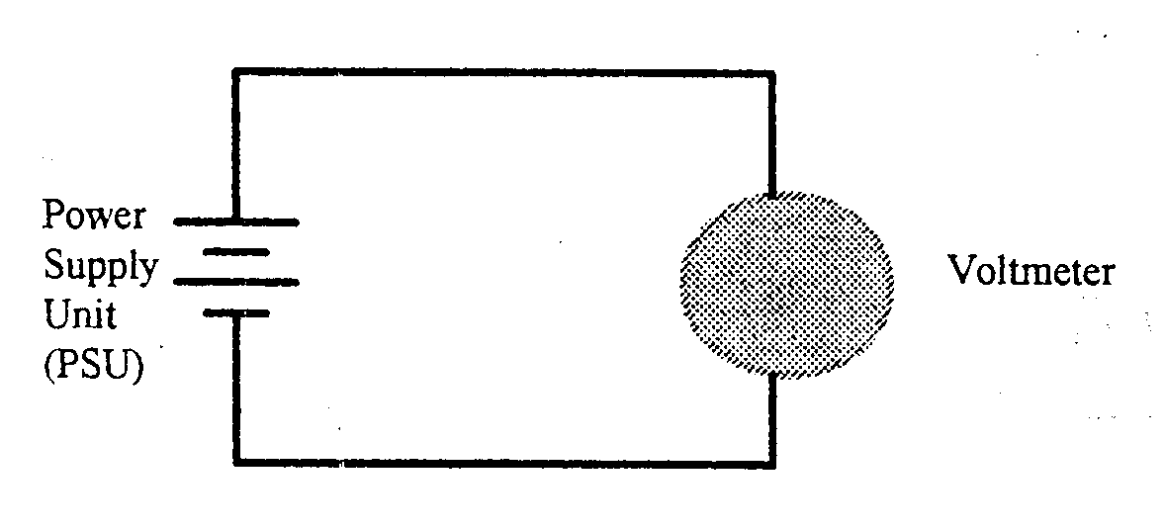
Figure A1
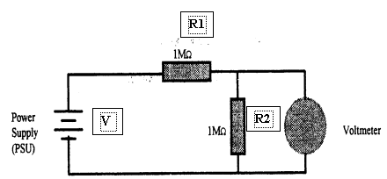
2. Connect the two lMohm resistors and the DMM as shown in Figure A2.

Figure A2
3. If the resistors were to act as a simple voltage divider, what would expect the meter to read?
Expected voltage =__________________

4. Measure the voltage across R2 .
Measured voltage = __________________
5. Calculate the difference from expected voltage
Difference from expected =______________

6. Calculate the possible DMM reading error according to the DMM specification. (See appendix A)
DMM error = ______________________

Expected voltage | Measured voltage | Difference from expected | DMM error

7. Compare this with the possible DMM error according to the DMM specification and comment on any difference found.
________________________________________________________________________
________________________________________________________________________
________________________________________________________________________
________________________________________________________________________

8. Use the DMM to measure the value of the resistor and see if this explains your deduction.
________________________________________________________________________
________________________________________________________________________
________________________________________________________________________
________________________________________________________________________

9. Use a second DMM to check the PSU voltage without disconnecting your circuit as shown in Figure A2 . Comment the results on any difference found.
________________________________________________________________________
________________________________________________________________________
________________________________________________________________________
________________________________________________________________________

10. Connect the second DMM in parallel with the first DMM. Note if there are any changes in voltage readings and try to explain the phenomenon.
________________________________________________________________________
________________________________________________________________________
________________________________________________________________________

- By using the above measured data, can you estimate the input resistance of the DMM ? If yes, devise how.

PART B: Resistor Measurement Errors ( Discussion)

Any ammeter will have a measurable, but small internal resistance causing a voltage drop across it. If we wish to measure both the current through, and voltage across, a resistor it can be seen from the figures below that:
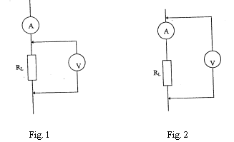

Fig. 1: The voltmeter represents an additional load causing the ammeter to read the sum of the meter current and the current through the resistor.
Fig. 2: The voltmeter reads the voltage across both the resistor and the ammeter.

Questions:

If a multi-range electronic voltmeter presents a constant resistance over its operating range and a multi-range ammeter present a constant resistance over its operating range, estimate whether the configuration shown in Fig. 1 or Fig. 2 is best suited to the following situations:

1. R_{L} is a small valued resistor with a high current flowing through it.

2. R_{L} is a large valued resistor with a low current flowing through it.

SUMMARY

In not less than 100 words, write down what you have learnt from this experiment.

