Influence of a mined-out ore zone on the mining of a nearby ore zone in David Bell Mine

R. Doran, K. McKirdy and X. Yi*
David Bell Mine

Abstract

Mining has advanced from the bottom 11A sublevel to the current 10A and 10B sublevels in the C-zone orebody. The C-zone dips north at about 60 degrees and is approximately parallel to the overlying mined-out A-zone. It comes up to the same elevation as the A-zone above the 11A sublevel on which the horizontal distance between the two ore zones is about 75 m. The hanging wall drifts and rockmass for the stopes between 11C and 10A sublevels in the C-zone experienced unusual stress conditions.

Three-dimensional elastic stress modelling was done to study the stress distributions around stopes, and the stress pattern change at the C-zone and A-zone junction. Modelling results clearly showed that the high stress zone, which was situated in the stope back on the 11C sublevel, moved to the C-zone hanging wall on 10A sublevel under the influence of the mined-out A-zone. Since the C-zone is only a few metres in thickness, the fractured rockmass in the back can be easily supported, but a large fractured hanging wall is expensive to support. This change of stress pattern required a modification in stope planning and support design as well as rehabilitation to a hanging wall haulage drift.

1. INTRODUCTION

Geology and mining methods.

Geologic units for the Hemlo Gold orebody are similar at the three mines (Sprott et al. 1999), but the ore zone thickness and dip are different. Most of the stopes in Williams Mine are 10 - 50 m thick and dip 70 degrees, whereas most of the stopes in David Bell Mine are 2 - 17 m and dip 53 - 65 degrees. For this stope geometry, caving in the hanging wall is much more likely to occur than in the back because of the surface dimension and gravity effects.

The primary mining method at David Bell Mine is long-hole open stoping with delayed hydraulic backfill. For 5-20 m thick ore zones, stopes are 20 m wide for primary stopes and 30 m for secondary stopes. Sublevels are at 25 m intervals. Thinner ore zones at the perimeter of the orebody are mined using the longitudinal retreat mining method. Down-hole and up-hole blast designs are used. Down holes are drilled from stope overcut in the ore zone, and up-holes are drilled from the haulage drift on the stope undercut. Hole diameter is 3 inches (76 mm).

All mine openings are supported with 2.3 m resin rebars spaced at 1.2 m x 1.2 m. 6 gauge screen is used on lower sublevels. Screens are held by 0.9 m mechanical bolts and push plates on resin rebars. In development blasting, back holes are loaded with “Powdersplit” or ANFO traced with “B-Line” to minimise blast damage.

Secondary stopes usually lag behind primary stopes by one sublevel. Stopes are backfilled by hydraulic transport at a pulp density of 72-78%. Primary stopes are filled with cemented backfill at 30:1 sand/cement ratio (3.2 % cement), and secondary stopes are filled with dry backfill. A 4-6 m thick backfill plug of 20:1 sand/cement ratio (4.8 % cement) is placed at the bottom and a 2 m thick waste cap is placed at the top of all stopes.

Purposes

In situ stresses used in the modelling are the same for the three mines and modelling techniques are similar (Sprott et al.1999). Back analysis of the J2 stope 11C-10A showed that the highly stressed / damaged zone, which occurs normally in the back of a stope, transferred to the hanging wall of the J2 stope because of the influence of the mined out A-zone. The results of the modelling correlated with underground observations.

Modelling was performed for the advancing sequence from the time when 11C-I4 stope was mined in October of 1997 to the present time when 10A-I4 stope was mined in May of 1998 for calibrations. The modelling for the future mining sequence attempted to answer the following question: whether or not the stress conditions for the stopes above the 10A sublevel get worse?

Model Calibrations

Underground observations

Underground observations were made in May of 1998 before mucking in the J2 stope between 11C and 10A sublevels commenced.

On the 10A sublevel, ground conditions in the H/W drift between J1 and J2 X/C deteriorated considerably after the blasting of the J2 stope 11C-10A. Discontinuous seismic sound was heard. An open foliation fracture was seen in the three crosscuts of I4, J1, and J2, with an increasing opening, from one to tens of millimetres, at 8 m distance from the hanging wall contact (Fig. 1). The direction of shear displacement was identified on the east walls of the J1 and J2 crosscuts, indicating that the footwall of the fracture displaced towards the west. This fracture coincided with the hanging wall porphyry sill/dyke in the I4 crosscut. Two additional foliation fractures appeared in the J2 crosscut in the less hard sericitic rock unit situated to the north of the porphyry sill. At the J2 intersection, an open foliation fracture (max. aperture 10 mm) was seen on the floor close to the north wall.

A cavity survey that was done when the stope was mucked out revealed 2 - 4 m of hanging wall caving in the centre section of the stope (Fig. 1). The hanging wall cables which had a 2.5 m row spacing and a 2 to 2.5 toe spacing ruptured during mucking.

In the 10 sublevel rail-haulage, minor spalling was observed in the hanging wall of the J2 stope. The haulage drift is about 20 m from the stope as measured from the haulage south wall to the stope hanging wall contact. Fresh slabbing of about 0.5 cubic metre volume occurred in an unsupported blast raise located at approximately 25 m from the hanging wall contact of the east edge of the stope. Additional caving of the stope hanging wall occurred as the mucking of the J2 stope was completed.

The above observations indicated an extraordinarily high amount of hanging wall caving for this secondary stope. The understanding of the causes of this activity was essential for future C zone stope planning.

Correlation between modelling results and observations

Fig. 2 shows the C-zone sequence in three modelling steps shown in grey, red, and yellow from the time the 11C-I4 stope was mined, to the present time. The distance between the C-zone and A-zone on the 10A sublevel is approximately 75 m.

J2 Section Plots prior to and after the Mining of 11C-J2 Stope

Fig. 3a and b clearly shows that the high stress zone transferred from the back of the stope to the upper hanging wall after the 11C-J2 stope was blasted. This occurred because of the influence of the mined-out A-zone. The hanging wall of 11C-J2 stope caved even though the approximately 5 m thick porphyry rock unit at the hanging wall contact was cablebolted (section 2.1).

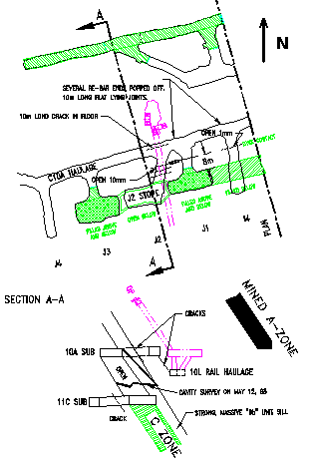

Figure 1. Ground observations for the J2 stope 11C-10A of the footwall C-Zone.
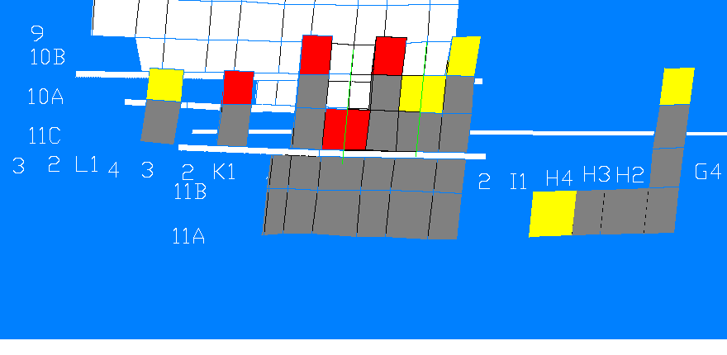
Figure 2. Mining sequence in C-zone from 11C-I4 to 10A-I4 stope mining.

Prior to the mining of 11C-J2 stope (Fig. 4a), there were high north-south stresses flowing through the 10L haulage drift. After the stope was blasted, the major principal stress direction changed to align with the foliation planes. This stress change explains for the gradual convergence of the north-south walls in the haulage drift prior to the blasting of the 11C-J2 stope, and the spalling and slabbing that followed the blasting.

The large high stress zone in the J2 stope back on the 11C sublevel (Fig. 4a) may have caused severe damage in the back as well as the immediate hanging wall. This may have contributed to the hanging wall caving after the 11C-J2 stope was mucked open.

Effect of 11C-J2 Mining on 11C-I4 Stope

Fig. 4a and b show that the mining of the J2 stope caused minor but significant enlargement of the yellow damage zone in the back of I4 stope on 10A sublevel. Minor popping was heard in the I4 stope back after the blasting of the 11C-J2 stope.

I4 Section Plots prior to and after the Mining of 10A-I4 Stope

With the blasting of I4 stope 10A-10B, spalling and slabbing occurred in the upper north wall of the hanging wall drift, and the separation of the foliation joints occurred on the lower north wall near the I4 stope.

Fig. 5a plots the stress contours for the time when 11C-I4 was mined and Fig. 5b shows the stress contours during the mining of 10A-I4 stope. The 10A-I4 stope has a larger damage zone in the stope back area but a smaller damage zone in the hanging wall area than the previous 11C-I4 stope. Since the hanging wall has a much larger hydraulic radius than the back, the hanging wall stability is of more concern. This indicates that the hanging wall stress conditions will gradually improve as the C-zone front advances above the 10A sublevel, the bottom of the A-zone. This issue will be further discussed in section 3).

Stope dilution study

Stope dilution studies based on cavity surveys provided additional evidence that the dilution was substantially higher than usual for stopes approaching the A-zone bottom elevation.

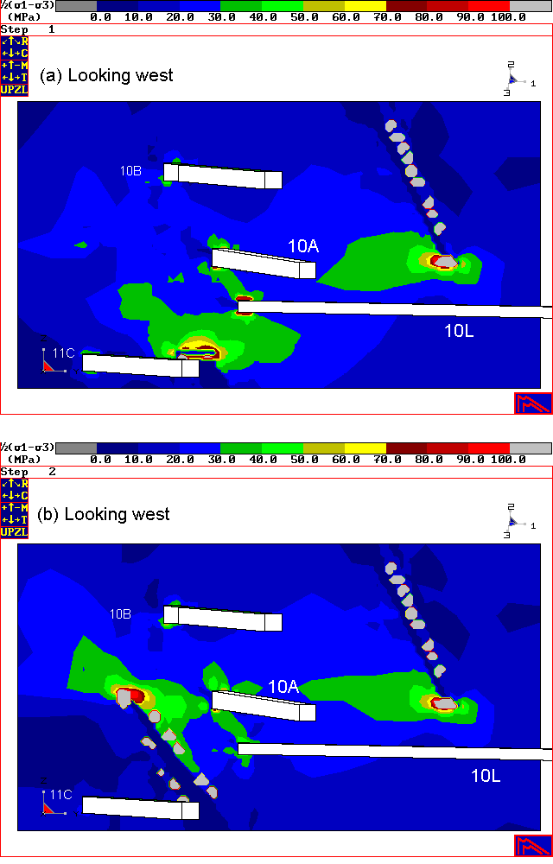

Figure 3. Stress deviator contour plots for J2 section, (a) before and (b) after 11C-J2 was mined.

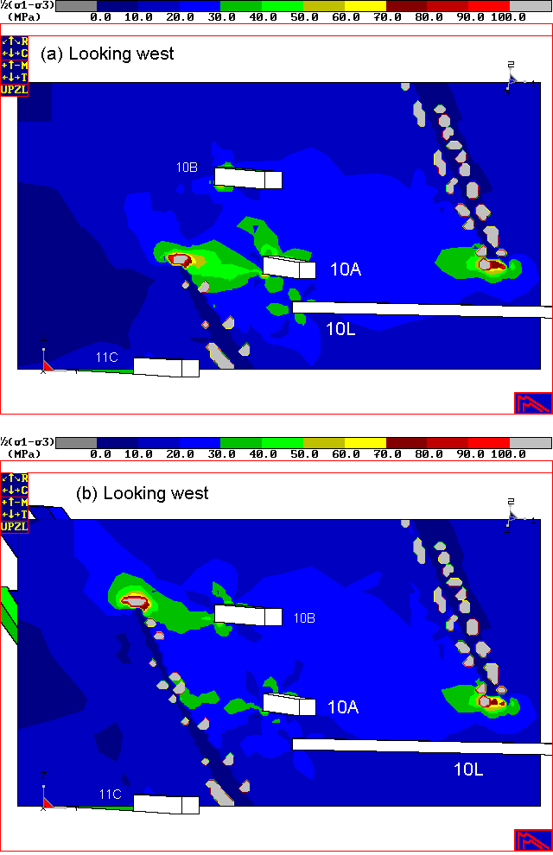

Figure 4. Stress deviator contour plots for I4 section, (a) before and (b) after 11C-I4 was mined.

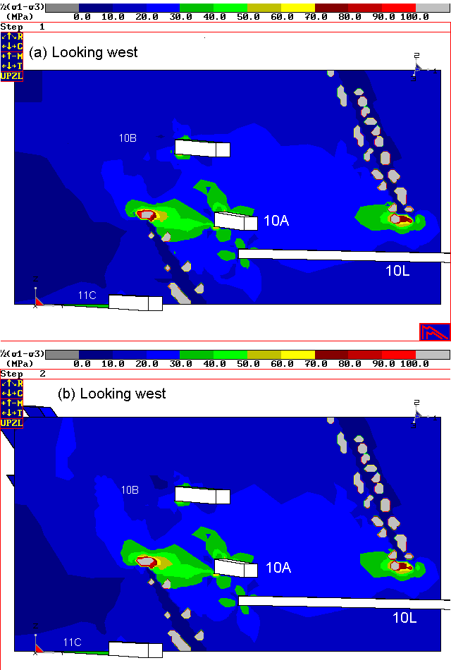

Figure 5. Stress deviator contour plots for I4 section when (a) 11C-I4 and (b) 10A-I4 were mined.

Modelling for Future Mining

Fig. 6a shows the projected geometry when the 10A-J2 stope is mined. The resulting stress deviator contours are shown in Fig. 6b. Compared to Fig. 3b, the stress concentrations in the hanging wall are significantly lower. Since the caving that occurred in the J2 stope between 11C and 10A sublevels caused severe undercutting of the foliated rockmass in the hanging wall on 10A sublevel, the hanging wall ground conditions for both 11C-J2 and 10A-J2 stopes should be treated the same for purposes of stope planning.

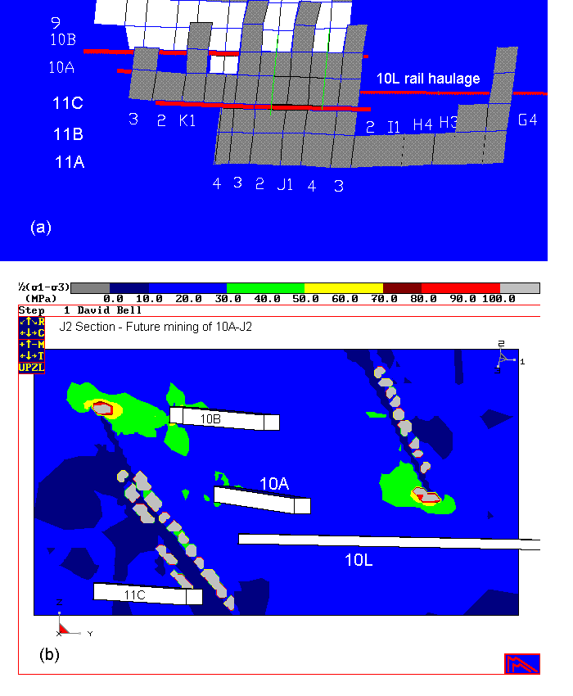
Figure 6. (a) Stope geometry and (b) stress deviator contours when the 10A-J2 stope is mined in the future.

Based on the above modelling results, it can be concluded that the worst hanging wall stress conditions occur in the stopes between 11C and 10B sublevels, i.e., one sublevel below and one sublevel above the bottom elevation of the mined out A-zone. The ground conditions will improve for stopes above 10B sublevel.

Conclusions

Modelling results agree remarkably well with reactions that took place during the mining sequence from 11C-I4 to 10A-I4 stopes. The modelling shows that the stope hanging wall stress condition will gradually improve as the C-zone front advances above the 10B sublevel.

The worst stope hanging wall stress conditions occur one sublevel below and one sublevel above the bottom elevation of the mined-out A-zone. Ground stress conditions in the C-Zone will improve as stopes are mined above 10B sublevel.

Acknowledgements

RocCAD software (XY RocCAD Inc., registered Copyright 1998) was used to construct the model geometry and MAP3D software (registered Trademark of Mine Modelling Ltd.) was used to compute the stresses. Modelling techniques and stresses-damage relations developed and obtained at both the Golden Giant and the Williams Mines were used in the present study.

References

D. Sprott, M. Toppi, X. Yi and W. Bawden 1999. Integration of stress damage factor into Mathew’s Stability Graph. CIM 14th Mine Operator’s Conference, Bathurst, New Brunswick, February 21-25, 1999.

APPENDIX A: A Study of Modelling Accuracy

The modelling results presented in this memo were obtained using the following MAP3D parameter settings: AL = 3, AG = 3, DOL = 1, DON = 0.5, DOC = 1, DOE = 2, DOG = 2, DOR = 5.

Because isolated abnormal high stress spots occur on the hanging and footwall contacts of the open stopes, increased accuracy settings were tried to see whether or not the damage zone size and shape (from the stress deviator plots) change with the setting changes. These settings are: AL = 3, AG = 2, DOL = 2, DON = 0.5, DOC = 2, DOE = 2, DOG = 2, DOR = 5.

With the increased accuracy, isolated abnormal high stress spots still existed, but the damage zone size and shape indicated by the yellow color with σ₁-σ₃ > 50 MPa remain unchanged. Therefore, the results presented in this paper are sufficiently accurate for the intended purposes.

* Correspondence: X.(Ping) Yi, Geology and Engineering, Williams Operating Corporation, Marathon, Ontario, P0T 2E0. Tel. (807) 238-1100 ext. 4219. Fax. (807) 238-1050.

