David Scozzaro
SGET 660
Week 2 Project
7/18/05

How To…
Add Fonts

- Finding a font
  - Open Internet Explorer (or another web browser)
  - Using www.1001freefonts.com, www.abstractfonts.com, www.highfonts.com, or another downloadable font website,* search and find the font you wish to download
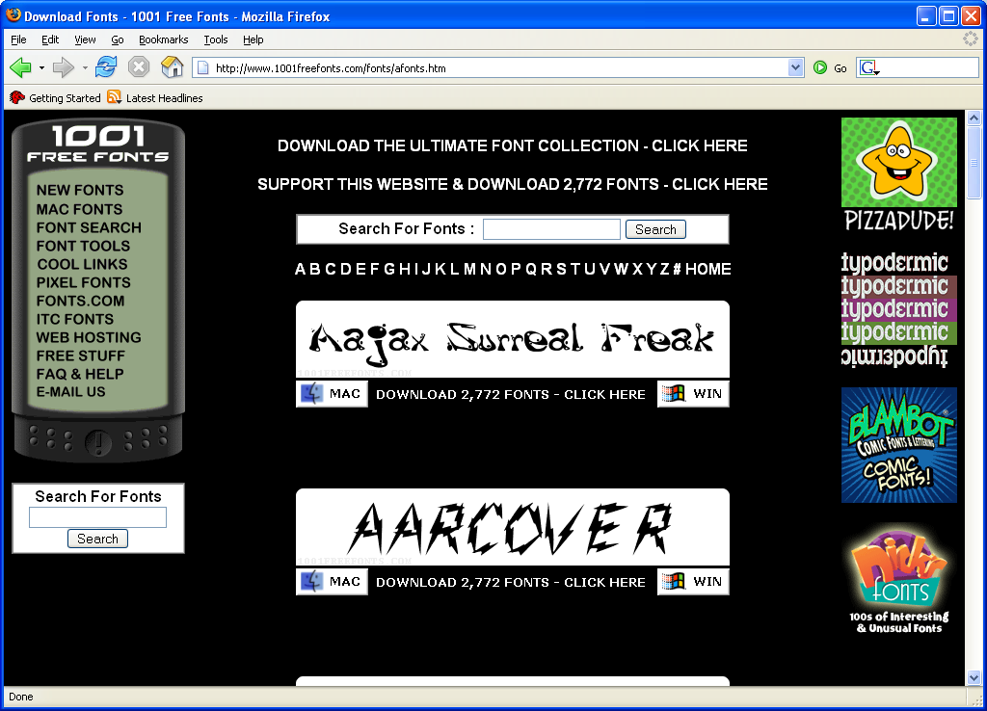
- Correctly downloading the font
  - Once you have selected a font, it is important that you save it to the correct place
  - Click on Download (for Windows)

  - You want to save it to disk
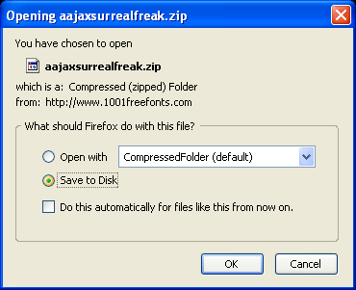
  - Click on OK.
    - If it allows you to, save the file to the desktop for the time being by clicking on the down arrow towards the top of the screen and clicking on the desktop icon (usually the very first one) Skip to Step G
    - If it automatically downloads to it’s own folder, follow steps E-F
  - A little pop-up box will appear in the bottom right hand corner when the download is completed. Click on the link that says “all files have finished downloading”
  - In the Downloads box, click “open.”
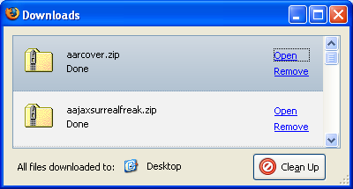
  - Often, Font files are saved as Zip files and must first be unzipped. If this is not necessary (if it is zipped, it will show up as a folder with a zipper going down the side and has the extension .zip, skip to Part III. To do this, look underneath the folder task menu on the left hand side and click on “Extract all Files”
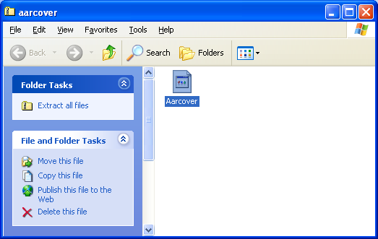
  - Follow the instructions provided by the unzipping program.
  - When it is time to save the font file, 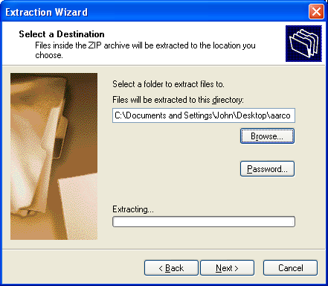
click on browse and choose desktop to save it for the time being
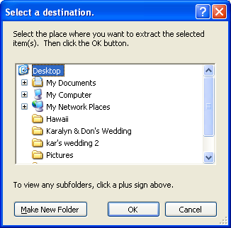
And press OK
  - follow the steps to finish out the process of unzipping the file
- Saving the font so you may use it
  - Once the file is saved onto the desktop, open up My Computer
  - Open Local Disk (C:)- AKA the hard drive
  - Open Windows
  - Open Fonts
  - Drag the font file (and not the zippered folder) from the desktop into the fonts file folder
  - To check, open Microsoft Word from your desktop shortcut or from the start menu in the bottom left hand corner.
  - Click on the font drop down arrow and scroll down to find the name of your font file
  - If it is there, you may delete the font from your desktop
  - If it is not, make sure you dragged the correct file into the Fonts folder

* Make sure the fonts you download are freeware. Shareware will cost you money!

