Syllabus for Advanced Algebra

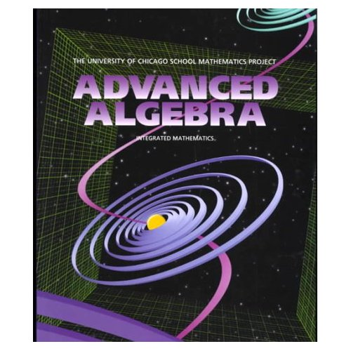

Instructor and email address:
Ms. D. Langenderfer, dlange@leeca.org

Location and voicemail:
Room G1, Olmsted Falls High School, 440-427-6058

Website:
www.ofhsmath.com
www.geocities.com/donnalangenderfer

Textbook:
Advanced Algebra
University of Chicago series, 2002 edition

Description and Goals: This course, which should follow the successful completion of Algebra 1 and Geometry, is designed to increase students’ understanding of Advanced Algebra. The course requires students to study topics such as linear functions, trigonometric functions, sequences and series, polynomial functions and logarithmic functions. Most of the class objectives are covered in chapters 1–13 of the text. The use of technology will be incorporated into this class on a regular basis.

Requirements: Daily attendance, along with the covered textbook, notebook, folder, and pencil, is required. A TI graphing calculator is required. Classroom rules are expected to be followed at all times or consequences will result. You will have no problem in our class if you are always respectful, responsible, and ready to learn.

Resources: Extra help is available for all students. Please see me to schedule time for extra assistance whenever necessary. Also please remember to check our website often at www.geocities.com/donnalangenderfer for links to online practice, games, current grades, homework assignments, test dates, and copies of the daily notes.

Evaluation: Student progress in this course is evaluated using tests, projects, quizzes, homework, and classwork. Total points earned are divided by total points possible to determine the overall grade on a scale of 90-100 A, 80-89 B, 70-79 C, 60-69 D. Well-kept notebooks will be considered for 1% extra credit at the end of each quarter. Your grades will be posted using your student ID numbers on a weekly basis, but you may see me at any time when you have questions or concerns about your progress in this course. In addition, your grades will be posted online weekly for you and your parents to view.

Tests and Exams: Chapter tests are always announced well in advance in class and on the website. There will be a semester and a cumulative year-end final exam as well.

ADVANCED ALGEBRA COURSE SCHEDULE (TENTATIVE)

Week 1 (08/22/07) CHAPTER 1
Week 2 (08/27/07) Functions
Week 3 (09/04/07)

Week 4 (09/10/07) CHAPTER 2
Week 5 (09/17/07) Variation and Graphs
Week 6 (09/24/07)

Week 7 (10/01/07) CHAPTER 3
Week 8 (10/08/07) Linear Functions
Week 9 (10/15/07)

Week 10 (10/22/07) CHAPTER 4
Week 11 (10/29/07) Matrices
Week 12 (11/05/07)

Week 13 (11/12/07) CHAPTER 5
Week 14 (11/26/07) Systems
Week 15 (12/03/07)

Week 16 (12/10/07) CHAPTER 6
Week 17 (12/17/07) Quadratic Functions
Week 18 (01/07/08)
Week 19 (01/14/08)

January 16-18, 2008 MIDTERM EXAM – CHAPTERS 1 THROUGH 6

Week 20 (01/22/08) CHAPTER 7
Week 21 (01/28/08) Powers
Week 22 (02/04/08)

Week 23 (02/11/08) CHAPTER 8
Week 24 (02/19/08) Inverses and Radicals
Week 25 (02/25/08)

Week 26 (03/03/08) CHAPTER 9
Week 27 (03/10/08) Exponential and Logarithmic Functions
Week 28 (03/17/08)

Week 29 (03/31/08) CHAPTER 10
Week 30 (04/07/08) Trigonometry
Week 31 (04/14/08)

Week 32 (04/21/08) CHAPTER 11
Week 33 (04/28/08) Polynomials
Week 34 (05/05/08)

Week 35 (05/12/08) CHAPTER 12 / CHAPTER 13
Week 36 (05/19/08) Quadratic Relations / Series and Combinations
Week 37 (05/27/08)

June 2 - 4, 2007 FINAL EXAM – CHAPTERS 1 THROUGH 13

