Flashcards OFLAMERON - technology for learning foreign words
Print the tape with the text (text box). The student must correctly divide the tape into fragments and make of them a phrase in Spanish See http://bretell.blogspot.com/
buena mañana <- good morning
English
Spanish
buenamañana - remove spaces
naenabumaña - rearrange the fragments of words
Tape for printing
naenabumaña
- type

You need to cut the tape into fragments, and to make a phrase “buena mañana”
buenas noches - good evening
buenasnoches - remove spaces
naschesbueno - rearrange the fragments of words
Tape for printing
naschesbueno

You need to cut the tape into fragments, and to make a phrase “buenas noches”
cómo se llama - what is your name
cómosellama - remove spaces
macellaómos - rearrange the fragments of words
Tape for printing
macellaómos
- type

You need to cut the tape into fragments, and to make a phrase “cómo se llama”
repita eso por favor - Please repeat that
repitaesoporfavor - remove spaces
vortaesrepioporfa - rearrange the fragments of words
Tape for printing
vortaesrepioporfa

You need to cut the tape into fragments, and to make a phrase “repita eso por favor”

How to learn. Example
siesendenachneinericht

senden sie eine nachricht

comprendo - I understand
comprendo - remove spaces
prencomdo - rearrange the fragments of words
Tape for printing
prencomdo
- type

You need to cut the tape into fragments, and to make a phrase “comprendo”
no comprendo - do not understand
nocomprendo - remove spaces
docompnoren - rearrange the fragments of words
Tape for printing
docompnoren

You need to cut the tape into fragments, and to make a phrase “no comprendo”
cómo se dice - how do you say
cómosedice - remove spaces
cósemocedi - rearrange the fragments of words
Tape for printing
cósemocedi
- type

You need to cut the tape into fragments, and to make a phrase “cómo se dice”
cómo está ud - how are you
cómoestáud - remove spaces
udestácómo - rearrange the fragments of words
Tape for printing
udestácómo
http://www.oflameron.ru

You need to cut the tape into fragments, and to make a phrase “cómo está ud”
voy a mi casa - I am going home
voyamicasa - remove spaces
micasavoya - rearrange the fragments of words
Tape for printing
micasavoya
- type

You need to cut the tape into fragments, and to make a phrase “voy a mi casa”
vivo en el campo - I live in the country
vivoenelcampo - remove spaces
povivocamenel - rearrange the fragments of words
Tape for printing
povivocamenel

You need to cut the tape into fragments, and to make a phrase “vivo en el campo”
por la noche - in the evening
porlanoche - remove spaces
chenoporla - rearrange the fragments of words
Tape for printing
chenoporla
- type

You need to cut the tape into fragments, and to make a phrase “por la noche”
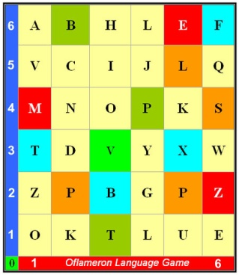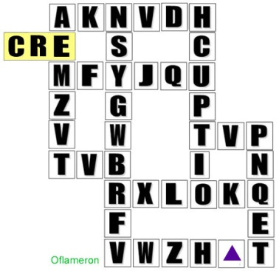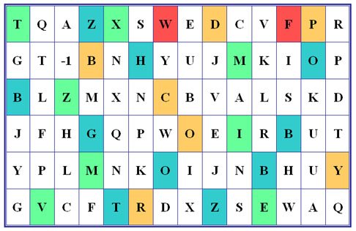
See http://geocities.ws/frenchfree/

dónde está - where is
dóndeestá - remove spaces
dónestáde - rearrange the fragments of words
Tape for printing
dónestáde

You need to cut the tape into fragments, and to make a phrase “dónde está”
más abajo - more below
másabajo - remove spaces
jomábasa - rearrange the fragments of words
Tape for printing
jomábasa

You need to cut the tape into fragments, and to make a phrase “más abajo”

How to learn. Example 2 (German)
taufenxirein

- cut the tape

ein taxi rufen

- make a phrase

You need to cut the tape into fragments, and to make a phrase “ein taxi rufen”
muchas gracias - thank you very much
muchasgracias - remove spaces
asmugracichas - rearrange the fragments of words
Tape for printing
asmugracichas

You need to cut the tape into fragments, and to make a phrase “muchas gracias”
de nada - you are welcome
- remove spaces
dadena - rearrange the fragments of words
Tape for printing
dadena

You need to cut the tape into fragments, and to make a phrase “de nada”
Author
© by Valery V Shmeleff http://www.oflameron.ru http://www.shmeleff.com

